INTERNET PROGRAMMING LAB
Laboratory Record – Experiments 1 to 9
Name | Sanjay Adithya S J
Register Number | 192311336
Course Name | Internet Programming
Course Code | CSA4301
Technologies used: HTML5, CSS3 and JavaScript (browser localStorage for data)

INDEX
Exp. No. | Name of the Experiment | Page No.
1 | Library Management System | 3
2 | Online Hotel Room Booking | 13
3 | Online Bus Ticket Booking System | 22
4 | Online Train Reservation System | 33
5 | Online Flight Reservation System | 43
6 | Online Cake Ordering System | 53
7 | Beauty Parlour Appointment Booking | 61
8 | Hospital Appointment Booking System | 71
9 | TechSavvy Online Shopping Platform | 81

Experiment No: 1
Name of the Experiment: Library Management System
AIM
To design and develop a library website that lets students search books, view borrow history and fines, and download study material, and lets the librarian add, update and delete books, issue and return books, calculate fines and manage year/semester-wise material.
PROCEDURE
- Create a project folder and add the files index.html, style.css, common.js and app.js (library).
- In index.html create an empty container <div id="app"> and link the style sheet and the JavaScript files.
- In common.js write the shared helper functions: browser storage (localStorage), user registration, login, logout, table building and the page header with tabs.
- In app.js create the demo data: librarian and student accounts, sample books and study material.
- Write the librarian screens: add, update and delete books, issue a book to a student for 14 days, mark a book returned, calculate the fine (₹5 per day after the expiry date) and add or view material year-wise and semester-wise.
- Write the student screens: search books, borrow history with issue date and expiry date, check fine, search and download material, and edit profile.
- Open index.html in a web browser and log in with the demo accounts to test every option.
- Observe the output, capture the screenshots and record the result.
CODE
index.html
<!DOCTYPE html><html lang="en"><head><meta charset="utf-8"><meta name="viewport" content="width=device-width,initial-scale=1"><title>1. Library Management System</title><link rel="stylesheet" href="style.css"></head><body data-ns="lib_"><div id="app"></div><script src="common.js"></script><script src="app.js"></script></body></html>
app.js
Auth.seed([
{ name: "Librarian", email: "admin@lib.com", password: "admin123", role: "admin" },
{
name: "Demo Student",
email: "student@lib.com",
password: "1234",
role: "student",
year: "2",
dept: "CSE",
},
]);
if (!DB.get("books")) {
DB.set("books", [
{
id: "b1",
title: "Operating System Concepts",
author: "Silberschatz",
isbn: "9781118063330",
copies: 3,
},
{
id: "b2",
title: "Computer Networks",
author: "Tanenbaum",
isbn: "9780132126953",
copies: 2,
},
{
id: "b3",
title: "Database System Concepts",
author: "Korth",
isbn: "9780078022159",
copies: 2,
},
]);
DB.set("issues", []);
DB.set("mats", [
{
id: "m1",
title: "DBMS Unit 1 Notes",
year: "2",
sem: "3",
content: "Sample DBMS notes: ER model, keys, normalization.",
},
]);
}
const FINE = 5,
DAYS = 14,
B = () => DB.get("books", []),
I = () => DB.get("issues", []),
M = () => DB.get("mats", []);
const fineOf = (i) =>
i.paid ? 0 : Math.max(0, diffDays(i.due, i.returned || today())) * FINE;
const avail = (b) => b.copies - I().filter((i) => i.bid === b.id && !i.returned).length;
const bt = (id) => esc((B().find((b) => b.id === id) || {}).title || "(deleted)");

function start() {
const me = Auth.me();
if (!me)
return mountAuth(
$("#app"),
{
regRoles: ["student"],
hint: "Demo: admin@lib.com / admin123 · student@lib.com / 1234",
extra:
'<label>Year</label><input name="year"><label>Department</label><input name="dept">',
},
start,
);
shell(
"📚 City Library",
me.role === "admin"
? {
Books: adminBooks,
"Issue / Return": issueView,
Fines: fineView,
Materials: matView,
}
: {
"Search Books": searchView,
"My Borrowings": myIssues,
"My Fines": myFines,
Materials: matView,
Profile: profile,
},
me,
);
}

const bookTable = (q, adm) =>
tbl(
["Title", "Author", "ISBN", "Available", adm ? "Actions" : ""],
B()
.filter((b) => (b.title + b.author + b.isbn).toLowerCase().includes(q.toLowerCase()))
.map((b) => [
esc(b.title),
esc(b.author),
esc(b.isbn),
avail(b) + " / " + b.copies,
adm
? `<button class="btn sm" onclick="editBook('${b.id}')">Update</button> <button class="btn sm red" onclick="delBook('${b.id}')">Delete</button>`
: "",
]),
);
function searchBox(m, adm, pre = "") {
m.insertAdjacentHTML(
"beforeend",
`<div class="card">${pre}<input id="q" placeholder="Search by title, author or ISBN"><div id="t"></div></div>`,
);
const d = () => ($("#t").innerHTML = bookTable($("#q").value, adm));
$("#q").oninput = d;
d();
}
function adminBooks(m) {
m.innerHTML = `<div class="card"><h3>Add Book</h3><form id="f" class="row"><input name="title" placeholder="Title" required><input name="author" placeholder="Author" required><input name="isbn" placeholder="ISBN"><input name="copies" type="number" min="1" value="1"><button class="btn">Add Book</button></form></div>`;
$("#f").onsubmit = (e) => {
const f = fd(e),
b = B();
b.push({ id: uid(), ...f, copies: +f.copies });
DB.set("books", b);
toast("Book added");
refresh();
};
searchBox(m, true);
}
function editBook(id) {
const bs = B(),
b = bs.find((x) => x.id === id),
t = prompt("Title", b.title);
if (t === null) return;
b.title = t || b.title;
b.author = prompt("Author", b.author) || b.author;
b.copies = +prompt("Copies", b.copies) || b.copies;
DB.set("books", bs);
refresh();
}
function delBook(id) {
if (confirm("Delete this book?")) {
DB.set(
"books",
B().filter((b) => b.id !== id),
);
refresh();
}
}
function searchView(m) {
m.innerHTML = "";
searchBox(m, false);
}

function issueView(m) {
const st = Auth.users().filter((u) => u.role === "student");
m.innerHTML = `<div class="card"><h3>Issue Book</h3><form id="f" class="row"><select name="bid">${B()
.filter((b) => avail(b) > 0)
.map((b) => `<option value="${b.id}">${esc(b.title)}</option>`)
.join(
"",
)}</select><select name="sid">${st.map((u) => `<option value="${u.email}">${esc(u.name)} (${u.email})</option>`).join("")}</select><button class="btn">Issue for ${DAYS} days</button></form></div>
<div class="card"><h3>Issue Register</h3>${tbl(
["Book", "Student", "Issued", "Expiry", "Status", "Fine", ""],
I()
.slice()
.reverse()
.map((i) => [
bt(i.bid),
i.sid,
i.date,
i.due,
i.returned ? "Returned " + i.returned : "<b>Issued</b>",
fineOf(i) ? rs(fineOf(i)) : "-",
i.returned
? ""
: `<button class="btn sm" onclick="ret('${i.id}')">Mark returned</button>`,
]),
)}</div>`;
$("#f").onsubmit = (e) => {
const f = fd(e);
if (!f.bid || !f.sid) return toast("Choose a book and a student");
const is = I();
is.push({
id: uid(),
...f,
date: today(),
due: addDays(today(), DAYS),
returned: null,
paid: false,
});
DB.set("issues", is);
toast("Book issued");
refresh();
};
}
function ret(id) {
const is = I(),
i = is.find((x) => x.id === id);
i.returned = today();
DB.set("issues", is);
toast(fineOf(i) ? "Returned late. Fine " + rs(fineOf(i)) : "Returned");
refresh();
}
function fineView(m) {
const l = I().filter((i) => fineOf(i) > 0);
m.innerHTML = `<div class="card"><h3>Fines (₹${FINE}/day after expiry)</h3>${tbl(
["Student", "Book", "Expiry", "Returned", "Fine", ""],
l.map((i) => [
i.sid,
bt(i.bid),
i.due,
i.returned || "Not yet",
rs(fineOf(i)),
`<button class="btn sm" onclick="payFine('${i.id}')">Mark paid</button>`,
]),
)}</div>`;
}
function payFine(id) {
const is = I(),
i = is.find((x) => x.id === id);
if (!i.returned) return toast("Book not returned yet");
i.paid = true;
DB.set("issues", is);
refresh();
}
function myIssues(m) {
const me = Auth.me();
m.innerHTML = `<div class="card"><h3>My Borrow History</h3>${tbl(
["Book", "Issue date", "Expiry date", "Status"],
I()
.filter((i) => i.sid === me.email)
.reverse()
.map((i) => [
bt(i.bid),
i.date,
i.due,
i.returned
? "Returned " + i.returned
: i.due < today()
? '<span class="bad">Overdue</span>'
: "Issued",
]),
)}</div>`;
}
function myFines(m) {
const me = Auth.me(),
l = I().filter((i) => i.sid === me.email && fineOf(i) > 0),
t = l.reduce((s, i) => s + fineOf(i), 0);
m.innerHTML = `<div class="card"><h3>My Fine</h3><p class="big ${t ? "bad" : "ok"}">${rs(t)}</p>${tbl(
["Book", "Expiry", "Fine"],
l.map((i) => [bt(i.bid), i.due, rs(fineOf(i))]),
)}<p><small>Pay the fine at the library counter; the librarian will mark it paid.</small></p></div>`;
}

function matView(m) {
const adm = Auth.me().role === "admin";
m.innerHTML =
(adm
? `<div class="card"><h3>Update Material</h3><form id="f" class="row"><input name="title" placeholder="Title" required><select name="year">${opt([1, 2, 3, 4])}</select><select name="sem">${opt([1, 2, 3, 4, 5, 6, 7, 8])}</select><textarea name="content" placeholder="Notes / content"></textarea><button class="btn">Add</button></form></div>`
: "") +
`<div class="card"><h3>${adm ? "View" : "Search"} Material</h3><div class="row"><select id="y">${opt([1, 2, 3, 4], "All years")}</select><select id="s">${opt([1, 2, 3, 4, 5, 6, 7, 8], "All semesters")}</select></div><div id="t"></div></div>`;
const d = () =>
($("#t").innerHTML = tbl(
["Title", "Year", "Sem", ""],
M()
.filter(
(x) =>
(!$("#y").value || x.year === $("#y").value) &&
(!$("#s").value || x.sem === $("#s").value),
)
.map((x) => [
esc(x.title),
x.year,
x.sem,
`<button class="btn sm" onclick="dlMat('${x.id}')">Download</button>${adm ? ` <button class="btn sm red" onclick="delMat('${x.id}')">Delete</button>` : ""}`,
]),
));
$("#y").onchange = $("#s").onchange = d;
d();
if (adm)
$("#f").onsubmit = (e) => {
const ms = M();
ms.push({ id: uid(), ...fd(e) });
DB.set("mats", ms);
toast("Material added");
refresh();
};
}
function dlMat(id) {
const x = M().find((m) => m.id === id);
download(
x.title.replace(/\W+/g, "_") + ".txt",
`${x.title}\nYear ${x.year} · Semester ${x.sem}\n\n${x.content}`,
);
}
function delMat(id) {
DB.set(
"mats",
M().filter((m) => m.id !== id),
);
refresh();
}
function profile(m) {
const u = Auth.me();
m.innerHTML = `<div class="card"><h3>My Profile</h3><form id="f"><label>Name</label><input name="name" value="${esc(u.name)}"><label>Email</label><input value="${esc(u.email)}" disabled><label>Year</label><input name="year" value="${esc(u.year || "")}"><label>Department</label><input name="dept" value="${esc(u.dept || "")}"><button class="btn">Save profile</button></form></div>`;
$("#f").onsubmit = (e) => {
Auth.save({ ...u, ...fd(e) });
toast("Profile saved");
refresh();
};
}
start();
Common files (common.js, style.css) are listed in the Appendix.

OUTPUT
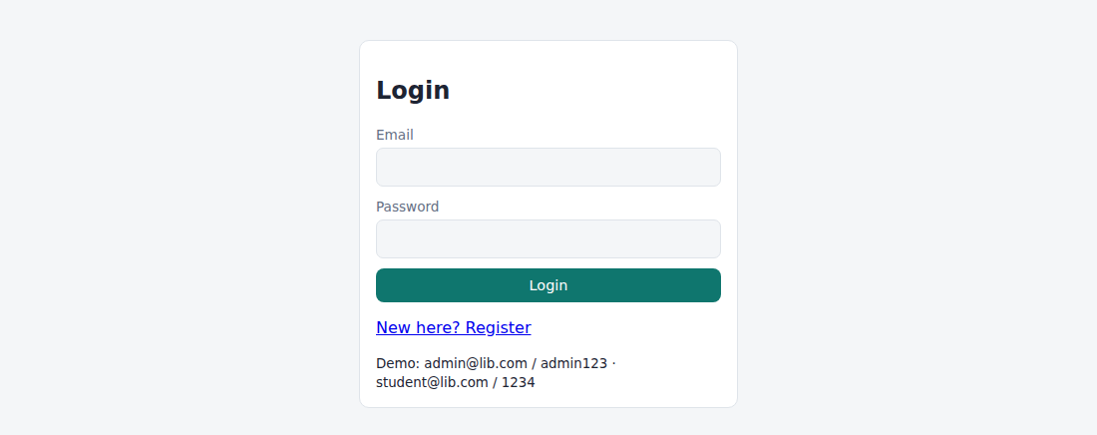
Fig. 1.1 – Login page
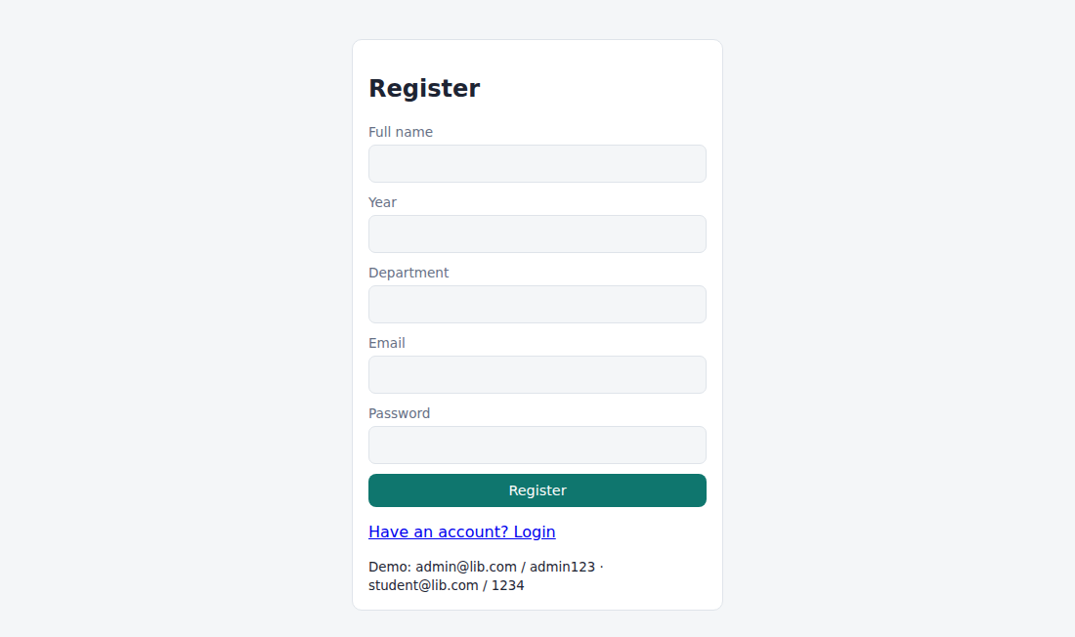
Fig. 1.2 – Registration page
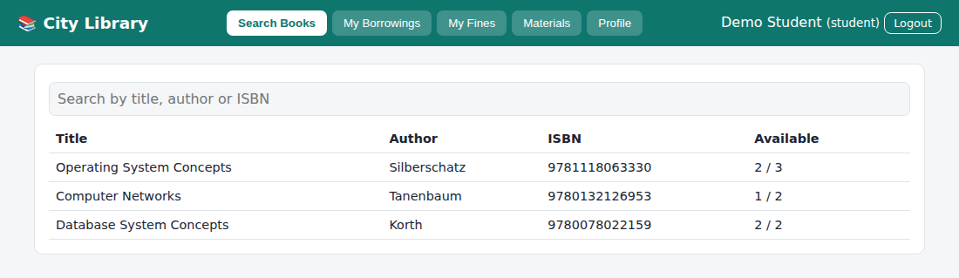
Fig. 1.3 – Student – Search Books
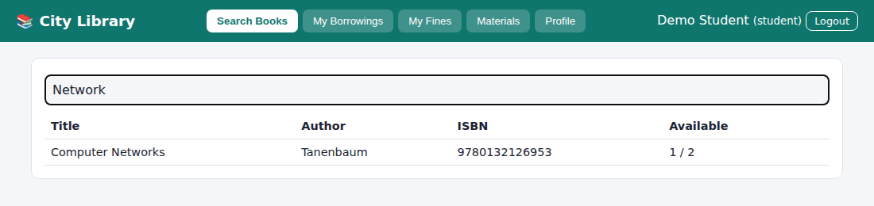
Fig. 1.4 – Student – Search Books (search result)
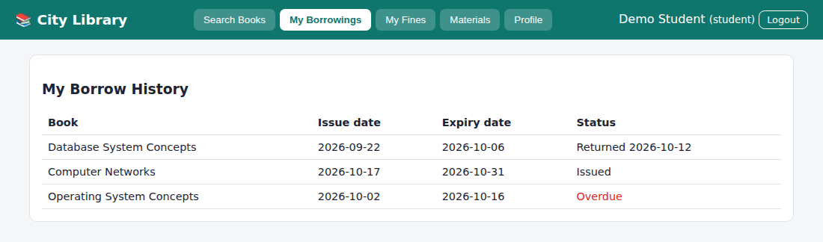
Fig. 1.5 – Student – My Borrowings
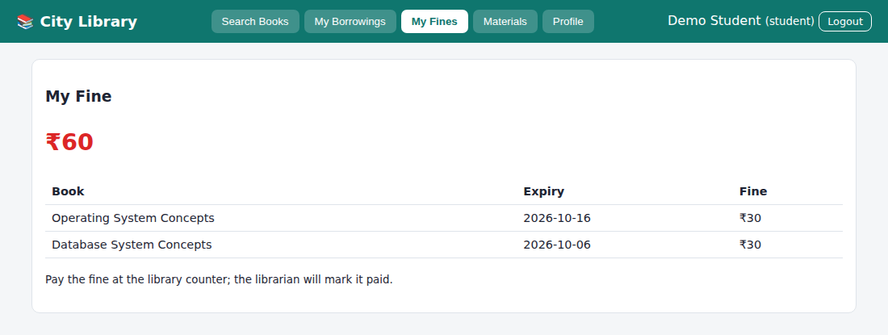
Fig. 1.6 – Student – My Fines
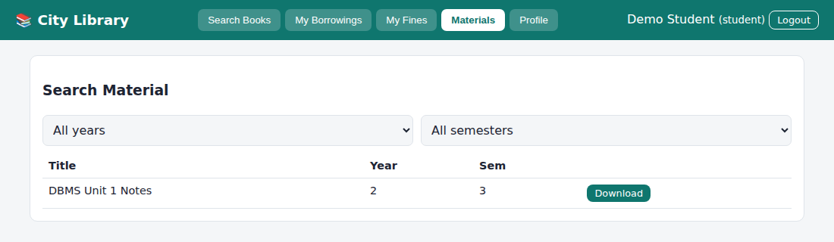
Fig. 1.7 – Student – Materials
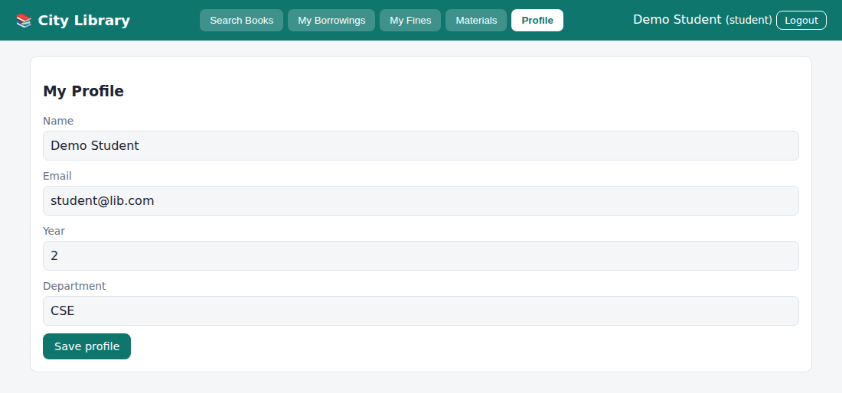
Fig. 1.8 – Student – Profile
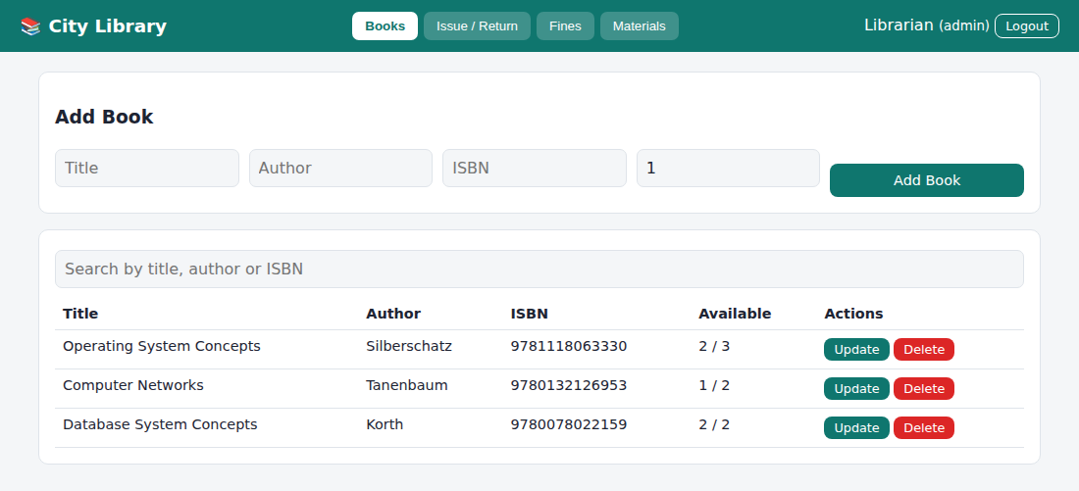
Fig. 1.9 – Admin (Librarian) – Books
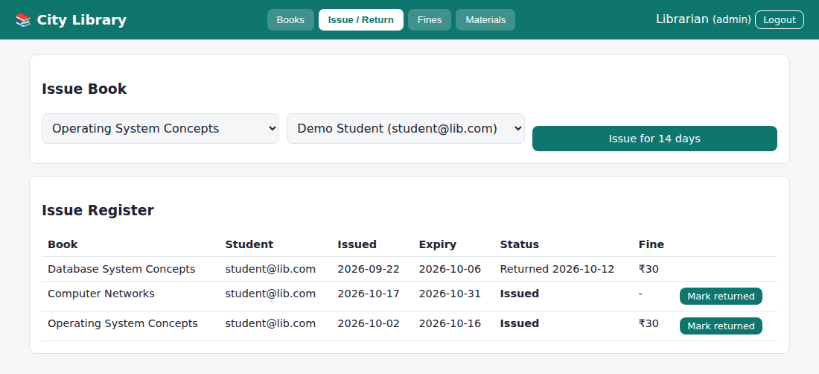
Fig. 1.10 – Admin (Librarian) – Issue / Return
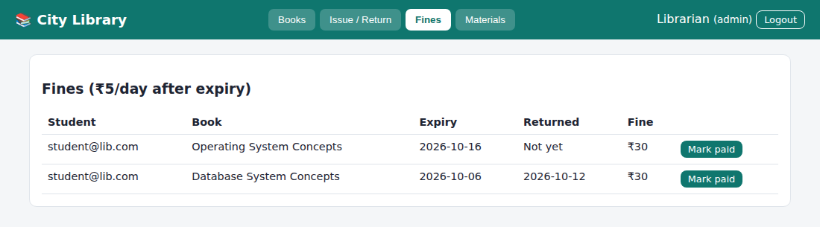
Fig. 1.11 – Admin (Librarian) – Fines
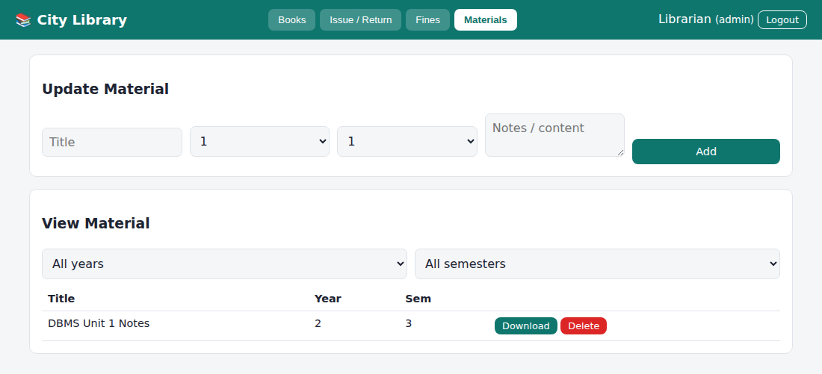
Fig. 1.12 – Admin (Librarian) – Materials
RESULT
Thus the Library Management System website was designed and implemented successfully using HTML, CSS and JavaScript, and the output was verified.

Experiment No: 2
Name of the Experiment: Online Hotel Room Booking
AIM
To develop a responsive hotel booking website in which users can register, check room availability, book, change or cancel a booking up to 3 days before arrival, and view their history, while administrators manage room quantity, price, bookings and static pages.
PROCEDURE
- Create a project folder and add the files index.html, style.css, common.js and app.js (hotel).
- In index.html create an empty container <div id="app"> and link the style sheet and the JavaScript files.
- In common.js write the shared helper functions: browser storage (localStorage), user registration, login, logout, table building and the page header with tabs.
- In app.js create the demo data: four room types (Single, Double, Deluxe, Suite) with quantity and price, and the static pages.
- Write the availability check by counting overlapping bookings for each night of the stay, then the booking form (room type, check-in, check-out, guests) with the total price.
- Write the booking history page and allow change or cancel only when the arrival date is at least 3 days away.
- Write the administrator screens: change room quantity and price, change or cancel any booking, and edit the Room Information, About Us, Contact Us, Q&A, Travel Guide and Privacy Policy pages.
- Open index.html in a web browser and log in with the demo accounts to test every option.
- Observe the output, capture the screenshots and record the result.
CODE
index.html
<!DOCTYPE html><html lang="en"><head><meta charset="utf-8"><meta name="viewport" content="width=device-width,initial-scale=1"><title>2. Hotel Room Booking</title><link rel="stylesheet" href="style.css"></head><body data-ns="hotel_"><div id="app"></div><script src="common.js"></script><script src="app.js"></script></body></html>
app.js
Auth.seed([
{ name: "Hotel Admin", email: "admin@hotel.com", password: "admin123", role: "admin" },
{
name: "Demo Guest",
email: "guest@hotel.com",
password: "1234",
role: "user",
phone: "9999999999",
},
]);
const PT = {
rooms: "Room Information",
about: "About Us",
contact: "Contact Us",
faq: "Customer Service Q&A",
travel: "Local Travel & Shipping Guide",
privacy: "Privacy Policy",
};
if (!DB.get("rooms")) {
DB.set("rooms", {
Single: { qty: 5, price: 2000 },
Double: { qty: 5, price: 3200 },
Deluxe: { qty: 3, price: 4800 },
Suite: { qty: 2, price: 7500 },
});
DB.set("bk", []);
DB.set("pages", {
rooms:
"Single: cosy room for one. Double: two beds, city view. Deluxe: king bed, balcony. Suite: living area, bathtub, lounge access.",
about:
"Grand Palm Hotel has welcomed guests since 1998 with warm service and comfortable rooms.",
contact: "Phone: +91 99999 99999 · Email: stay@grandpalm.example · 12 Lake Road.",
faq: "Q: Check-in time? A: 2 PM. Q: Can I cancel? A: Up to 3 days before arrival.",
travel:
"Airport 12 km (taxi ₹600). Railway station 3 km. Local sightseeing cabs at the front desk.",
privacy: "We store only the details needed for your booking and never sell your data.",
});
}
const RM = () => DB.get("rooms"),
BK = () => DB.get("bk", []);
function availOn(t, a, b, skip) {
const q = RM()[t].qty,
bk = BK().filter((x) => x.type === t && x.status === "Booked" && x.id !== skip);
let min = q;
for (let d = a; d < b; d = addDays(d, 1))
min = Math.min(min, q - bk.filter((x) => x.ci <= d && d < x.co).length);
return min;
}
const canMod = (b) => b.status === "Booked" && diffDays(today(), b.ci) >= 3;

function start() {
const me = Auth.me();
if (!me)
return mountAuth(
$("#app"),
{
regRoles: ["user"],
hint: "Demo: admin@hotel.com / admin123 · guest@hotel.com / 1234",
extra: '<label>Phone</label><input name="phone">',
},
start,
);
shell(
"🏨 Grand Palm Hotel",
me.role === "admin"
? {
"Rooms & Prices": adminRooms,
Bookings: (m) => bookings(m, 1),
"Edit Pages": adminPages,
}
: {
Home: home,
"Check & Book": bookView,
"My Bookings": (m) => bookings(m, 0),
Profile: profile,
},
me,
);
}
function home(m) {
const R = RM(),
P = DB.get("pages");
m.innerHTML =
`<div class="grid">${Object.keys(R)
.map(
(t) =>
`<div class="card"><h3>${t}</h3><p class="big">${rs(R[t].price)}</p><small>per night · ${R[t].qty} rooms</small></div>`,
)
.join("")}</div><br>` +
Object.keys(PT)
.map((k) => `<div class="card"><h3>${PT[k]}</h3><p>${esc(P[k])}</p></div>`)
.join("");
}
function bookView(m) {
const R = RM();
m.innerHTML = `<div class="card"><h3>Check availability & book</h3><form id="f"><div class="row"><div><label>Room type</label><select name="type">${opt(Object.keys(R))}</select></div><div><label>Check-in</label><input type="date" name="ci" min="${today()}" required></div><div><label>Check-out</label><input type="date" name="co" min="${addDays(today(), 1)}" required></div><div><label>Guests</label><input type="number" name="guests" min="1" max="6" value="1"></div></div><button type="button" class="btn sec" id="ck">Check availability</button> <button class="btn">Book now</button></form><p id="res"></p></div>`;
const chk = () => {
const f = Object.fromEntries(new FormData($("#f")));
if (!f.ci || !f.co || f.co <= f.ci) {
$("#res").textContent = "Choose a check-out date after check-in";
return null;
}
const a = availOn(f.type, f.ci, f.co),
n = diffDays(f.ci, f.co);
$("#res").innerHTML =
a > 0
? `<span class="ok">✔ ${a} room(s) free</span> · ${n} night(s) · Total ${rs(n * R[f.type].price)}`
: '<span class="bad">✘ Fully booked for these dates</span>';
return a > 0 ? f : null;
};
$("#ck").onclick = chk;
$("#f").onsubmit = (e) => {
e.preventDefault();
const f = chk();
if (!f) return;
const b = BK();
b.push({
id: uid(),
user: Auth.me().email,
...f,
guests: +f.guests,
total: diffDays(f.ci, f.co) * R[f.type].price,
status: "Booked",
});
DB.set("bk", b);
toast("Booking confirmed");
refresh();
};
}
function bookings(m, adm) {
const me = Auth.me(),
l = BK()
.filter((b) => adm || b.user === me.email)
.reverse();
m.innerHTML = `<div class="card"><h3>${adm ? "All bookings" : "My booking history"}</h3>${tbl(
["Ref", "Guest", "Room", "Check-in", "Check-out", "Guests", "Total", "Status", ""],
l.map((b) => [
b.id.slice(-5),
b.user,
b.type,
b.ci,
b.co,
b.guests,
rs(b.total),
b.status,
b.status !== "Booked"
? ""
: adm || canMod(b)
? `<button class="btn sm" onclick="modBk('${b.id}')">Change</button> <button class="btn sm red" onclick="cancelBk('${b.id}')">Cancel</button>`
: "<small>Locked (under 3 days)</small>",
]),
)}</div>`;
}
function modBk(id) {
const bs = BK(),
b = bs.find((x) => x.id === id),
adm = Auth.me().role === "admin";
const type = adm
? prompt("Room type (" + Object.keys(RM()).join("/") + ")", b.type)
: b.type,
ci = prompt("Check-in (YYYY-MM-DD)", b.ci),
co = ci && prompt("Check-out (YYYY-MM-DD)", b.co),
g = co && prompt("Guests", b.guests);
if (
!type ||
!RM()[type] ||
!ci ||
!co ||
co <= ci ||
isNaN(Date.parse(ci)) ||
isNaN(Date.parse(co))
)
return toast("Change cancelled / invalid input");
if (!adm && diffDays(today(), ci) < 3)
return toast("New check-in must be at least 3 days away");
if (availOn(type, ci, co, id) < 1) return toast("No rooms free for these dates");
Object.assign(b, {
type,
ci,
co,
guests: +g || b.guests,
total: diffDays(ci, co) * RM()[type].price,
});
DB.set("bk", bs);
toast("Booking updated");
refresh();
}
function cancelBk(id) {
if (!confirm("Cancel this booking?")) return;
const bs = BK();
bs.find((x) => x.id === id).status = "Cancelled";
DB.set("bk", bs);
refresh();
}
function adminRooms(m) {
const R = RM();
m.innerHTML = `<div class="card"><h3>Room quantity & price</h3><form id="f">${tbl(
["Type", "Quantity", "Price / night (₹)"],
Object.keys(R).map((t) => [
t,
`<input type="number" min="0" name="q_${t}" value="${R[t].qty}">`,
`<input type="number" min="0" name="p_${t}" value="${R[t].price}">`,
]),
)}<br><button class="btn">Save changes</button></form></div>`;
$("#f").onsubmit = (e) => {
const f = fd(e);
Object.keys(R).forEach((t) => {
R[t].qty = +f["q_" + t];
R[t].price = +f["p_" + t];
});
DB.set("rooms", R);
toast("Rooms updated");
};
}
function adminPages(m) {
const P = DB.get("pages");
m.innerHTML = `<div class="card"><h3>Edit static pages</h3><form id="f"><select name="k" id="k">${Object.keys(
PT,
)
.map((k) => `<option value="${k}">${PT[k]}</option>`)
.join(
"",
)}</select><textarea name="v" id="v" rows="6"></textarea><button class="btn">Save page</button></form></div>`;
const load = () => ($("#v").value = P[$("#k").value]);
$("#k").onchange = load;
load();
$("#f").onsubmit = (e) => {
const f = fd(e);
P[f.k] = f.v;
DB.set("pages", P);
toast("Page saved");
};
}
function profile(m) {
const u = Auth.me();
m.innerHTML = `<div class="card"><h3>My profile</h3><form id="f"><label>Name</label><input name="name" value="${esc(u.name)}"><label>Email</label><input value="${esc(u.email)}" disabled><label>Phone</label><input name="phone" value="${esc(u.phone || "")}"><button class="btn">Save profile</button></form></div>`;
$("#f").onsubmit = (e) => {
Auth.save({ ...u, ...fd(e) });
toast("Profile saved");
};
}
start();
Common files (common.js, style.css) are listed in the Appendix.

OUTPUT
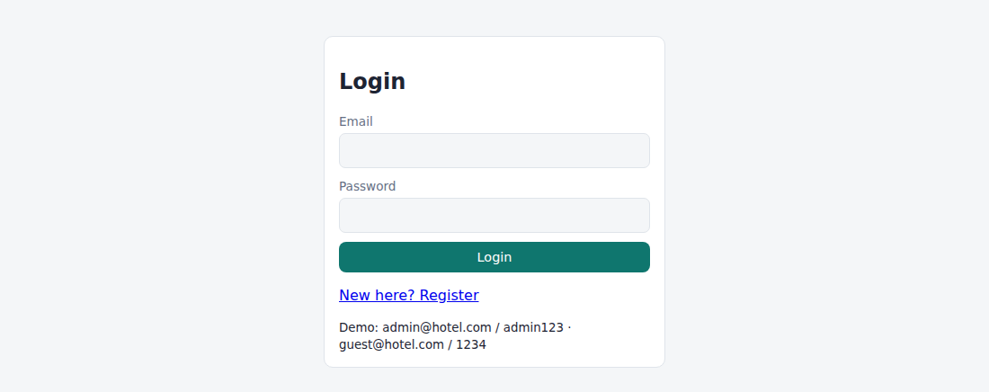
Fig. 2.1 – Login page
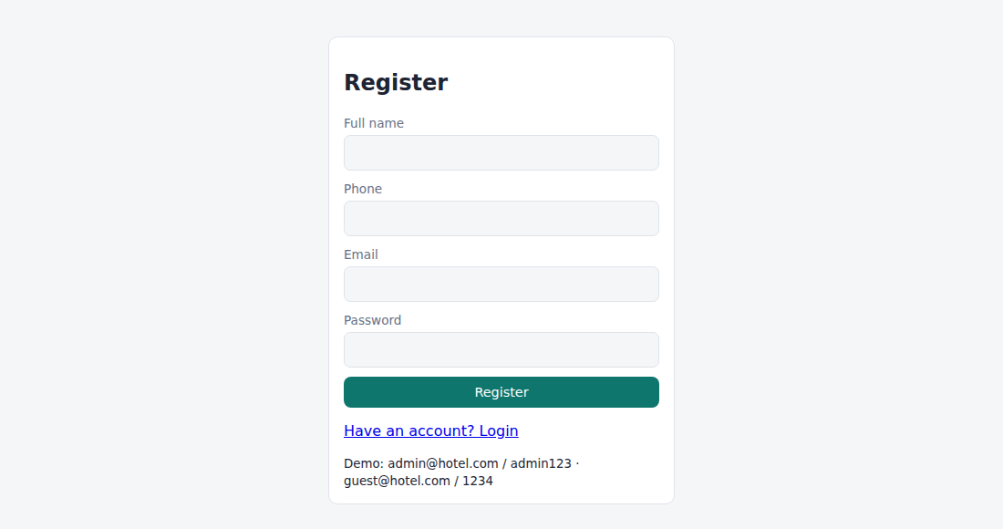
Fig. 2.2 – Registration page
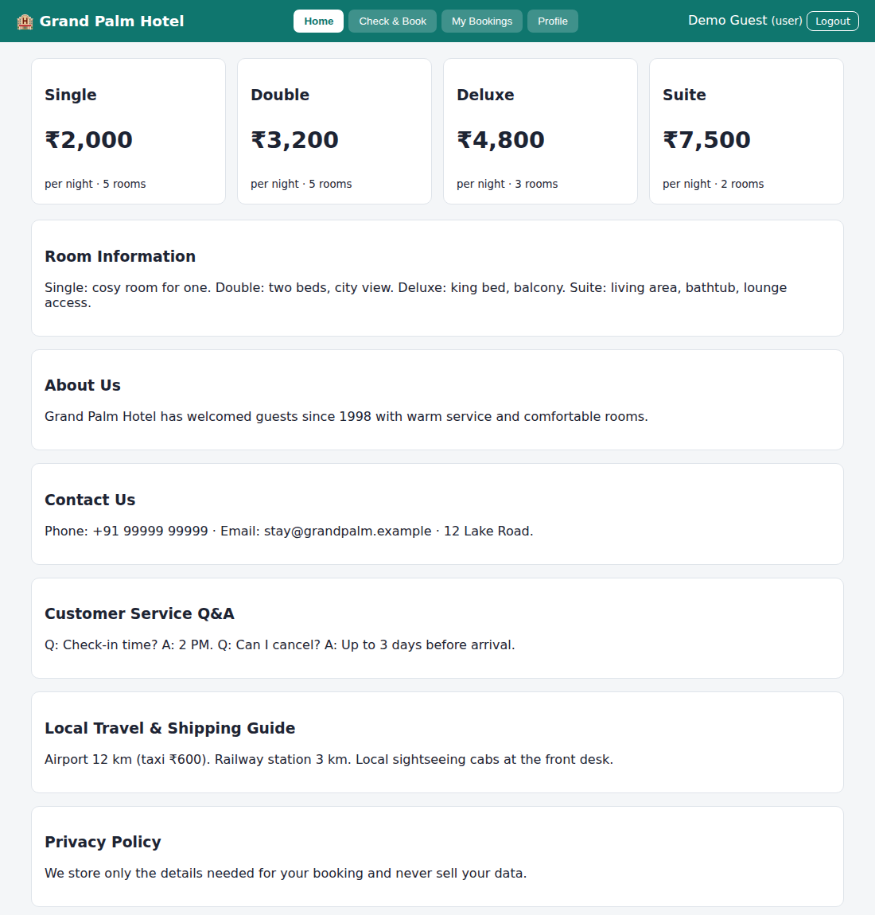
Fig. 2.3 – User – Home
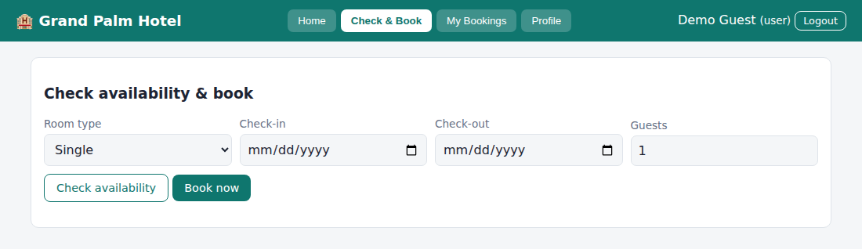
Fig. 2.4 – User – Check & Book
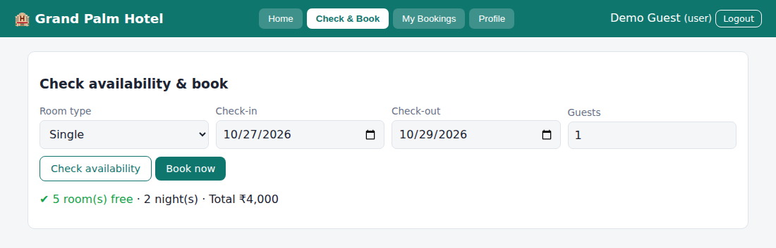
Fig. 2.5 – User – Check & Book (availability checked)
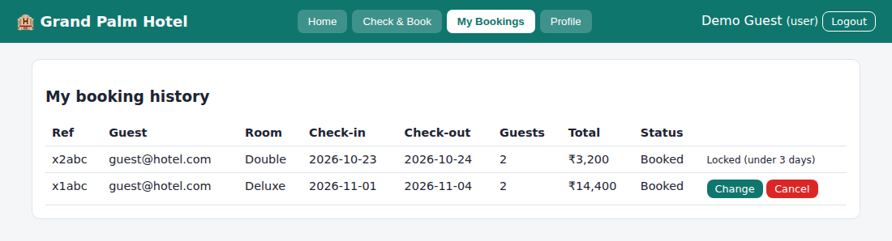
Fig. 2.6 – User – My Bookings
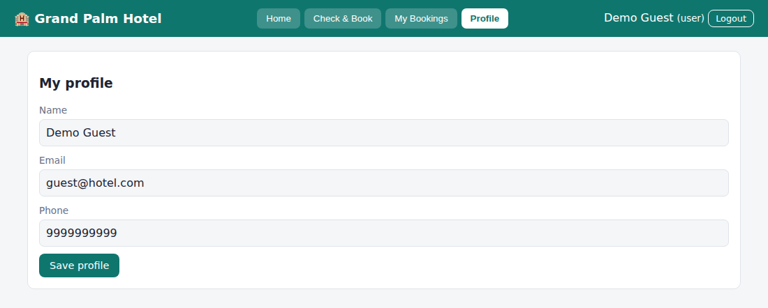
Fig. 2.7 – User – Profile
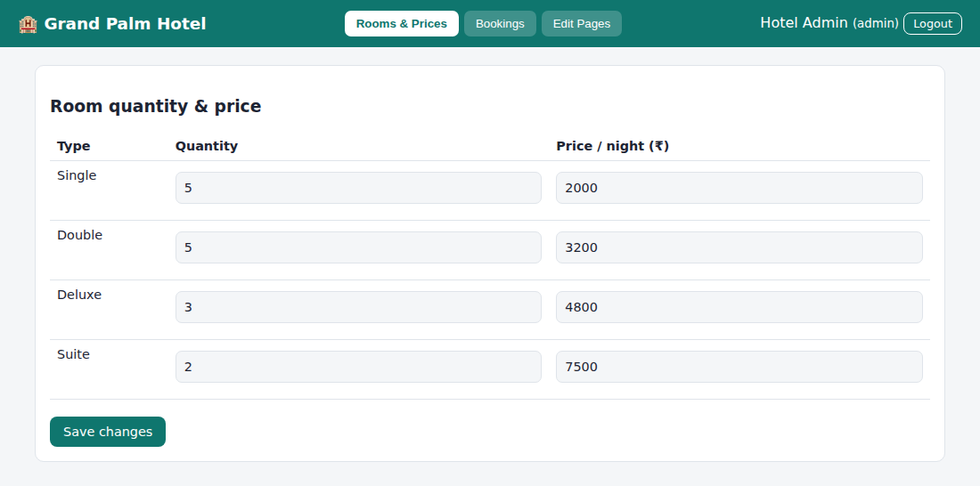
Fig. 2.8 – Admin – Rooms & Prices
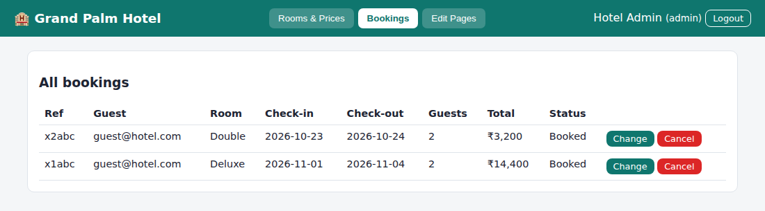
Fig. 2.9 – Admin – Bookings
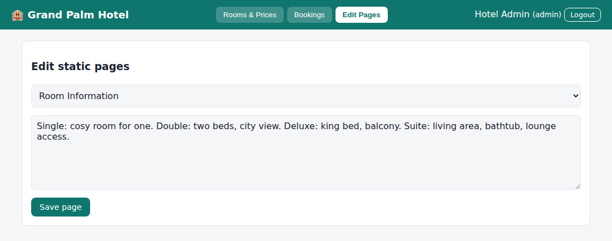
Fig. 2.10 – Admin – Edit Pages
RESULT
Thus the Online Hotel Room Booking website was designed and implemented successfully using HTML, CSS and JavaScript, and the output was verified.

Experiment No: 3
Name of the Experiment: Online Bus Ticket Booking System
AIM
To develop an online bus ticket booking system with route/date/time search, seat selection, passenger details, payment, ticket cancellation, comments and password management, with an admin panel for bus categories, buses, users and reports.
PROCEDURE
- Create a project folder and add the files index.html, style.css, common.js and app.js (bus).
- In index.html create an empty container <div id="app"> and link the style sheet and the JavaScript files.
- In common.js write the shared helper functions: browser storage (localStorage), user registration, login, logout, table building and the page header with tabs.
- In app.js create the demo data: bus categories (Volvo, Sleeper Coach, Coach) and buses with route, time, fare and seats.
- Write the user screens: search by route, date and time, select seats on a seat grid, enter passenger details, make the payment, view booking history, cancel a ticket and post comments on a bus.
- Add the Forgot Password and Change Password options.
- Write the admin screens: manage categories, add, update and delete buses, view users, moderate comments and generate the booking and revenue report.
- Open index.html in a web browser and log in with the demo accounts to test every option.
- Observe the output, capture the screenshots and record the result.
CODE
index.html
<!DOCTYPE html><html lang="en"><head><meta charset="utf-8"><meta name="viewport" content="width=device-width,initial-scale=1"><title>3. Online Bus Ticket Booking</title><link rel="stylesheet" href="style.css"></head><body data-ns="bus_"><div id="app"></div><script src="common.js"></script><script src="app.js"></script></body></html>
app.js
Auth.seed([
{ name: "Bus Admin", email: "admin@bus.com", password: "admin123", role: "admin" },
{ name: "Demo User", email: "user@bus.com", password: "1234", role: "user" },
]);
if (!DB.get("buses")) {
DB.set("cats", ["Volvo", "Sleeper Coach", "Coach"]);
DB.set("bk", []);
DB.set("cm", []);
DB.set("buses", [
{
id: "b1",
name: "KPN Express",
cat: "Volvo",
from: "Coimbatore",
to: "Chennai",
time: "21:30",
price: 850,
seats: 30,
desc: "AC multi-axle Volvo, charging points",
img: "🚌",
},
{
id: "b2",
name: "SRS Sleeper",
cat: "Sleeper Coach",
from: "Coimbatore",
to: "Bangalore",
time: "22:00",
price: 700,
seats: 24,
desc: "AC sleeper berths",
img: "🛏",
},
{
id: "b3",
name: "City Link",
cat: "Coach",
from: "Chennai",
to: "Coimbatore",
time: "08:00",
price: 450,
seats: 36,
desc: "Non-AC push-back coach",
img: "🚍",
},
]);
}
const BU = () => DB.get("buses", []),
BK = () => DB.get("bk", []),
CM = () => DB.get("cm", []),
CT = () => DB.get("cats", []);
let SEL = [],
CB = null;
const taken = (id, d) =>
BK()
.filter((b) => b.bus === id && b.date === d && b.status === "Booked")
.flatMap((b) => b.seats.map(String));
const bn = (id) => esc((BU().find((b) => b.id === id) || {}).name || "(removed)");
function start() {
const me = Auth.me();
if (!me) {
mountAuth(
$("#app"),
{ regRoles: ["user"], hint: "Demo: admin@bus.com / admin123 · user@bus.com / 1234" },
start,
);
return forgot($("#app"));
}
shell(
"🚌 Online Bus Tickets",
me.role === "admin"
? {
Categories: catView,
Buses: busAdmin,
Users: usersView,
"Bookings & Report": reportView,
Comments: cmAdmin,
Password: pwView,
}
: { "Search & Book": searchView, "My Bookings": myBk, Password: pwView },
me,
);
}
function searchView(m) {
m.innerHTML = `<div class="card"><form id="f" class="row"><input name="from" placeholder="From"><input name="to" placeholder="To"><input type="date" name="date" min="${today()}" value="${today()}" required><input type="time" name="time" title="Departs after"><button class="btn">Search buses</button></form></div><div id="res"></div><div id="sel"></div>`;
$("#f").onsubmit = (e) => {
const f = fd(e),
q = (a, b) => !b || a.toLowerCase().includes(b.toLowerCase());
$("#res").innerHTML =
BU()
.filter((b) => q(b.from, f.from) && q(b.to, f.to) && (!f.time || b.time >= f.time))
.map(
(b) =>
`<div class="card"><div class="row"><div style="flex:0 0 70px;font-size:3rem">${esc(b.img)}</div><div><h3>${esc(b.name)} <span class="tag">${esc(b.cat)}</span></h3>${esc(b.from)} → ${esc(b.to)} · departs ${b.time}<br><small>${esc(b.desc)}</small></div><div><b>${rs(b.price)}</b><br>${b.seats - taken(b.id, f.date).length} seats free<br><button class="btn sm" onclick="pick('${b.id}','${f.date}')">Select seats</button> <button class="btn sm sec" onclick="cmts('${b.id}')">Comments</button></div></div></div>`,
)
.join("") || '<div class="card">No buses found for this search.</div>';
};
}
function pick(id, date) {
CB = BU().find((x) => x.id === id);
SEL = [];
const t = taken(id, date);
$("#sel").innerHTML = `<div class="card"><h3>${esc(CB.name)} · ${date}</h3>${seatGrid(
Array.from({ length: CB.seats }, (_, i) => String(i + 1)),
t,
)}<form id="pf"><div id="pax"></div><select name="m">${opt(["Credit card", "Debit card", "UPI", "Net banking"])}</select><input name="ref" placeholder="Card / UPI reference" required><p id="tot"></p><button class="btn">Pay & book</button></form></div>`;
$("#pf").onsubmit = (e) => {
const f = fd(e);
if (!SEL.length) return toast("Select at least one seat");
if (SEL.some((s) => taken(id, date).includes(s))) return toast("A seat was just taken");
const bk = BK(),
b = {
id: uid(),
pnr: "BT" + Math.floor(1e5 + Math.random() * 9e5),
user: Auth.me().email,
bus: id,
date,
seats: SEL.slice(),
pax: SEL.map((s) => ({ seat: s, name: f["n" + s], age: f["a" + s] })),
total: SEL.length * CB.price,
pay: f.m,
status: "Booked",
};
bk.push(b);
DB.set("bk", bk);
alert(
`Payment successful.\nTicket ${b.pnr} confirmed.\nA confirmation email has been sent (simulated).`,
);
refresh();
};
}
function seat(btn, n) {
const i = SEL.indexOf(n);
if (i < 0) {
SEL.push(n);
btn.classList.remove("sec");
} else {
SEL.splice(i, 1);
btn.classList.add("sec");
}
SEL.sort((a, b) => a - b);
$("#pax").innerHTML = SEL.map(
(s) =>
`<div class="row"><input name="n${s}" placeholder="Passenger name (seat ${s})" required><input name="a${s}" type="number" min="1" placeholder="Age" required></div>`,
).join("");
$("#tot").textContent = "Total: " + rs(SEL.length * CB.price);
}
function cmts(id) {
const b = BU().find((x) => x.id === id);
$("#sel").innerHTML = `<div class="card"><h3>Comments on ${esc(b.name)}</h3>${
CM()
.filter((c) => c.bus === id)
.map((c) => `<p><b>${esc(c.name)}</b>: ${esc(c.text)}</p>`)
.join("") || "<p>No comments yet.</p>"
}<form id="cf" class="row"><input name="t" placeholder="Write a comment" required><button class="btn">Post</button></form></div>`;
$("#cf").onsubmit = (e) => {
const c = CM();
c.push({ id: uid(), bus: id, name: Auth.me().name, text: fd(e).t });
DB.set("cm", c);
cmts(id);
};
}
function myBk(m) {
m.innerHTML = `<div class="card"><h3>My bookings</h3>${tbl(
["Ticket", "Bus", "Date", "Seats", "Total", "Status", ""],
BK()
.filter((b) => b.user === Auth.me().email)
.reverse()
.map((b) => [
b.pnr,
bn(b.bus),
b.date,
b.seats.join(", "),
rs(b.total),
b.status,
b.status === "Booked" && b.date >= today()
? `<button class="btn sm red" onclick="cancelBk('${b.id}')">Cancel ticket</button>`
: "",
]),
)}</div>`;
}
function cancelBk(id) {
if (!confirm("Cancel this ticket?")) return;
const k = BK();
k.find((b) => b.id === id).status = "Cancelled";
DB.set("bk", k);
refresh();
}
function catView(m) {
m.innerHTML = `<div class="card"><h3>Bus categories</h3><form id="f" class="row"><input name="c" placeholder="New category (Volvo, Sleeper…)" required><button class="btn">Add</button></form>${tbl(
["Category", ""],
CT().map((c) => [
esc(c),
`<button class="btn sm red" onclick="delCat('${esc(c)}')">Delete</button>`,
]),
)}</div>`;
$("#f").onsubmit = (e) => {
DB.set("cats", [...CT(), fd(e).c]);
refresh();
};
}
function delCat(c) {
DB.set(
"cats",
CT().filter((x) => x !== c),
);
refresh();
}
function busAdmin(m) {
m.innerHTML = `<div class="card"><h3>Add bus</h3><form id="f"><div class="row"><input name="name" placeholder="Bus name" required><select name="cat">${opt(CT())}</select><input name="img" placeholder="Photo (emoji or image URL)" value="🚌"></div><div class="row"><input name="from" placeholder="From" required><input name="to" placeholder="To" required><input type="time" name="time" required><input type="number" name="price" placeholder="Fare" required><input type="number" name="seats" placeholder="Seats" required></div><textarea name="desc" placeholder="Description"></textarea><button class="btn">Add bus</button></form></div><div class="card">${tbl(
["Bus", "Route", "Time", "Fare", "Seats", ""],
BU().map((b) => [
esc(b.name) + '<br><span class="tag">' + esc(b.cat) + "</span>",
esc(b.from + " → " + b.to),
b.time,
rs(b.price),
b.seats,
`<button class="btn sm" onclick="updBus('${b.id}')">Update</button> <button class="btn sm red" onclick="delBus('${b.id}')">Delete</button>`,
]),
)}</div>`;
$("#f").onsubmit = (e) => {
const f = fd(e),
l = BU();
l.push({ id: uid(), ...f, price: +f.price, seats: +f.seats });
DB.set("buses", l);
refresh();
};
}
function updBus(id) {
const l = BU(),
b = l.find((x) => x.id === id);
b.time = prompt("Departure time", b.time) || b.time;
b.price = +prompt("Fare", b.price) || b.price;
b.seats = +prompt("Total seats", b.seats) || b.seats;
b.desc = prompt("Description", b.desc) ?? b.desc;
DB.set("buses", l);
refresh();
}
function delBus(id) {
if (confirm("Delete bus?")) {
DB.set(
"buses",
BU().filter((b) => b.id !== id),
);
refresh();
}
}
function usersView(m) {
m.innerHTML = `<div class="card"><h3>Registered users</h3>${tbl(
["Name", "Email", ""],
Auth.users()
.filter((u) => u.role === "user")
.map((u) => [
esc(u.name),
u.email,
`<button class="btn sm red" onclick="delUser('${u.email}')">Remove</button>`,
]),
)}</div>`;
}
function delUser(e) {
DB.set(
"users",
Auth.users().filter((u) => u.email !== e),
);
refresh();
}
function reportView(m) {
const ok = BK().filter((b) => b.status === "Booked");
m.innerHTML = `<div class="grid"><div class="card"><small>Active bookings</small><p class="big">${ok.length}</p></div><div class="card"><small>Revenue</small><p class="big">${rs(ok.reduce((s, b) => s + b.total, 0))}</p></div><div class="card"><small>Cancelled</small><p class="big">${BK().length - ok.length}</p></div></div><br><div class="card"><h3>Report by bus</h3>${tbl(
["Bus", "Tickets", "Seats sold", "Revenue"],
BU().map((b) => {
const k = ok.filter((x) => x.bus === b.id);
return [
esc(b.name),
k.length,
k.reduce((s, x) => s + x.seats.length, 0),
rs(k.reduce((s, x) => s + x.total, 0)),
];
}),
)}</div><div class="card"><h3>All bookings</h3>${tbl(
["Ticket", "User", "Bus", "Date", "Seats", "Total", "Status"],
BK().map((b) => [
b.pnr,
b.user,
bn(b.bus),
b.date,
b.seats.join(","),
rs(b.total),
b.status,
]),
)}</div>`;
}
function cmAdmin(m) {
m.innerHTML = `<div class="card"><h3>Comments</h3>${tbl(
["Bus", "User", "Comment", ""],
CM().map((c) => [
bn(c.bus),
esc(c.name),
esc(c.text),
`<button class="btn sm red" onclick="delCm('${c.id}')">Delete</button>`,
]),
)}</div>`;
}
function delCm(id) {
DB.set(
"cm",
CM().filter((c) => c.id !== id),
);
refresh();
}
start();
Common files (common.js, style.css) are listed in the Appendix.

OUTPUT
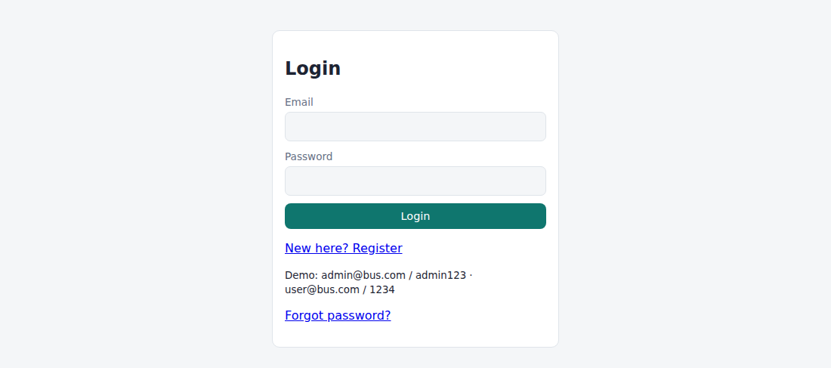
Fig. 3.1 – Login page
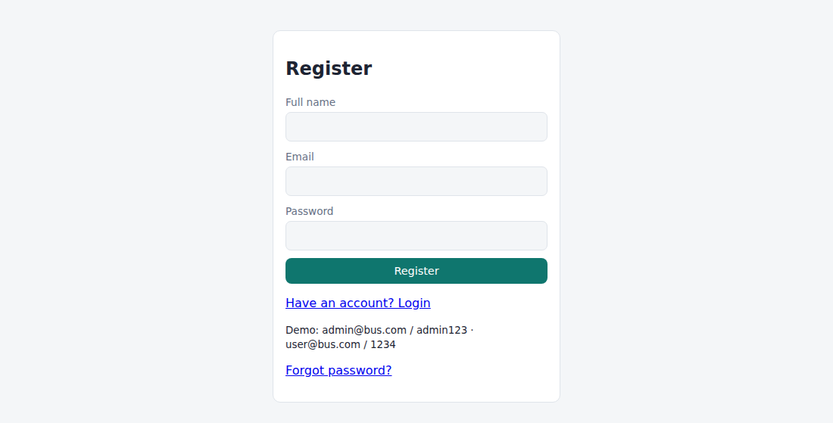
Fig. 3.2 – Registration page
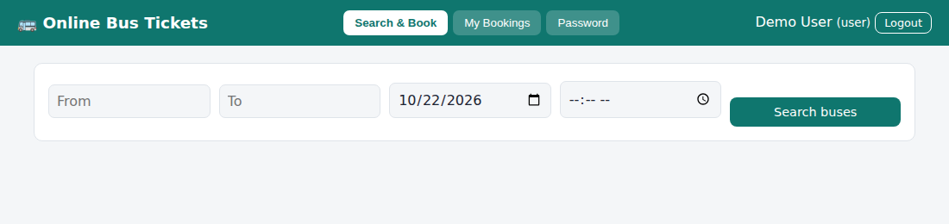
Fig. 3.3 – User – Search & Book
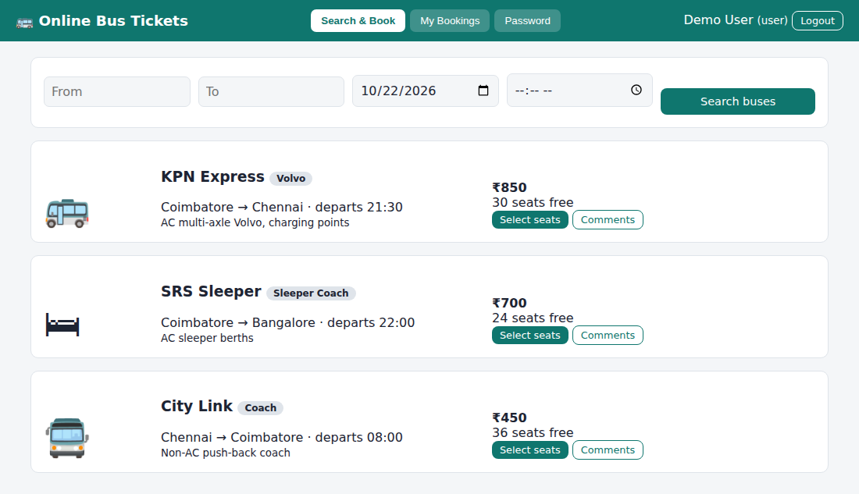
Fig. 3.4 – User – Search & Book (search results)
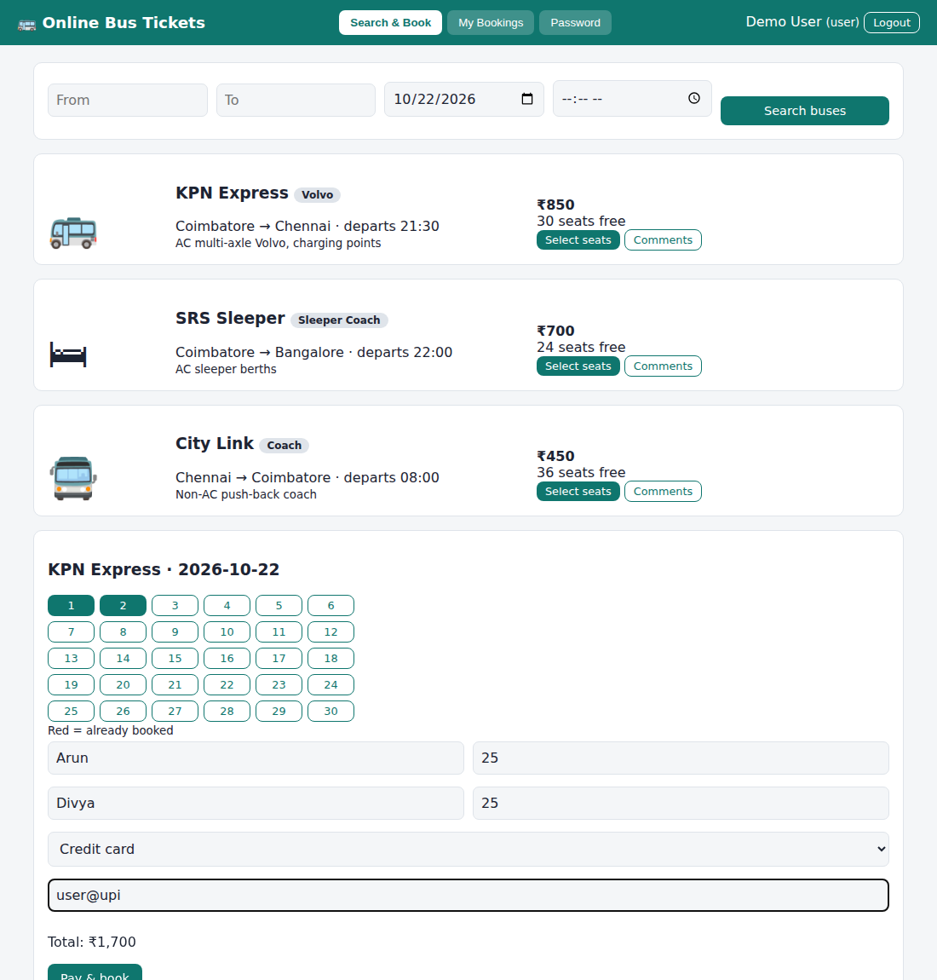
Fig. 3.5 – User – seat selection and passenger details
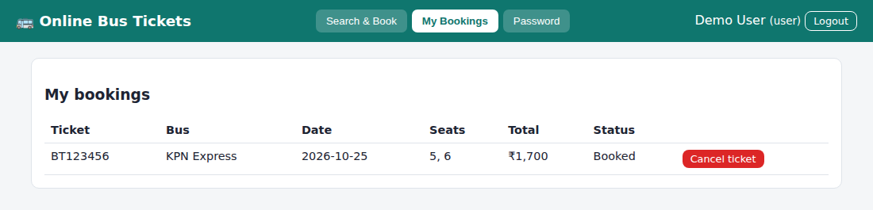
Fig. 3.6 – User – My Bookings
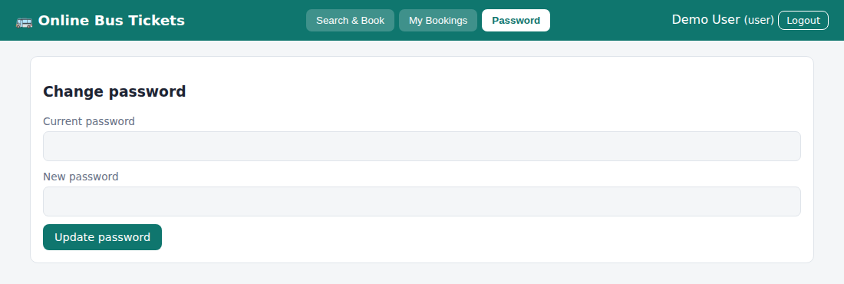
Fig. 3.7 – User – Password
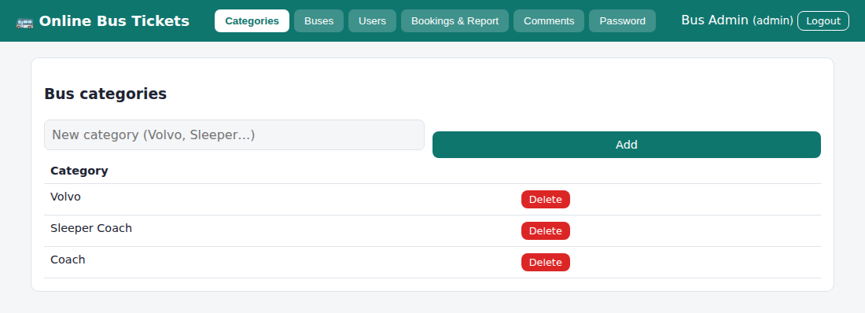
Fig. 3.8 – Admin – Categories
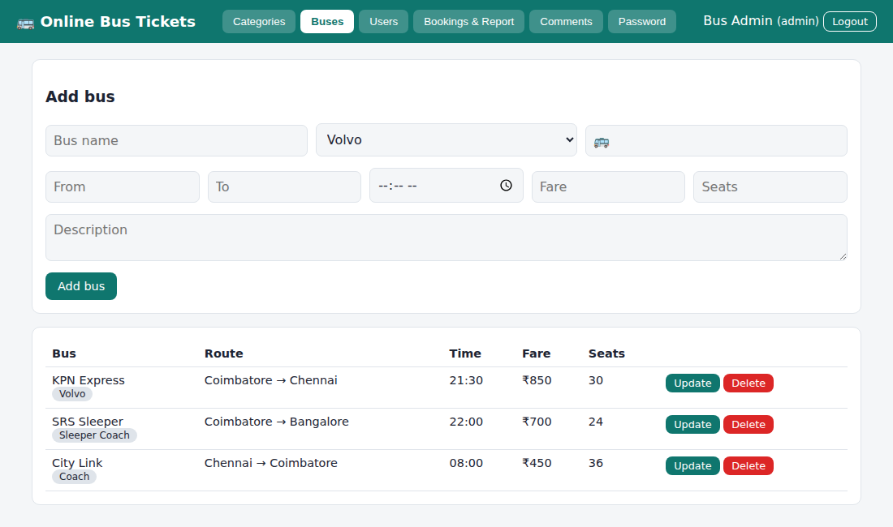
Fig. 3.9 – Admin – Buses
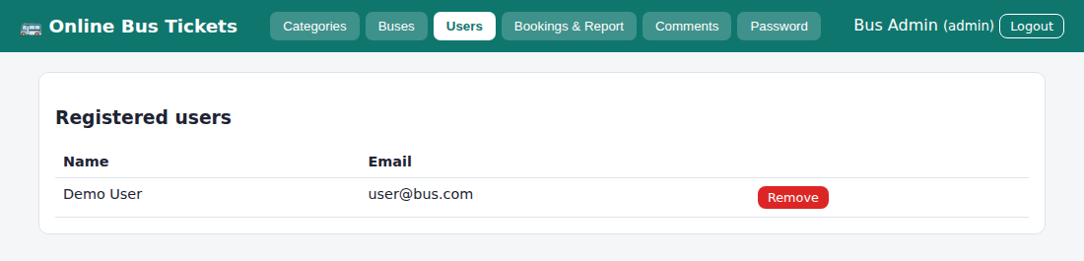
Fig. 3.10 – Admin – Users
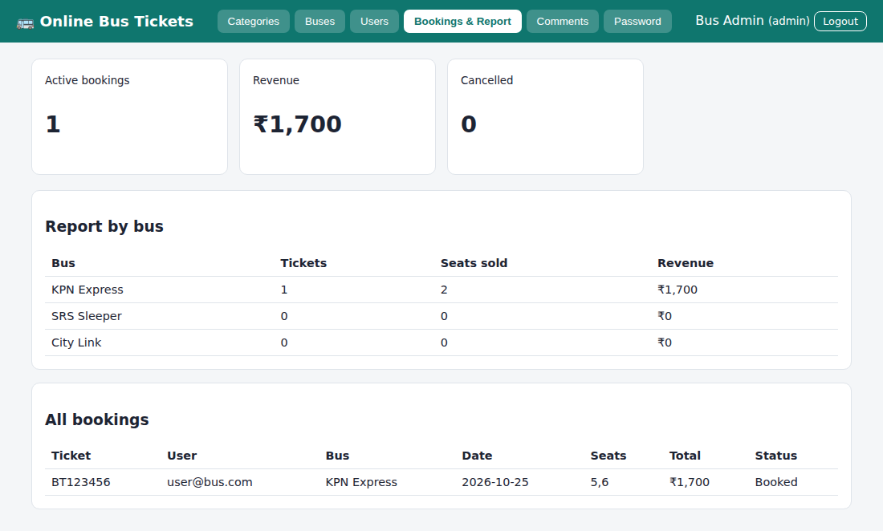
Fig. 3.11 – Admin – Bookings & Report
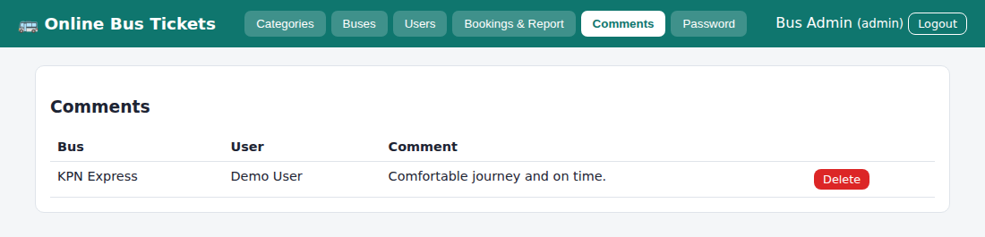
Fig. 3.12 – Admin – Comments
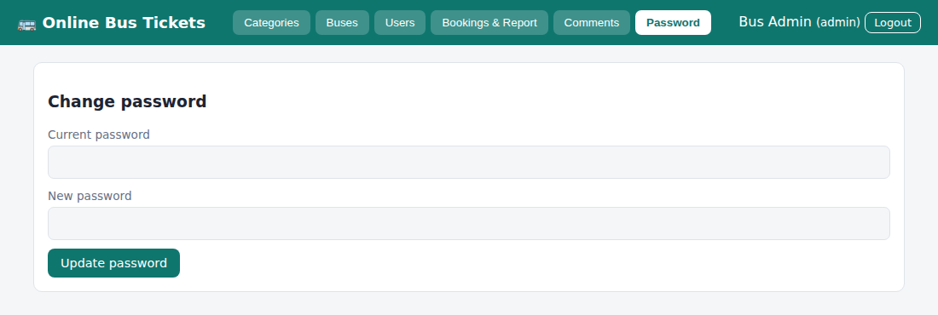
Fig. 3.13 – Admin – Password
RESULT
Thus the Online Bus Ticket Booking System website was designed and implemented successfully using HTML, CSS and JavaScript, and the output was verified.

Experiment No: 4
Name of the Experiment: Online Train Reservation System
AIM
To develop a railway reservation system with train search, class-wise seat availability, PNR generation with Confirmed/RAC/Waiting status, PNR status check, cancellation with refund rules and an admin panel for trains, fares, payments and refunds.
PROCEDURE
- Create a project folder and add the files index.html, style.css, common.js and app.js (train).
- In index.html create an empty container <div id="app"> and link the style sheet and the JavaScript files.
- In common.js write the shared helper functions: browser storage (localStorage), user registration, login, logout, table building and the page header with tabs.
- In app.js create the demo data: trains with route, stations on the way, timing, and seats and fare for each class (SL, 3A, 2A).
- Write the booking page: search by origin, destination, date and class, show seat availability, collect passenger details, accept online or offline payment and generate a 10-digit PNR with status Confirmed, RAC or Waiting List.
- Write the PNR status page and the cancel page; calculate the refund by the refund rules (percentage depends on the days left before the journey) and keep it pending for admin approval.
- Write the admin screens: add trains, update fares and seats, set refund rules, view payment details and pass the refund.
- Open index.html in a web browser and log in with the demo accounts to test every option.
- Observe the output, capture the screenshots and record the result.
CODE
index.html
<!DOCTYPE html><html lang="en"><head><meta charset="utf-8"><meta name="viewport" content="width=device-width,initial-scale=1"><title>4. Railway Reservation System</title><link rel="stylesheet" href="style.css"></head><body data-ns="train_"><div id="app"></div><script src="common.js"></script><script src="app.js"></script></body></html>
app.js
Auth.seed([
{ name: "Railway Admin", email: "admin@rail.com", password: "admin123", role: "admin" },
{ name: "Demo Passenger", email: "pax@rail.com", password: "1234", role: "passenger" },
]);
if (!DB.get("trains")) {
DB.set("bk", []);
DB.set("refund", { d3: 75, d1: 50, d0: 25 });
DB.set("trains", [
{
id: "t1",
no: "12675",
name: "Kovai Express",
from: "Coimbatore",
to: "Chennai",
via: "Tiruppur, Erode, Salem",
time: "06:15",
cls: {
SL: { seats: 6, fare: 350 },
"3A": { seats: 4, fare: 950 },
"2A": { seats: 2, fare: 1350 },
},
},
{
id: "t2",
no: "12680",
name: "Chennai Intercity",
from: "Chennai",
to: "Coimbatore",
via: "Salem, Erode, Tiruppur",
time: "14:10",
cls: {
SL: { seats: 6, fare: 350 },
"3A": { seats: 4, fare: 950 },
"2A": { seats: 2, fare: 1350 },
},
},
]);
}
const TR = () => DB.get("trains", []),
BK = () => DB.get("bk", []),
RF = () => DB.get("refund");
const used = (t, d, c) =>
BK()
.filter((b) => b.train === t && b.date === d && b.cls === c && b.status === "CNF")
.reduce((s, b) => s + b.pax.length, 0);
const tn = (id) => {
const t = TR().find((x) => x.id === id);
return t ? esc(t.no + " " + t.name) : "(removed)";
};
function start() {
const me = Auth.me();
if (!me) {
mountAuth(
$("#app"),
{
regRoles: ["passenger"],
hint: "Demo: admin@rail.com / admin123 · pax@rail.com / 1234",
},
start,
);
return forgot($("#app"));
}
shell(
"🚆 Railway Reservation",
me.role === "admin"
? {
Trains: trainAdmin,
"Refund Rules": rulesView,
Payments: payView,
Refunds: refundAdmin,
}
: {
"Book Ticket": bookView,
"My Tickets": myTix,
"PNR Status": pnrView,
"Cancel Ticket": cancelView,
Password: pwView,
},
me,
);
}
function bookView(m) {
m.innerHTML = `<div class="card"><h3>Search trains</h3><form id="f" class="row"><input name="from" placeholder="Origin station" required><input name="to" placeholder="Destination station" required><input type="date" name="date" min="${today()}" value="${today()}" required><select name="cls">${opt(["SL", "3A", "2A"])}</select><button class="btn">Find trains</button></form></div><div id="res"></div><div id="sel"></div>`;
$("#f").onsubmit = (e) => {
const f = fd(e),
q = (a, b) => a.toLowerCase().includes(b.toLowerCase());
$("#res").innerHTML = `<div class="card">${tbl(
["Train", "Via", "Departs", "Class", "Fare", "Availability", ""],
TR()
.filter((t) => q(t.from, f.from) && q(t.to, f.to) && t.cls[f.cls])
.map((t) => {
const c = t.cls[f.cls],
left = c.seats - used(t.id, f.date, f.cls);
return [
esc(t.no + " " + t.name),
esc(t.via),
t.time,
f.cls,
rs(c.fare),
left > 0
? `<span class="ok">Available ${left}</span>`
: '<span class="bad">Full – RAC/WL</span>',
`<button class="btn sm" onclick="bookForm('${t.id}','${f.date}','${f.cls}')">Book</button>`,
];
}),
)}</div>`;
};
}
function bookForm(id, date, cls) {
const t = TR().find((x) => x.id === id),
n = +prompt("Number of passengers (1-6)", 1);
if (!n || n < 1 || n > 6) return;
$("#sel").innerHTML =
`<div class="card"><h3>${esc(t.name)} · ${date} · ${cls}</h3><form id="pf">${Array.from({ length: n }, (_, i) => `<div class="row"><input name="n${i}" placeholder="Passenger ${i + 1} name" required><input name="a${i}" type="number" min="1" placeholder="Age" required><select name="g${i}">${opt(["Male", "Female", "Other"])}</select></div>`).join("")}<p>Fare: <b>${rs(n * t.cls[cls].fare)}</b></p><select name="m">${opt(["Online – Card", "Online – UPI", "Offline – Counter"])}</select><button class="btn">Pay & generate PNR</button></form></div>`;
$("#pf").onsubmit = (e) => {
const f = fd(e),
c = used(id, date, cls),
S = t.cls[cls].seats,
st = c + n <= S ? "CNF" : c + n <= S + 5 ? "RAC" : "WL";
const b = {
id: uid(),
pnr: String(Math.floor(1e9 + Math.random() * 9e9)),
user: Auth.me().email,
train: id,
date,
cls,
from: t.from,
to: t.to,
pax: Array.from({ length: n }, (_, i) => ({
name: f["n" + i],
age: f["a" + i],
g: f["g" + i],
})),
total: n * t.cls[cls].fare,
pay: f.m,
status: st,
refund: null,
};
const k = BK();
k.push(b);
DB.set("bk", k);
alert(
`Payment received.\nPNR: ${b.pnr}\nStatus: ${st === "CNF" ? "Confirmed" : st === "RAC" ? "RAC" : "Waiting list"}`,
);
refresh();
};
}
const stTxt = (s) =>
({
CNF: '<span class="ok">Confirmed</span>',
RAC: "RAC",
WL: '<span class="bad">Waiting list</span>',
CAN: "Cancelled",
})[s];
function myTix(m) {
m.innerHTML = `<div class="card"><h3>My tickets</h3>${tbl(
["PNR", "Train", "Date", "Class", "Passengers", "Fare", "Status", ""],
BK()
.filter((b) => b.user === Auth.me().email)
.reverse()
.map((b) => [
b.pnr,
tn(b.train),
b.date,
b.cls,
b.pax.map((p) => esc(p.name)).join(", "),
rs(b.total),
stTxt(b.status) +
(b.refund
? "<br><small>Refund " + rs(b.refund.amt) + " (" + b.refund.status + ")</small>"
: ""),
`<button class="btn sm sec" onclick="printTix('${b.id}')">Print</button>`,
]),
)}</div>`;
}
function printTix(id) {
const b = BK().find((x) => x.id === id),
w = window.open("", "_blank");
w.document.write(
`<pre>RAILWAY E-TICKET\nPNR: ${b.pnr}\nTrain: ${b.train && tn(b.train)}\nJourney: ${b.from} to ${b.to} on ${b.date}\nClass: ${b.cls}\nPassengers: ${b.pax.map((p) => p.name + " (" + p.age + ")").join(", ")}\nFare: ${rs(b.total)}\nStatus: ${b.status}</pre>`,
);
w.print();
}
function pnrView(m) {
m.innerHTML = `<div class="card"><h3>Check PNR status</h3><form id="f" class="row"><input name="p" placeholder="10-digit PNR" required><button class="btn">Check</button></form><div id="o"></div></div>`;
$("#f").onsubmit = (e) => {
const b = BK().find((x) => x.pnr === fd(e).p.trim());
$("#o").innerHTML = b
? `<p>${tn(b.train)} · ${b.date} · ${b.cls}<br>Status: <b>${stTxt(b.status)}</b></p>`
: '<p class="bad">PNR not found.</p>';
};
}
function cancelView(m) {
m.innerHTML = `<div class="card"><h3>Cancel ticket</h3><form id="f" class="row"><input name="p" placeholder="Enter PNR" required><button class="btn red">Request cancellation</button></form><p><small>Refund: ${RF().d3}% if 3+ days before journey, ${RF().d1}% for 1–2 days, ${RF().d0}% on the day.</small></p></div>`;
$("#f").onsubmit = (e) => cancelPnr(fd(e).p.trim());
}
function cancelPnr(p) {
const k = BK(),
b = k.find((x) => x.pnr === p && x.user === Auth.me().email);
if (!b) return toast("PNR not found");
if (b.status === "CAN") return toast("Already cancelled");
const d = diffDays(today(), b.date),
r = RF(),
pct = d >= 3 ? r.d3 : d >= 1 ? r.d1 : r.d0;
b.status = "CAN";
b.refund = {
pct,
amt: Math.round((b.total * pct) / 100),
status: "Pending admin approval",
};
DB.set("bk", k);
alert(
`Ticket cancelled. Refund ${rs(b.refund.amt)} (${pct}%) will be passed after admin approval.`,
);
refresh();
}
function trainAdmin(m) {
m.innerHTML = `<div class="card"><h3>Add train</h3><form id="f"><div class="row"><input name="no" placeholder="Train no." required><input name="name" placeholder="Name" required><input name="from" placeholder="From" required><input name="to" placeholder="To" required></div><div class="row"><input name="via" placeholder="Via stations"><input type="time" name="time" required></div><div class="row">${["SL", "3A", "2A"].map((c) => `<input type="number" name="s${c}" placeholder="${c} seats" required><input type="number" name="f${c}" placeholder="${c} fare" required>`).join("")}</div><button class="btn">Add train</button></form></div><div class="card">${tbl(
["Train", "Route", "Classes (seats / fare)", ""],
TR().map((t) => [
esc(t.no + " " + t.name),
esc(t.from + " → " + t.to),
Object.entries(t.cls)
.map(([c, v]) => c + ": " + v.seats + " / " + rs(v.fare))
.join("<br>"),
`<button class="btn sm" onclick="fareTrain('${t.id}')">Update fares</button> <button class="btn sm red" onclick="delTrain('${t.id}')">Delete</button>`,
]),
)}</div>`;
$("#f").onsubmit = (e) => {
const f = fd(e),
l = TR();
l.push({
id: uid(),
no: f.no,
name: f.name,
from: f.from,
to: f.to,
via: f.via,
time: f.time,
cls: Object.fromEntries(
["SL", "3A", "2A"].map((c) => [c, { seats: +f["s" + c], fare: +f["f" + c] }]),
),
});
DB.set("trains", l);
refresh();
};
}
function fareTrain(id) {
const l = TR(),
t = l.find((x) => x.id === id);
Object.keys(t.cls).forEach((c) => {
t.cls[c].fare = +prompt(c + " fare", t.cls[c].fare) || t.cls[c].fare;
t.cls[c].seats = +prompt(c + " seats", t.cls[c].seats) || t.cls[c].seats;
});
DB.set("trains", l);
refresh();
}
function delTrain(id) {
DB.set(
"trains",
TR().filter((t) => t.id !== id),
);
refresh();
}
function rulesView(m) {
const r = RF();
m.innerHTML = `<div class="card"><h3>Refund rules (% of fare)</h3><form id="f"><label>3 or more days before journey</label><input name="d3" type="number" value="${r.d3}"><label>1–2 days before</label><input name="d1" type="number" value="${r.d1}"><label>Same day</label><input name="d0" type="number" value="${r.d0}"><button class="btn">Save rules</button></form></div>`;
$("#f").onsubmit = (e) => {
const f = fd(e);
DB.set("refund", { d3: +f.d3, d1: +f.d1, d0: +f.d0 });
toast("Rules saved");
};
}
function payView(m) {
m.innerHTML = `<div class="card"><h3>Payment details</h3>${tbl(
["PNR", "User", "Train", "Date", "Amount", "Mode", "Status"],
BK().map((b) => [b.pnr, b.user, tn(b.train), b.date, rs(b.total), b.pay, b.status]),
)}</div>`;
}
function refundAdmin(m) {
m.innerHTML = `<div class="card"><h3>Refund requests</h3>${tbl(
["PNR", "User", "Refund", "Status", ""],
BK()
.filter((b) => b.refund)
.map((b) => [
b.pnr,
b.user,
rs(b.refund.amt) + " (" + b.refund.pct + "%)",
b.refund.status,
b.refund.status !== "Refunded"
? `<button class="btn sm" onclick="passRefund('${b.id}')">Pass refund</button>`
: "",
]),
)}</div>`;
}
function passRefund(id) {
const k = BK();
k.find((b) => b.id === id).refund.status = "Refunded";
DB.set("bk", k);
refresh();
}
start();
Common files (common.js, style.css) are listed in the Appendix.

OUTPUT
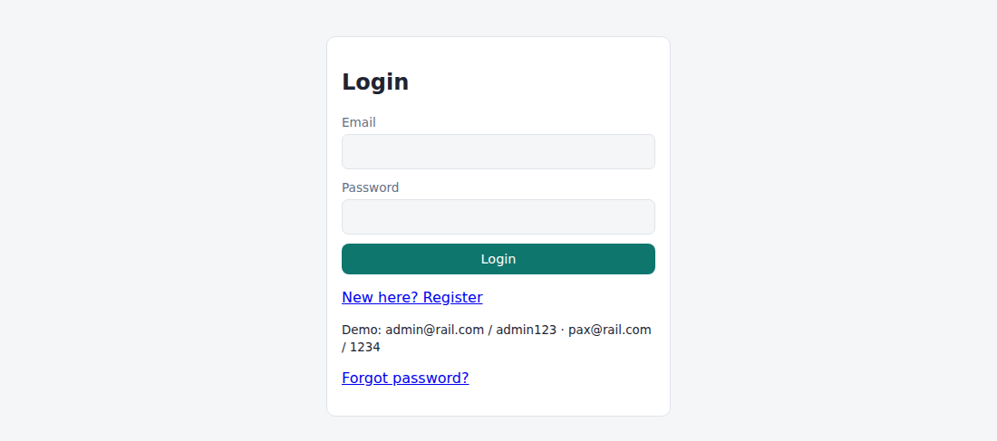
Fig. 4.1 – Login page
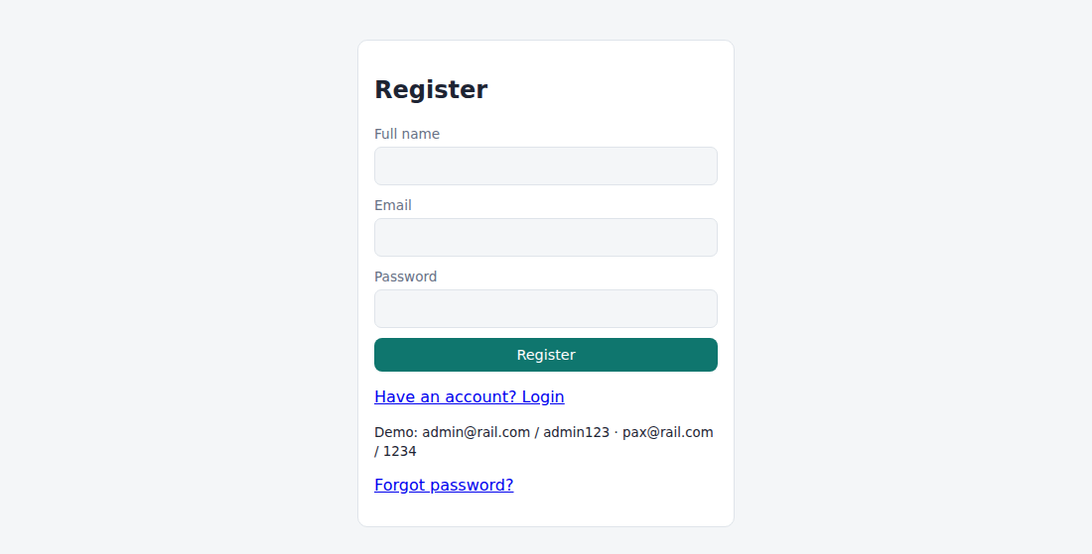
Fig. 4.2 – Registration page
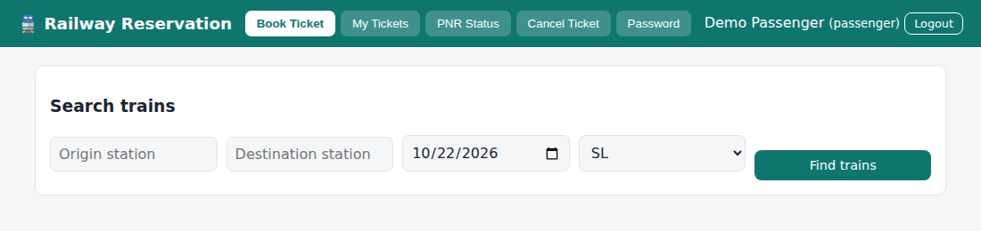
Fig. 4.3 – Passenger – Book Ticket
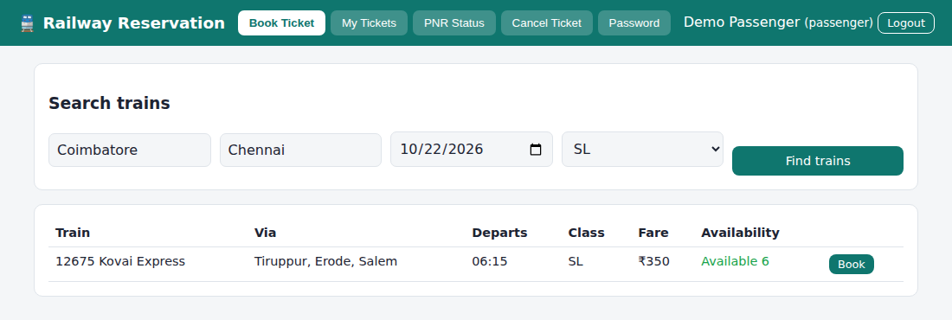
Fig. 4.4 – Passenger – Book Ticket (train list with seat availability)
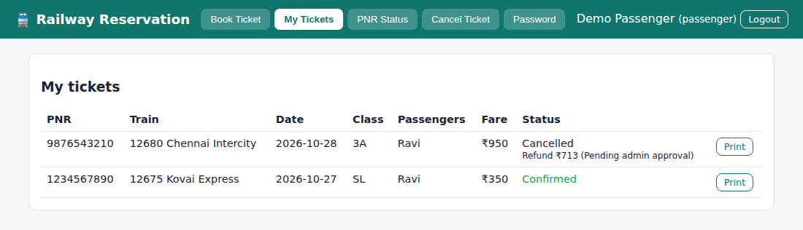
Fig. 4.5 – Passenger – My Tickets
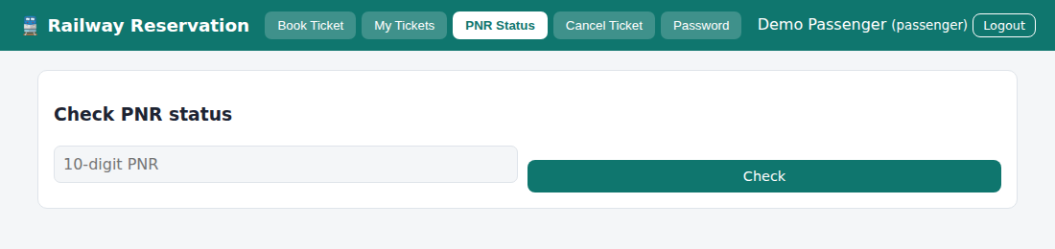
Fig. 4.6 – Passenger – PNR Status
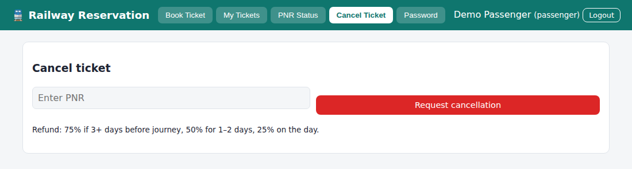
Fig. 4.7 – Passenger – Cancel Ticket
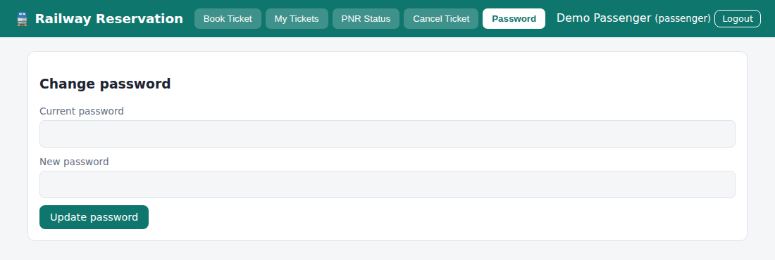
Fig. 4.8 – Passenger – Password
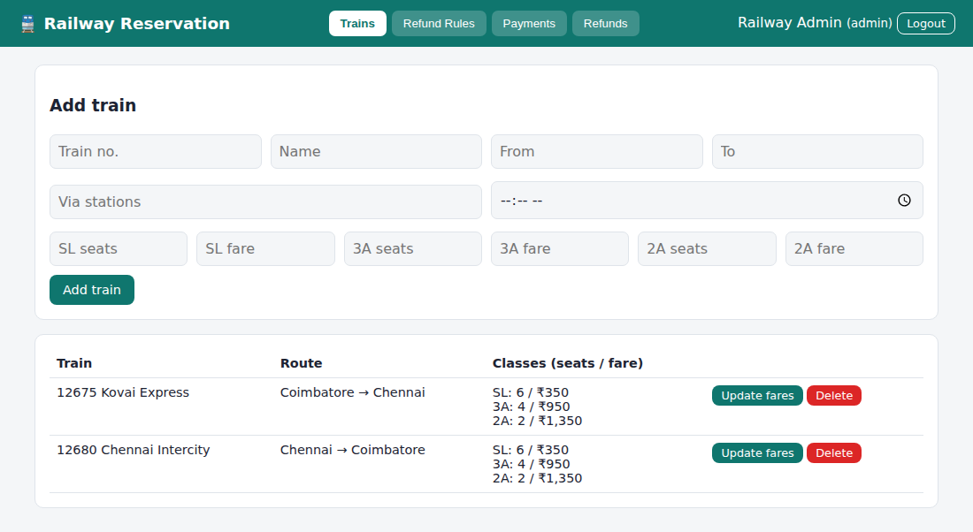
Fig. 4.9 – Admin – Trains
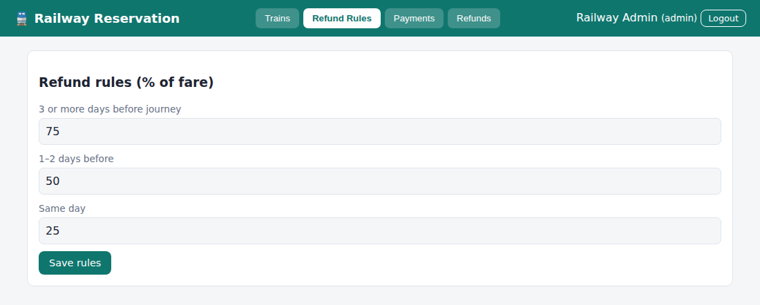
Fig. 4.10 – Admin – Refund Rules
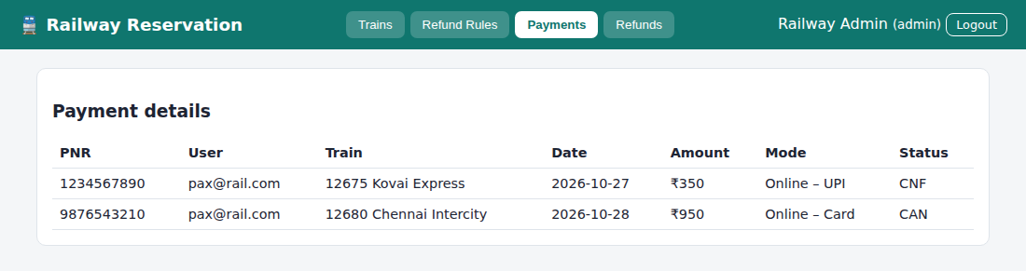
Fig. 4.11 – Admin – Payments
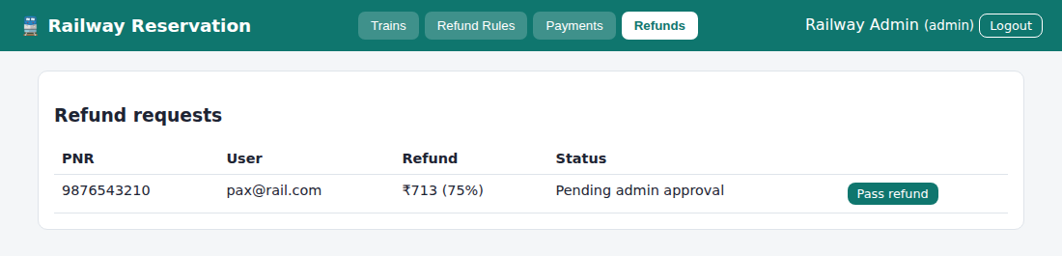
Fig. 4.12 – Admin – Refunds
RESULT
Thus the Online Train Reservation System website was designed and implemented successfully using HTML, CSS and JavaScript, and the output was verified.

Experiment No: 5
Name of the Experiment: Online Flight Reservation System
AIM
To develop a flight reservation website with flight search, seat map, booking, ticket payment, my tickets, cancellation, printable e-ticket and feedback, with an admin panel for flights, booking status, feedback and reports.
PROCEDURE
- Create a project folder and add the files index.html, style.css, common.js and app.js (flight).
- In index.html create an empty container <div id="app"> and link the style sheet and the JavaScript files.
- In common.js write the shared helper functions: browser storage (localStorage), user registration, login, logout, table building and the page header with tabs.
- In app.js create the demo data: flights with airline, route, timings and Economy and Business fares.
- Write the Search Flight page and the Book Ticket page with an Economy and Business seat map and passenger details.
- Write the Ticket Payment page, My Ticket page (with print ticket), Cancel Ticket and Customer Feedback pages, and the Forgot Password option.
- Write the admin screens: manage flights and fares, view booking status, read customer feedback and view the revenue report.
- Open index.html in a web browser and log in with the demo accounts to test every option.
- Observe the output, capture the screenshots and record the result.
CODE
index.html
<!DOCTYPE html><html lang="en"><head><meta charset="utf-8"><meta name="viewport" content="width=device-width,initial-scale=1"><title>5. Flight Reservation System</title><link rel="stylesheet" href="style.css"></head><body data-ns="fly_"><div id="app"></div><script src="common.js"></script><script src="app.js"></script></body></html>
app.js
Auth.seed([
{ name: "Airline Admin", email: "admin@fly.com", password: "admin123", role: "admin" },
{ name: "Demo Traveller", email: "user@fly.com", password: "1234", role: "user" },
]);
if (!DB.get("fl")) {
DB.set("bk", []);
DB.set("fb", []);
DB.set("fl", [
{
id: "f1",
no: "AI-101",
airline: "Air India",
from: "Coimbatore",
to: "Delhi",
dep: "06:00",
arr: "08:45",
eco: 5200,
bus: 11800,
},
{
id: "f2",
no: "6E-202",
airline: "IndiGo",
from: "Chennai",
to: "Mumbai",
dep: "09:30",
arr: "11:35",
eco: 4300,
bus: 9900,
},
{
id: "f3",
no: "UK-303",
airline: "Vistara",
from: "Delhi",
to: "Coimbatore",
dep: "18:20",
arr: "21:05",
eco: 5600,
bus: 12500,
},
]);
}
const FL = () => DB.get("fl", []),
BK = () => DB.get("bk", []);
let SEL = [],
CF = null,
CTX = null;
const E = Array.from({ length: 24 }, (_, i) => "E" + (i + 1)),
Bz = Array.from({ length: 6 }, (_, i) => "B" + (i + 1));
const taken = (id, d) =>
BK()
.filter((b) => b.fl === id && b.date === d && b.status === "Confirmed")
.flatMap((b) => b.seats);
const fn = (id) => {
const f = FL().find((x) => x.id === id);
return f ? esc(f.no + " " + f.airline) : "(removed)";
};
function start() {
const me = Auth.me();
if (!me) {
mountAuth(
$("#app"),
{
regRoles: ["user"],
title: "Login",
hint: "Demo: admin@fly.com / admin123 · user@fly.com / 1234",
},
start,
);
return forgot($("#app"));
}
shell(
"✈ Flight Reservation",
me.role === "admin"
? {
Flights: flightAdmin,
"Booking Status": statusView,
Feedback: fbView,
Report: reportView,
Password: pwView,
}
: {
"Search Flight": searchView,
"My Tickets": myTix,
Feedback: fbForm,
Password: pwView,
},
me,
);
}
function searchView(m) {
m.innerHTML = `<div class="card"><form id="f" class="row"><input name="from" placeholder="From"><input name="to" placeholder="To"><input type="date" name="date" min="${today()}" value="${today()}" required><select name="cls"><option value="eco">Economy</option><option value="bus">Business</option></select><button class="btn">Search flights</button></form></div><div id="res"></div><div id="sel"></div>`;
$("#f").onsubmit = (e) => {
const f = fd(e),
q = (a, b) => !b || a.toLowerCase().includes(b.toLowerCase());
$("#res").innerHTML = `<div class="card">${tbl(
["Flight", "Route", "Dep → Arr", "Fare", "Seats left", ""],
FL()
.filter((x) => q(x.from, f.from) && q(x.to, f.to))
.map((x) => {
const pool = f.cls === "eco" ? E : Bz,
left = pool.filter((s) => !taken(x.id, f.date).includes(s)).length;
return [
esc(x.no + " " + x.airline),
esc(x.from + " → " + x.to),
x.dep + " → " + x.arr,
rs(x[f.cls]),
left,
left
? `<button class="btn sm" onclick="pick('${x.id}','${f.date}','${f.cls}')">Select seats</button>`
: "Sold out",
];
}),
)}</div>`;
};
}
function pick(id, date, cls) {
CF = FL().find((x) => x.id === id);
SEL = [];
CTX = { date, cls };
$("#sel").innerHTML =
`<div class="card"><h3>${esc(CF.no)} · ${date} · ${cls === "eco" ? "Economy" : "Business"}</h3>${seatGrid(cls === "eco" ? E : Bz, taken(id, date))}<form id="pf"><div id="pax"></div><p id="tot"></p><button class="btn">Continue to payment</button></form></div>`;
$("#pf").onsubmit = (e) => {
const f = fd(e);
if (!SEL.length) return toast("Select at least one seat");
const pax = SEL.map((s) => ({ seat: s, name: f["n" + s], age: f["a" + s] })),
total = SEL.length * CF[cls];
$("#sel").innerHTML =
`<div class="card"><h3>Ticket payment</h3><p>${pax.length} passenger(s) · <b class="big">${rs(total)}</b></p><form id="yf" class="row"><select name="m">${opt(["Credit card", "Debit card", "UPI", "Net banking"])}</select><input name="ref" placeholder="Card / UPI reference" required><button class="btn">Pay now</button></form></div>`;
$("#yf").onsubmit = (ev) => {
const g = fd(ev);
if (SEL.some((s) => taken(id, date).includes(s))) return toast("Seat just taken");
const k = BK(),
b = {
id: uid(),
pnr: "FL" + Math.floor(1e5 + Math.random() * 9e5),
user: Auth.me().email,
fl: id,
date,
cls,
seats: SEL.slice(),
pax,
total,
pay: g.m,
status: "Confirmed",
};
k.push(b);
DB.set("bk", k);
alert(`Payment successful. PNR ${b.pnr}.\nE-ticket emailed (simulated).`);
refresh();
};
};
}
function seat(btn, n) {
const i = SEL.indexOf(n);
if (i < 0) {
SEL.push(n);
btn.classList.remove("sec");
} else {
SEL.splice(i, 1);
btn.classList.add("sec");
}
$("#pax").innerHTML = SEL.map(
(s) =>
`<div class="row"><input name="n${s}" placeholder="Passenger name (seat ${s})" required><input name="a${s}" type="number" min="1" placeholder="Age" required></div>`,
).join("");
$("#tot").textContent = "Total: " + rs(SEL.length * CF[CTX.cls]);
}
function myTix(m) {
m.innerHTML = `<div class="card"><h3>My tickets & itinerary</h3>${tbl(
["PNR", "Flight", "Date", "Seats", "Total", "Status", ""],
BK()
.filter((b) => b.user === Auth.me().email)
.reverse()
.map((b) => [
b.pnr,
fn(b.fl),
b.date,
b.seats.join(", "),
rs(b.total),
b.status,
b.status === "Confirmed"
? `<button class="btn sm sec" onclick="printTix('${b.id}')">Print</button> <button class="btn sm red" onclick="cancelTix('${b.id}')">Cancel</button>`
: "",
]),
)}</div>`;
}
function printTix(id) {
const b = BK().find((x) => x.id === id),
f = FL().find((x) => x.id === b.fl) || {},
w = window.open("", "_blank");
w.document.write(
`<pre>E-TICKET\nPNR: ${b.pnr}\nFlight: ${f.no} ${f.airline}\n${f.from} → ${f.to} ${b.date} ${f.dep}-${f.arr}\nPassengers: ${b.pax.map((p) => p.name + " [" + p.seat + "]").join(", ")}\nPaid: ${rs(b.total)}</pre>`,
);
w.print();
}
function cancelTix(id) {
if (!confirm("Cancel this ticket?")) return;
const k = BK();
k.find((b) => b.id === id).status = "Cancelled";
DB.set("bk", k);
refresh();
}
function fbForm(m) {
m.innerHTML = `<div class="card"><h3>Customer feedback</h3><form id="f"><select name="r">${opt(["5", "4", "3", "2", "1"])}</select><textarea name="t" placeholder="Tell us about your experience" required></textarea><button class="btn">Send feedback</button></form></div>`;
$("#f").onsubmit = (e) => {
const l = DB.get("fb", []);
l.push({ user: Auth.me().email, date: today(), ...fd(e) });
DB.set("fb", l);
toast("Thank you!");
e.target.reset();
};
}
function flightAdmin(m) {
m.innerHTML = `<div class="card"><h3>Add flight</h3><form id="f"><div class="row"><input name="no" placeholder="Flight no." required><input name="airline" placeholder="Airline" required><input name="from" placeholder="From" required><input name="to" placeholder="To" required></div><div class="row"><input type="time" name="dep" required><input type="time" name="arr" required><input type="number" name="eco" placeholder="Economy fare" required><input type="number" name="bus" placeholder="Business fare" required></div><button class="btn">Add flight</button></form></div><div class="card">${tbl(
["Flight", "Route", "Time", "Economy", "Business", ""],
FL().map((x) => [
esc(x.no + " " + x.airline),
esc(x.from + " → " + x.to),
x.dep + " → " + x.arr,
rs(x.eco),
rs(x.bus),
`<button class="btn sm" onclick="fareFl('${x.id}')">Update fares</button> <button class="btn sm red" onclick="delFl('${x.id}')">Delete</button>`,
]),
)}</div>`;
$("#f").onsubmit = (e) => {
const f = fd(e),
l = FL();
l.push({ id: uid(), ...f, eco: +f.eco, bus: +f.bus });
DB.set("fl", l);
refresh();
};
}
function fareFl(id) {
const l = FL(),
x = l.find((y) => y.id === id);
x.eco = +prompt("Economy fare", x.eco) || x.eco;
x.bus = +prompt("Business fare", x.bus) || x.bus;
DB.set("fl", l);
refresh();
}
function delFl(id) {
DB.set(
"fl",
FL().filter((x) => x.id !== id),
);
refresh();
}
function statusView(m) {
m.innerHTML = `<div class="card"><h3>Booking status</h3>${tbl(
["PNR", "User", "Flight", "Date", "Seats", "Total", "Status"],
BK().map((b) => [
b.pnr,
b.user,
fn(b.fl),
b.date,
b.seats.join(","),
rs(b.total),
b.status,
]),
)}</div>`;
}
function fbView(m) {
m.innerHTML = `<div class="card"><h3>Customer feedback</h3>${tbl(
["Date", "User", "Rating", "Feedback"],
DB.get("fb", []).map((f) => [f.date, f.user, f.r + " ★", esc(f.t)]),
)}</div>`;
}
function reportView(m) {
const ok = BK().filter((b) => b.status === "Confirmed");
m.innerHTML = `<div class="grid"><div class="card"><small>Confirmed tickets</small><p class="big">${ok.length}</p></div><div class="card"><small>Revenue</small><p class="big">${rs(ok.reduce((s, b) => s + b.total, 0))}</p></div><div class="card"><small>Cancelled</small><p class="big">${BK().length - ok.length}</p></div></div><br><div class="card"><h3>Revenue by flight</h3>${tbl(
["Flight", "Passengers", "Revenue"],
FL().map((f) => {
const k = ok.filter((b) => b.fl === f.id);
return [
esc(f.no + " " + f.airline),
k.reduce((s, b) => s + b.seats.length, 0),
rs(k.reduce((s, b) => s + b.total, 0)),
];
}),
)}</div>`;
}
start();
Common files (common.js, style.css) are listed in the Appendix.

OUTPUT
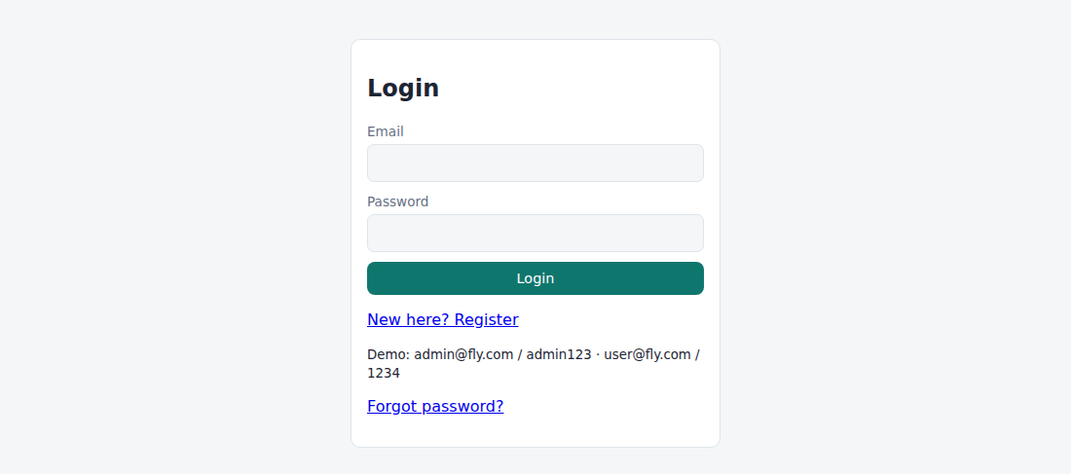
Fig. 5.1 – Login page
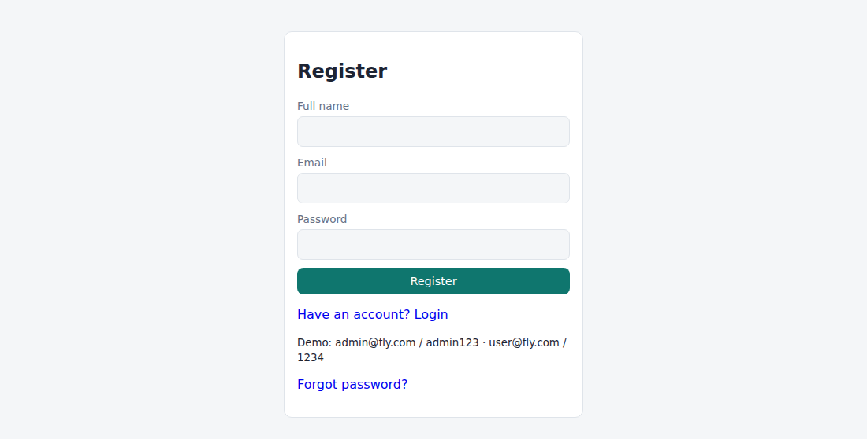
Fig. 5.2 – Registration page
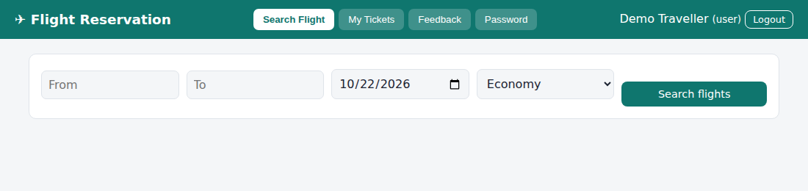
Fig. 5.3 – User – Search Flight
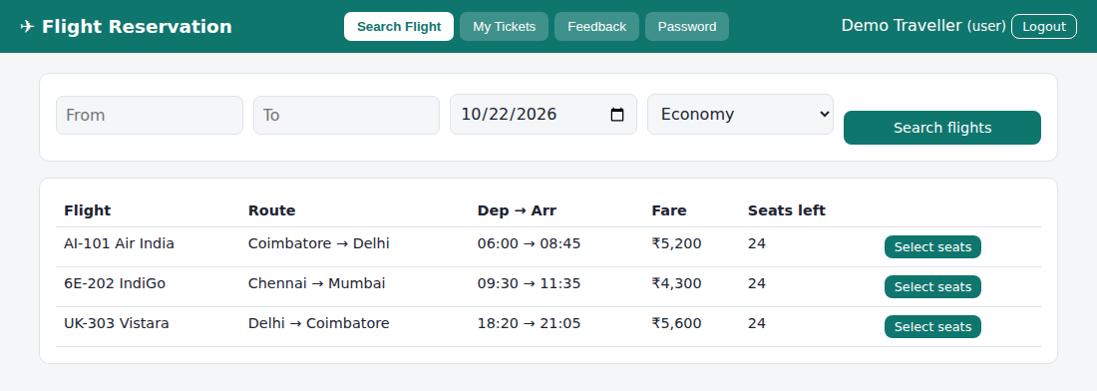
Fig. 5.4 – User – Search Flight (search results)
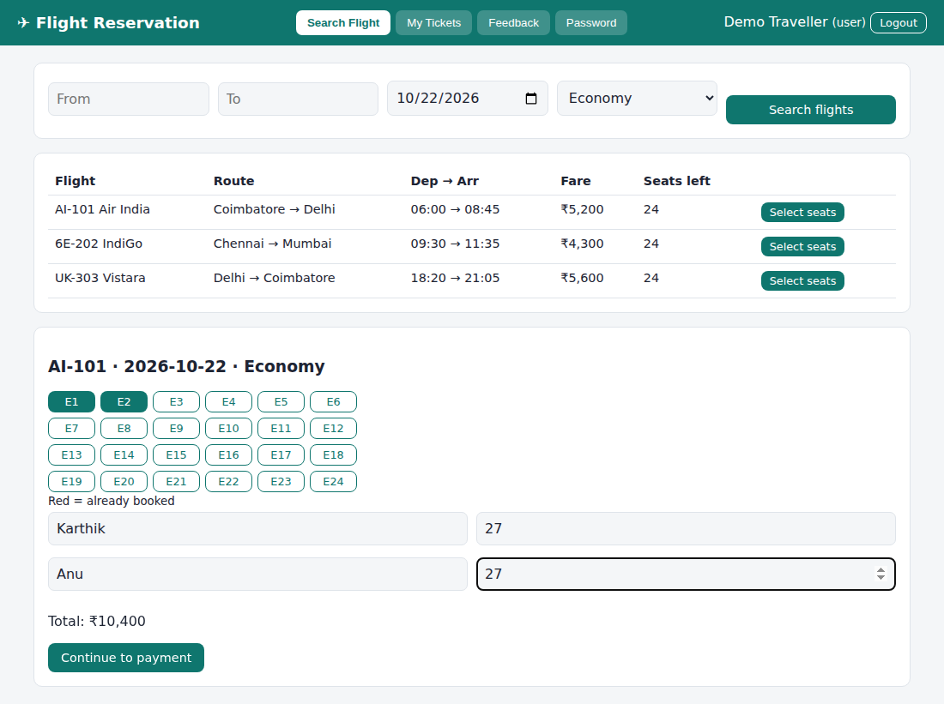
Fig. 5.5 – User – seat selection and passenger details
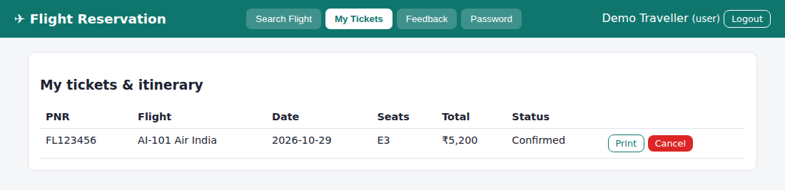
Fig. 5.6 – User – My Tickets
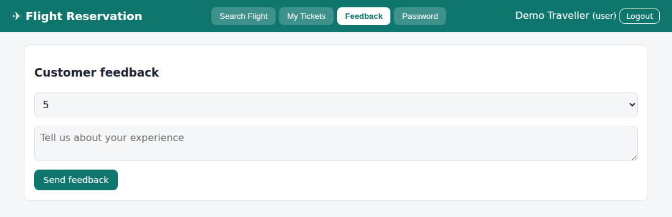
Fig. 5.7 – User – Feedback
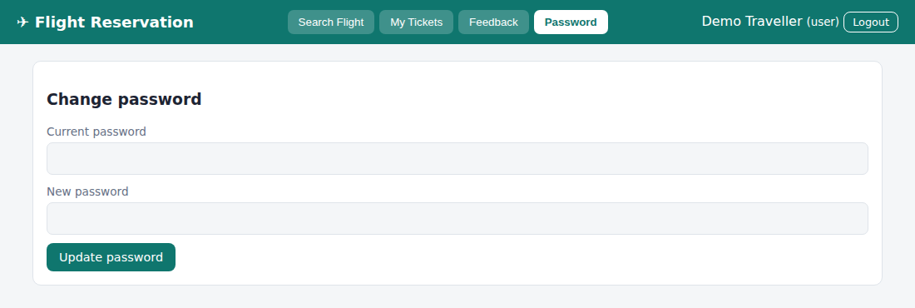
Fig. 5.8 – User – Password
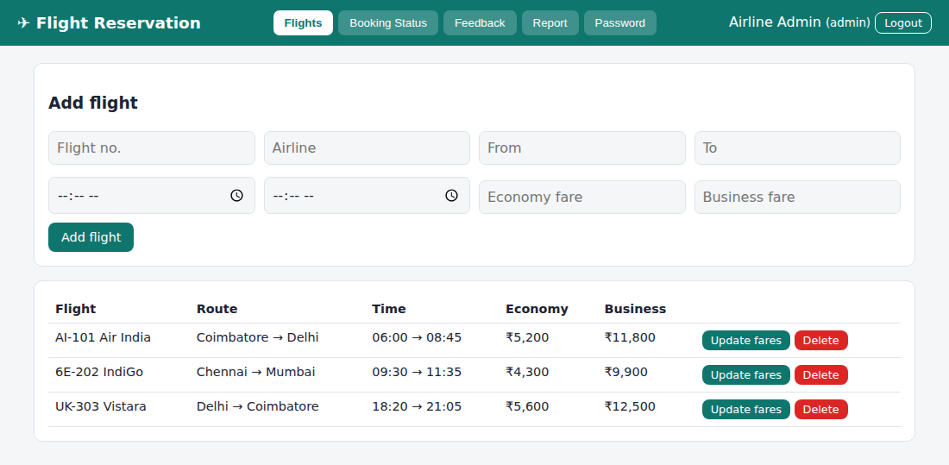
Fig. 5.9 – Admin – Flights
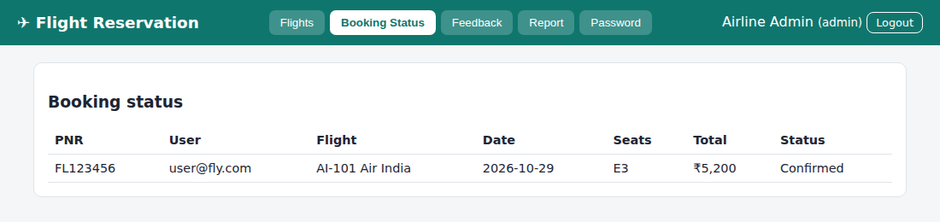
Fig. 5.10 – Admin – Booking Status
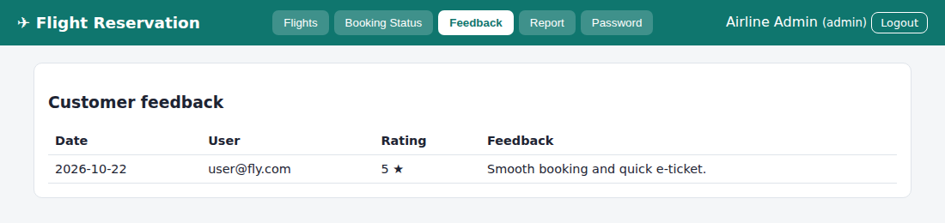
Fig. 5.11 – Admin – Feedback
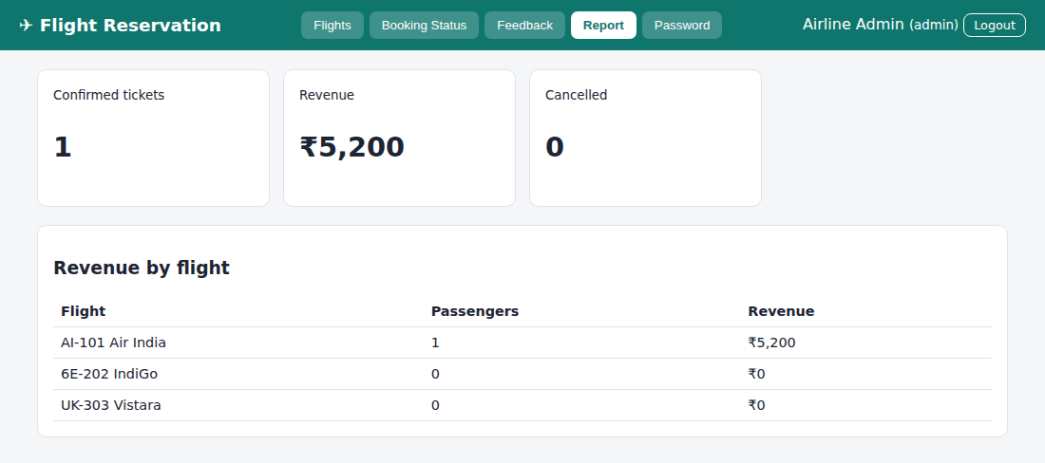
Fig. 5.12 – Admin – Report
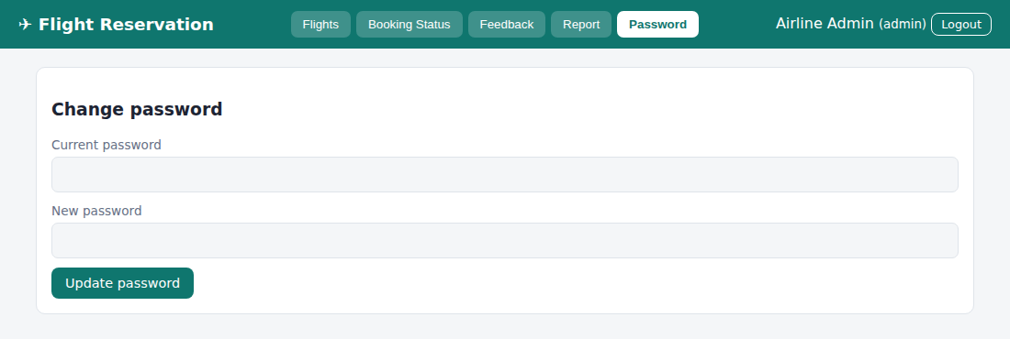
Fig. 5.13 – Admin – Password
RESULT
Thus the Online Flight Reservation System website was designed and implemented successfully using HTML, CSS and JavaScript, and the output was verified.

Experiment No: 6
Name of the Experiment: Online Cake Ordering System
AIM
To develop an online cake store where customers search and filter cakes, add them to a cart, enter a shipping address, place orders and track status, and the admin posts cakes with images and manages orders.
PROCEDURE
- Create a project folder and add the files index.html, style.css, common.js and app.js (cake).
- In index.html create an empty container <div id="app"> and link the style sheet and the JavaScript files.
- In common.js write the shared helper functions: browser storage (localStorage), user registration, login, logout, table building and the page header with tabs.
- In app.js create the demo data: admin and customer accounts and sample cakes with category, flavour, price and description.
- Write the customer screens: search and filter cakes by category, flavour and price, add to cart with size and message, edit or remove cart items, enter the shipping address and place the order.
- Write My Orders to show the shipping status and allow the address to be updated while the order is only placed.
- Write the admin screens: post cake details with an uploaded image, delete cakes and update the order status (Placed, Baking, Out for delivery, Delivered).
- Open index.html in a web browser and log in with the demo accounts to test every option.
- Observe the output, capture the screenshots and record the result.
CODE
index.html
<!DOCTYPE html><html lang="en"><head><meta charset="utf-8"><meta name="viewport" content="width=device-width,initial-scale=1"><title>6. Online Cake Ordering</title><link rel="stylesheet" href="style.css"></head><body data-ns="cake_"><div id="app"></div><script src="common.js"></script><script src="app.js"></script></body></html>
app.js
Auth.seed([
{ name: "Cake Admin", email: "admin@cake.com", password: "admin123", role: "admin" },
{ name: "Demo Customer", email: "cust@cake.com", password: "1234", role: "customer" },
]);
if (!DB.get("cakes")) {
DB.set("cakes", [
{
id: "k1",
name: "Choco Truffle",
cat: "Birthday",
sub: "Chocolate",
price: 650,
desc: "Rich dark chocolate ganache.",
img: "🎂",
},
{
id: "k2",
name: "Red Velvet Heart",
cat: "Anniversary",
sub: "Vanilla",
price: 850,
desc: "Cream cheese frosting.",
img: "❤️",
},
{
id: "k3",
name: "Fresh Fruit Gateau",
cat: "Birthday",
sub: "Fruit",
price: 720,
desc: "Seasonal fruits on whipped cream.",
img: "🍓",
},
{
id: "k4",
name: "Three-Tier Royal",
cat: "Wedding",
sub: "Vanilla",
price: 2400,
desc: "Fondant finish, serves 25.",
img: "🍰",
},
]);
DB.set("orders", []);
}
const SZ = { "0.5 kg": 0.6, "1 kg": 1, "2 kg": 1.9 },
ST = ["Placed", "Baking", "Out for delivery", "Delivered"];
const C = () => DB.get("cakes", []),
O = () => DB.get("orders", []),
cartKey = () => "cart_" + Auth.me().email,
CART = () => DB.get(cartKey(), []);
const price = (c, s) => Math.round(c.price * SZ[s]);
const img = (c) =>
/^(data:|http)/.test(c)
? `<img src="${esc(c)}" alt="" style="width:100%;height:130px;object-fit:cover;border-radius:8px">`
: `<div style="font-size:70px;text-align:center">${esc(c)}</div>`;
function start() {
const me = Auth.me();
if (!me)
return mountAuth(
$("#app"),
{
regRoles: ["customer"],
hint: "Demo: admin@cake.com / admin123 · cust@cake.com / 1234",
},
start,
);
shell(
"🎂 Sweet Crumbs",
me.role === "admin"
? { "Manage Cakes": adminCakes, "Manage Orders": adminOrders }
: { Cakes: cakes, Cart: cartView, "My Orders": myOrders },
me,
);
}
function cakes(m) {
const L = C();
m.innerHTML = `<div class="card"><div class="row"><input id="q" placeholder="Search cake"><select id="c">${opt([...new Set(L.map((x) => x.cat))], "All categories")}</select><select id="s">${opt([...new Set(L.map((x) => x.sub))], "All flavours")}</select><select id="p"><option value="">Any price</option><option>700</option><option>1000</option><option>2500</option></select></div></div><div class="grid" id="g"></div>`;
const d = () => {
const q = $("#q").value.toLowerCase(),
c = $("#c").value,
s = $("#s").value,
p = +$("#p").value || 1e9;
$("#g").innerHTML =
L.filter(
(x) =>
x.name.toLowerCase().includes(q) &&
(!c || x.cat === c) &&
(!s || x.sub === s) &&
x.price <= p,
)
.map(
(x) =>
`<div class="card">${img(x.img)}<h4>${esc(x.name)}</h4><span class="tag">${esc(x.cat)}</span> <span class="tag">${esc(x.sub)}</span><p>${esc(x.desc)}</p><b>From ${rs(x.price)}/kg</b><select id="sz_${x.id}">${opt(Object.keys(SZ))}</select><input id="mg_${x.id}" placeholder="Message on cake"><button class="btn" onclick="addCart('${x.id}')">Add to cart</button></div>`,
)
.join("") || "<p>No cakes match your filters.</p>";
};
["q", "c", "s", "p"].forEach((i) => ($("#" + i).oninput = d));
d();
}
function addCart(id) {
const c = CART();
c.push({ cid: id, size: $("#sz_" + id).value, msg: $("#mg_" + id).value, qty: 1 });
DB.set(cartKey(), c);
toast("Added to cart");
}
function cartView(m) {
const c = CART(),
L = C();
let tot = 0;
const rows = c.map((x, i) => {
const k = L.find((a) => a.id === x.cid);
if (!k) return ["(removed)", "", "", "", ""];
const p = price(k, x.size) * x.qty;
tot += p;
return [
esc(k.name),
x.size,
esc(x.msg || "-"),
`<input type="number" min="1" value="${x.qty}" style="width:70px" onchange="setQty(${i},this.value)">`,
rs(p) + ` <button class="btn sm red" onclick="rmCart(${i})">Remove</button>`,
];
});
const u = Auth.me();
m.innerHTML = `<div class="card"><h3>Your cart</h3>${tbl(["Cake", "Size", "Message", "Qty", "Price"], rows)}<p class="big">Total ${rs(tot)}</p></div>${c.length ? `<div class="card"><h3>Shipping address</h3><form id="f"><div class="row"><input name="name" placeholder="Recipient name" value="${esc(u.name)}" required><input name="phone" placeholder="Phone" required></div><textarea name="addr" placeholder="Address" required></textarea><div class="row"><input name="city" placeholder="City / location" required><input name="date" type="date" min="${today()}" required></div><button class="btn">Place order</button></form></div>` : ""}`;
if (c.length)
$("#f").onsubmit = (e) => {
const f = fd(e),
o = O();
o.push({
id: uid(),
user: u.email,
items: c.map((x) => ({
name: L.find((a) => a.id === x.cid).name,
size: x.size,
msg: x.msg,
qty: x.qty,
})),
total: tot,
ship: f,
status: "Placed",
date: today(),
});
DB.set("orders", o);
DB.set(cartKey(), []);
toast("Order placed!");
refresh();
};
}
function setQty(i, v) {
const c = CART();
c[i].qty = Math.max(1, +v || 1);
DB.set(cartKey(), c);
refresh();
}
function rmCart(i) {
const c = CART();
c.splice(i, 1);
DB.set(cartKey(), c);
refresh();
}
const items = (o) =>
o.items
.map(
(i) => `${esc(i.name)} (${i.size}) ×${i.qty}${i.msg ? " “" + esc(i.msg) + "”" : ""}`,
)
.join("<br>");
function myOrders(m) {
const l = O()
.filter((o) => o.user === Auth.me().email)
.reverse();
m.innerHTML = `<div class="card"><h3>My orders & shipping status</h3>${tbl(
["Order", "Items", "Total", "Ship to", "Status", ""],
l.map((o) => [
o.id.slice(-5),
items(o),
rs(o.total),
esc(o.ship.addr + ", " + o.ship.city),
"<b>" +
o.status +
"</b><br><small>" +
ST.map((s, i) => (i <= ST.indexOf(o.status) ? "●" : "○")).join("") +
"</small>",
o.status === "Placed"
? `<button class="btn sm" onclick="editAddr('${o.id}')">Update address</button>`
: "",
]),
)}</div>`;
}
function editAddr(id) {
const os = O(),
o = os.find((x) => x.id === id),
a = prompt("New shipping address", o.ship.addr);
if (a) {
o.ship.addr = a;
DB.set("orders", os);
refresh();
}
}
function adminCakes(m) {
const L = C();
m.innerHTML = `<div class="card"><h3>Post cake details</h3><form id="f"><div class="row"><input name="name" placeholder="Cake name" required><input name="cat" placeholder="Category (Birthday…)" required><input name="sub" placeholder="Flavour / sub category" required><input name="price" type="number" placeholder="Price per kg" required></div><textarea name="desc" placeholder="Description"></textarea><label>Upload image (optional)</label><input type="file" name="file" accept="image/*"><button class="btn">Add cake</button></form></div><div class="card">${tbl(
["Cake", "Category", "Price", ""],
L.map((x) => [
esc(x.name),
esc(x.cat + " / " + x.sub),
rs(x.price),
`<button class="btn sm red" onclick="delCake('${x.id}')">Delete</button>`,
]),
)}</div>`;
$("#f").onsubmit = (e) => {
e.preventDefault();
const f = Object.fromEntries(new FormData(e.target)),
file = f.file,
save = (im) => {
const l = C();
l.push({
id: uid(),
name: f.name,
cat: f.cat,
sub: f.sub,
price: +f.price,
desc: f.desc,
img: im,
});
DB.set("cakes", l);
toast("Cake added");
refresh();
};
if (file && file.size) {
const r = new FileReader();
r.onload = () => save(r.result);
r.readAsDataURL(file);
} else save("🎂");
};
}
function delCake(id) {
DB.set(
"cakes",
C().filter((x) => x.id !== id),
);
refresh();
}
function adminOrders(m) {
m.innerHTML = `<div class="card"><h3>Orders</h3>${tbl(
["Order", "Customer", "Items", "Total", "Ship to", "Update status"],
O()
.slice()
.reverse()
.map((o) => [
o.id.slice(-5),
esc(o.ship.name) + "<br>" + esc(o.ship.phone),
items(o),
rs(o.total),
esc(o.ship.addr + ", " + o.ship.city) + "<br>Deliver on " + o.ship.date,
`<select onchange="setSt('${o.id}',this.value)">${ST.map((s) => `<option${s === o.status ? " selected" : ""}>${s}</option>`).join("")}</select>`,
]),
)}</div>`;
}
function setSt(id, s) {
const os = O();
os.find((o) => o.id === id).status = s;
DB.set("orders", os);
toast("Status updated");
}
start();
Common files (common.js, style.css) are listed in the Appendix.

OUTPUT
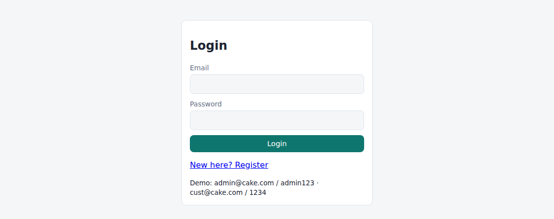
Fig. 6.1 – Login page
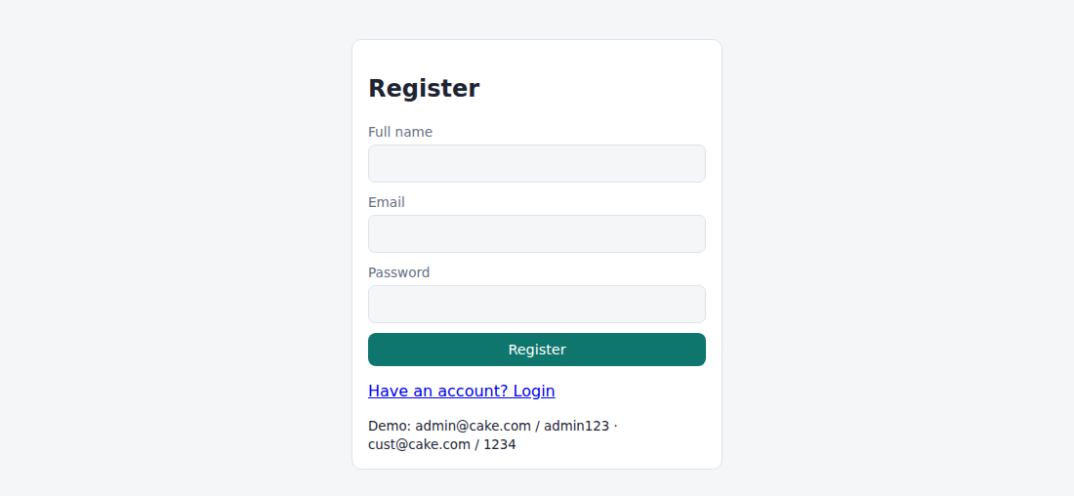
Fig. 6.2 – Registration page
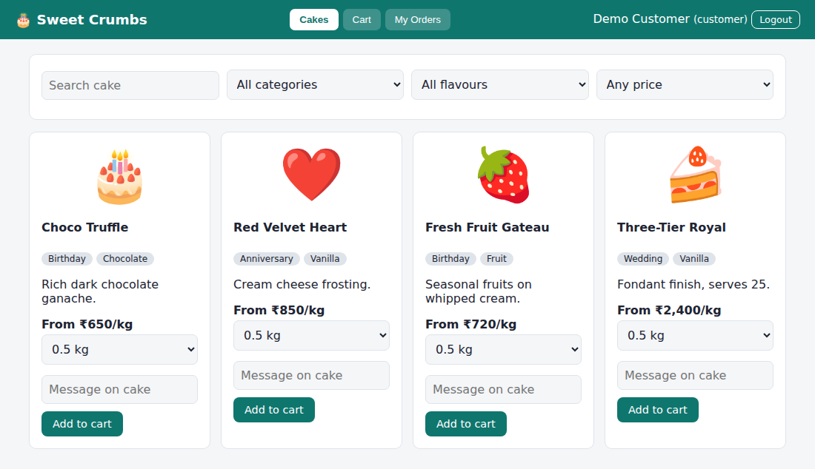
Fig. 6.3 – Customer – Cakes
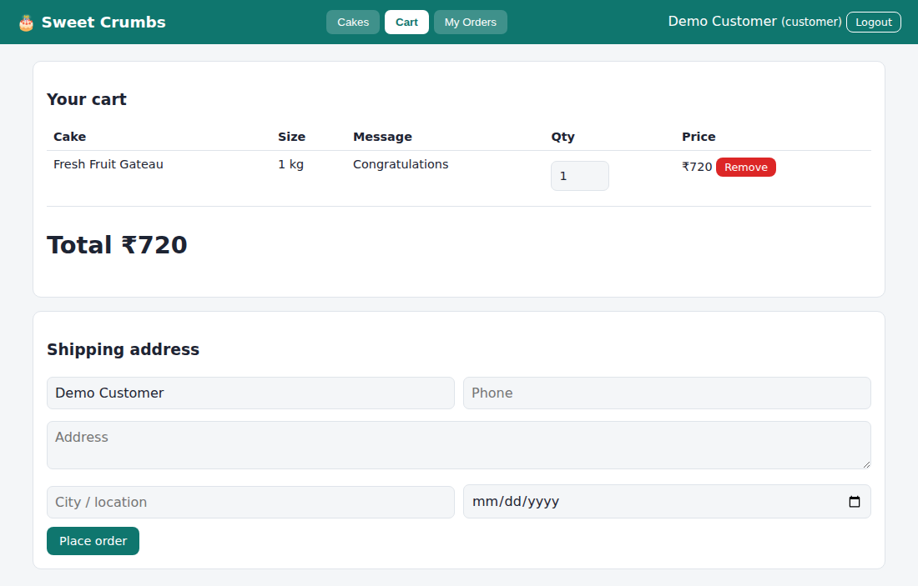
Fig. 6.4 – Customer – Cart
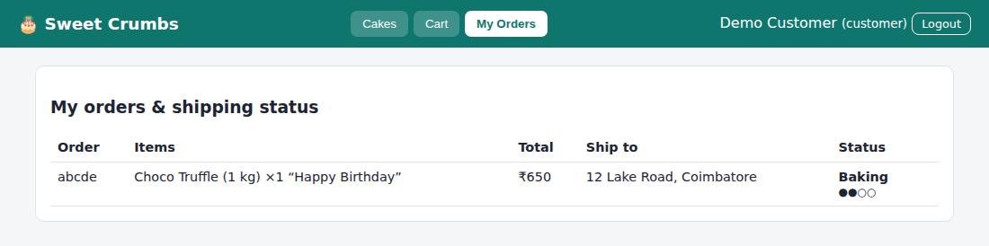
Fig. 6.5 – Customer – My Orders
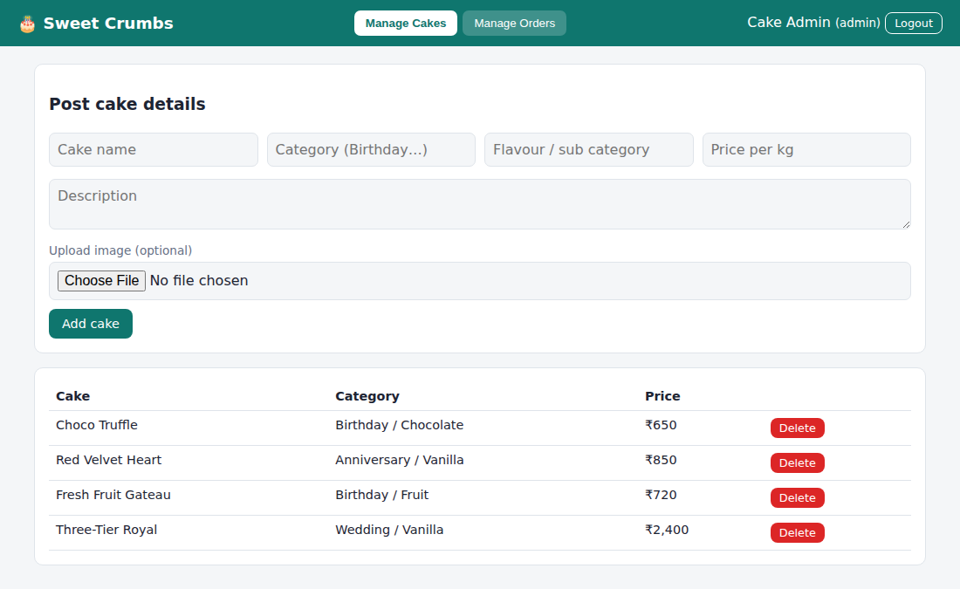
Fig. 6.6 – Admin – Manage Cakes
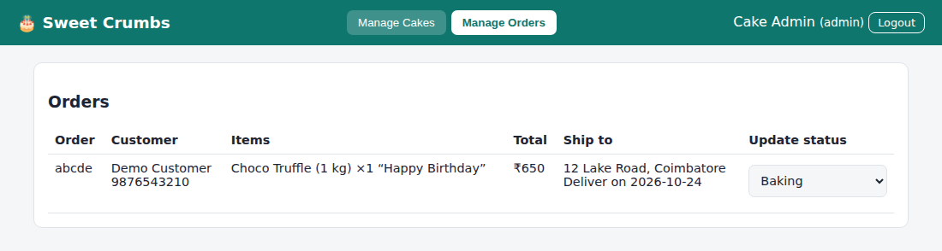
Fig. 6.7 – Admin – Manage Orders
RESULT
Thus the Online Cake Ordering System website was designed and implemented successfully using HTML, CSS and JavaScript, and the output was verified.

Experiment No: 7
Name of the Experiment: Beauty Parlour Appointment Booking
AIM
To develop an appointment booking system with a reservations calendar, slot lock-out, full or deposit payment, automatic cancellation of unpaid reservations, a customer account page and tools for the salon manager.
PROCEDURE
- Create a project folder and add the files index.html, style.css, common.js and app.js (beauty parlour).
- In index.html create an empty container <div id="app"> and link the style sheet and the JavaScript files.
- In common.js write the shared helper functions: browser storage (localStorage), user registration, login, logout, table building and the page header with tabs.
- In app.js create the demo data: services, stylists and the hourly time slots from 10:00 to 17:00.
- Write the booking page: choose service, stylist and date, show the slots with unavailable hours locked out, and take payment in full, as a 30% deposit or pay later.
- Add the automatic cancellation of unpaid reservations after one hour and the customer account page (upcoming reservations, history, reschedule, cancel, feedback and personal data).
- Write the manager screens: month calendar with booking counts, add, edit and cancel reservations, call or SMS the customer, block hours, manage services and stylists, and read feedback.
- Open index.html in a web browser and log in with the demo accounts to test every option.
- Observe the output, capture the screenshots and record the result.
CODE
index.html
<!DOCTYPE html><html lang="en"><head><meta charset="utf-8"><meta name="viewport" content="width=device-width,initial-scale=1"><title>7. Beauty Parlour Appointment Booking</title><link rel="stylesheet" href="style.css"></head><body data-ns="salon_"><div id="app"></div><script src="common.js"></script><script src="app.js"></script></body></html>
app.js
Auth.seed([
{
name: "Salon Manager",
email: "manager@salon.com",
password: "admin123",
role: "admin",
},
{
name: "Demo Customer",
email: "cust@salon.com",
password: "1234",
role: "customer",
phone: "9876543210",
},
]);
if (!DB.get("svc")) {
DB.set("rv", []);
DB.set("blk", []);
DB.set("fb", []);
DB.set("svc", [
{ id: "s1", name: "Haircut & Styling", price: 600 },
{ id: "s2", name: "Facial", price: 1200 },
{ id: "s3", name: "Manicure & Pedicure", price: 900 },
{ id: "s4", name: "Bridal Makeup", price: 6000 },
]);
DB.set("sty", [
{ id: "y1", name: "Anita", spec: "Hair" },
{ id: "y2", name: "Rhea", spec: "Skin & Makeup" },
{ id: "y3", name: "Kavya", spec: "Nails" },
]);
}
const SV = () => DB.get("svc", []),
ST = () => DB.get("sty", []),
RV = () => DB.get("rv", []),
BL = () => DB.get("blk", []),
SL = ["10:00", "11:00", "12:00", "13:00", "14:00", "15:00", "16:00", "17:00"];
const busy = (d, s, t, skip) =>
RV().some(
(r) =>
r.status === "Booked" && r.id !== skip && r.date === d && r.sty === s && r.time === t,
) || BL().some((b) => b.date === d && b.time === t);
const nm = (a, id) => esc((a.find((x) => x.id === id) || {}).name || "-");
(() => {
const r = RV();
let c = 0;
r.forEach((x) => {
if (x.status === "Booked" && !x.paid && Date.now() - x.created > 36e5) {
x.status = "Cancelled";
x.note = "Auto-cancelled: unpaid";
c = 1;
}
});
if (c) DB.set("rv", r);
})();
function start() {
const me = Auth.me();
if (!me)
return mountAuth(
$("#app"),
{
regRoles: ["customer"],
hint: "Demo: manager@salon.com / admin123 · cust@salon.com / 1234",
extra: '<label>Phone</label><input name="phone">',
},
start,
);
shell(
"💇 Glow Beauty Parlour",
me.role === "admin"
? {
Calendar: calView,
"Add Reservation": (m) => bookView(m, 1),
Reservations: resAdmin,
"Services & Stylists": catAdmin,
"Block Hours": blockView,
Feedback: fbView,
}
: {
"Book Appointment": (m) => bookView(m, 0),
"My Account": account,
"Services & Stylists": info,
},
me,
);
}
function bookView(m, adm) {
let T = "";
m.innerHTML = `<div class="card"><h3>${adm ? "Add reservation" : "Book an appointment"}</h3><form id="f">${adm ? '<div class="row"><input name="cn" placeholder="Customer name" required><input name="cp" placeholder="Phone" required></div>' : ""}<div class="row"><div><label>Service</label><select name="svc">${SV()
.map((s) => `<option value="${s.id}">${esc(s.name)} – ${rs(s.price)}</option>`)
.join("")}</select></div><div><label>Stylist</label><select name="sty">${ST()
.map((s) => `<option value="${s.id}">${esc(s.name)} (${esc(s.spec)})</option>`)
.join(
"",
)}</select></div><div><label>Date</label><input type="date" name="date" min="${today()}" value="${today()}"></div></div><label>Time (red = unavailable)</label><div id="sl" style="display:flex;gap:6px;flex-wrap:wrap;margin:6px 0 12px"></div><label>Payment</label><select name="pay">${adm ? '<option value="full">Paid at salon (full)</option><option value="later">Not paid yet</option>' : '<option value="full">Pay in full – Stripe</option><option value="dep">30% deposit – PayPal</option><option value="later">Pay later (auto-cancels in 1 hour)</option>'}</select><button class="btn">Confirm reservation</button></form></div>`;
const draw = () => {
const f = Object.fromEntries(new FormData($("#f")));
T = "";
$("#sl").innerHTML = SL.map(
(t) =>
`<button type="button" class="btn sm ${busy(f.date, f.sty, t) ? "red" : "sec"}" ${busy(f.date, f.sty, t) ? "disabled" : ""}>${t}</button>`,
).join("");
$$("#sl button:not([disabled])").forEach(
(b) =>
(b.onclick = () => {
T = b.textContent;
$$("#sl button:not([disabled])").forEach((x) =>
x.classList.toggle("sec", x !== b),
);
}),
);
};
$("#f").onchange = draw;
draw();
$("#f").onsubmit = (e) => {
const f = fd(e);
if (!T) return toast("Choose a time slot");
if (busy(f.date, f.sty, T)) return toast("Slot just taken");
const me = Auth.me(),
p = SV().find((s) => s.id === f.svc).price,
paid = f.pay === "full" ? p : f.pay === "dep" ? Math.round(p * 0.3) : 0,
l = RV();
l.push({
id: uid(),
user: adm ? "walk-in" : me.email,
name: adm ? f.cn : me.name,
phone: adm ? f.cp : me.phone || "",
svc: f.svc,
sty: f.sty,
date: f.date,
time: T,
price: p,
paid,
status: "Booked",
created: Date.now(),
});
DB.set("rv", l);
alert(
"Reservation confirmed" +
(paid
? ". Paid " + rs(paid)
: ". Please pay within 1 hour or it will be cancelled automatically") +
". A reminder will be sent (simulated).",
);
refresh();
};
}
const rrow = (r, adm) => [
r.date + "<br>" + r.time,
nm(SV(), r.svc),
nm(ST(), r.sty),
adm ? esc(r.name) + "<br><small>" + esc(r.phone) + "</small>" : "",
rs(r.price) + "<br><small>paid " + rs(r.paid) + "</small>",
r.status + (r.note ? "<br><small>" + r.note + "</small>" : ""),
];
const act = (r) =>
r.status === "Booked"
? `<button class="btn sm" onclick="resched('${r.id}')">Reschedule</button> <button class="btn sm red" onclick="cancelR('${r.id}')">Cancel</button>`
: "";
function account(m) {
const me = Auth.me(),
mine = RV().filter((r) => r.user === me.email),
up = mine.filter((r) => r.status === "Booked" && r.date >= today()),
his = mine.filter((r) => !up.includes(r));
m.innerHTML = `<div class="card"><h3>Upcoming reservations</h3>${tbl(
["When", "Service", "Stylist", "", "Price", "Status", ""],
up.map((r) => [
...rrow(r, 0),
act(r) +
(r.paid < r.price
? ` <button class="btn sm" onclick="payBal('${r.id}')">Pay balance</button>`
: ""),
]),
)}</div><div class="card"><h3>Reservation history</h3>${tbl(
["When", "Service", "Stylist", "", "Price", "Status", ""],
his.map((r) => [
...rrow(r, 0),
r.status === "Booked"
? `<button class="btn sm sec" onclick="feedback('${r.id}')">Leave feedback</button>`
: "",
]),
)}</div><div class="card"><h3>Personal data</h3><form id="f"><input name="name" value="${esc(me.name)}"><input name="phone" value="${esc(me.phone || "")}" placeholder="Phone"><button class="btn">Save</button></form></div>`;
$("#f").onsubmit = (e) => {
Auth.save({ ...me, ...fd(e) });
toast("Saved");
refresh();
};
}
function payBal(id) {
const l = RV(),
r = l.find((x) => x.id === id);
r.paid = r.price;
DB.set("rv", l);
toast("Balance paid");
refresh();
}
function cancelR(id) {
if (!confirm("Cancel this reservation?")) return;
const l = RV();
l.find((r) => r.id === id).status = "Cancelled";
DB.set("rv", l);
refresh();
}
function resched(id) {
const l = RV(),
r = l.find((x) => x.id === id),
d = prompt("New date (YYYY-MM-DD)", r.date),
t = d && prompt("New time (" + SL.join(", ") + ")", r.time);
if (!d || !t) return;
if (!SL.includes(t) || d < today() || busy(d, r.sty, t, id))
return toast("Slot unavailable");
r.date = d;
r.time = t;
DB.set("rv", l);
refresh();
}
function feedback(id) {
const t = prompt(
'How was your visit? (rating 1-5, then a comment e.g. "5 lovely service")',
);
if (!t) return;
const f = DB.get("fb", []);
f.push({ user: Auth.me().email, text: t, date: today() });
DB.set("fb", f);
const l = RV();
l.find((r) => r.id === id).status = "Done";
DB.set("rv", l);
refresh();
}
function info(m) {
m.innerHTML = `<div class="grid"><div class="card"><h3>Services</h3>${SV()
.map((s) => `<p>${esc(s.name)} — <b>${rs(s.price)}</b></p>`)
.join("")}</div><div class="card"><h3>Stylists</h3>${ST()
.map((s) => `<p><b>${esc(s.name)}</b><br><small>${esc(s.spec)}</small></p>`)
.join("")}</div></div>`;
}
let CY = new Date().getFullYear(),
CMo = new Date().getMonth(),
SD = today();
function calView(m) {
const first = new Date(CY, CMo, 1),
days = new Date(CY, CMo + 1, 0).getDate(),
pad = first.getDay(),
cells = [];
for (let i = 0; i < pad; i++) cells.push("<div></div>");
for (let d = 1; d <= days; d++) {
const ds = ymd(new Date(CY, CMo, d)),
n = RV().filter((r) => r.date === ds && r.status === "Booked").length;
cells.push(
`<button class="btn sm ${ds === SD ? "" : "sec"}" onclick="SD='${ds}';refresh()">${d}<br><small>${n ? n + " booked" : "free"}</small></button>`,
);
}
const day = RV()
.filter((r) => r.date === SD && r.status === "Booked")
.sort((a, b) => a.time.localeCompare(b.time));
m.innerHTML = `<div class="card"><h3><button class="btn sm sec" onclick="CMo--;if(CMo<0){CMo=11;CY--}refresh()">‹</button> ${first.toLocaleString("default", { month: "long" })} ${CY} <button class="btn sm sec" onclick="CMo++;if(CMo>11){CMo=0;CY++}refresh()">›</button></h3><div style="display:grid;grid-template-columns:repeat(7,1fr);gap:4px">${["S", "M", "T", "W", "T", "F", "S"].map((x) => `<b>${x}</b>`).join("")}${cells.join("")}</div></div><div class="card"><h3>${SD}: key information</h3>${tbl(
["Time", "Service", "Stylist", "Customer", "Payment"],
day.map((r) => [
r.time,
nm(SV(), r.svc),
nm(ST(), r.sty),
esc(r.name),
r.paid >= r.price ? "Paid" : "Due " + rs(r.price - r.paid),
]),
)}</div>`;
}
function resAdmin(m) {
const l = RV()
.filter((r) => r.date >= today() && r.status === "Booked")
.sort((a, b) => (a.date + a.time).localeCompare(b.date + b.time));
m.innerHTML = `<div class="card"><h3>Upcoming reservations</h3>${tbl(
["When", "Service", "Stylist", "Customer", "Price", "Status", "Actions"],
l.map((r) => [
...rrow(r, 1),
act(r) +
` <a class="btn sm sec" href="tel:${esc(r.phone)}">Call</a> <a class="btn sm sec" href="sms:${esc(r.phone)}?body=Reminder: your appointment on ${r.date} at ${r.time}">SMS</a>`,
]),
)}</div>`;
}
function catAdmin(m) {
m.innerHTML = `<div class="grid"><div class="card"><h3>Add service</h3><form id="a"><input name="name" placeholder="Service" required><input name="price" type="number" placeholder="Price" required><button class="btn">Add</button></form>${tbl(
["Service", "Price", ""],
SV().map((s) => [
esc(s.name),
rs(s.price),
`<button class="btn sm red" onclick="delX('svc','${s.id}')">×</button>`,
]),
)}</div><div class="card"><h3>Add stylist</h3><form id="b"><input name="name" placeholder="Name" required><input name="spec" placeholder="Speciality"><button class="btn">Add</button></form>${tbl(
["Stylist", ""],
ST().map((s) => [
esc(s.name),
`<button class="btn sm red" onclick="delX('sty','${s.id}')">×</button>`,
]),
)}</div></div>`;
$("#a").onsubmit = (e) => {
const f = fd(e);
DB.set("svc", [...SV(), { id: uid(), name: f.name, price: +f.price }]);
refresh();
};
$("#b").onsubmit = (e) => {
DB.set("sty", [...ST(), { id: uid(), ...fd(e) }]);
refresh();
};
}
function delX(k, id) {
DB.set(
k,
DB.get(k).filter((x) => x.id !== id),
);
refresh();
}
function blockView(m) {
m.innerHTML = `<div class="card"><h3>Lock out unavailable hours</h3><form id="f" class="row"><input type="date" name="date" min="${today()}" required><select name="time">${opt(SL)}</select><button class="btn">Block</button></form>${tbl(
["Date", "Time", ""],
BL().map((b, i) => [
b.date,
b.time,
`<button class="btn sm red" onclick="unblock(${i})">Unblock</button>`,
]),
)}</div>`;
$("#f").onsubmit = (e) => {
DB.set("blk", [...BL(), fd(e)]);
refresh();
};
}
function unblock(i) {
const b = BL();
b.splice(i, 1);
DB.set("blk", b);
refresh();
}
function fbView(m) {
m.innerHTML = `<div class="card"><h3>Customer feedback</h3>${tbl(
["Date", "Customer", "Feedback"],
DB.get("fb", []).map((f) => [f.date, f.user, esc(f.text)]),
)}</div>`;
}
start();
Common files (common.js, style.css) are listed in the Appendix.

OUTPUT
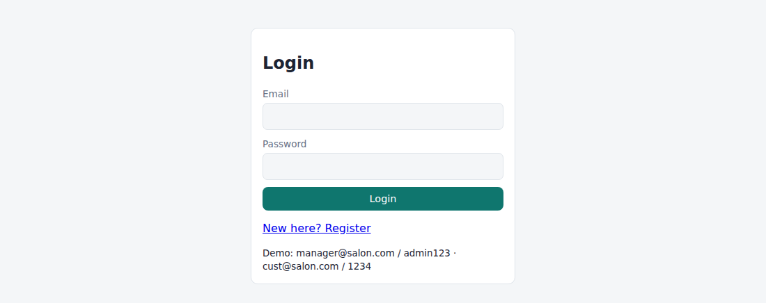
Fig. 7.1 – Login page
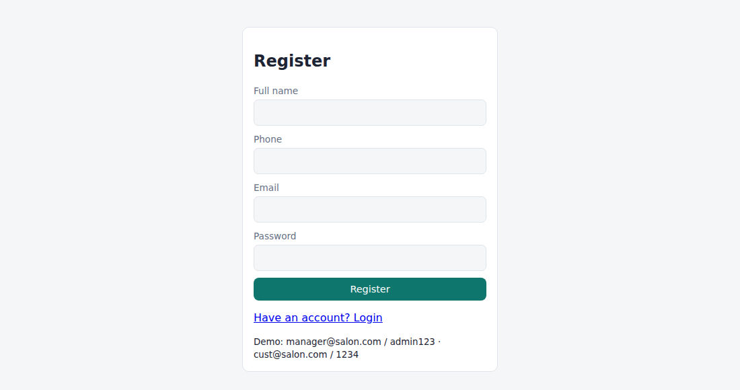
Fig. 7.2 – Registration page
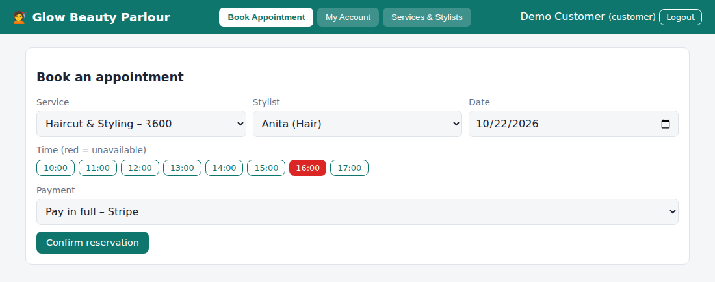
Fig. 7.3 – Customer – Book Appointment
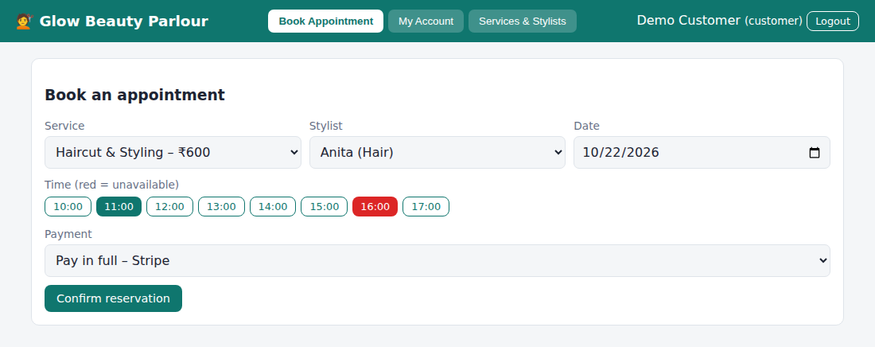
Fig. 7.4 – Customer – Book Appointment (time slot selected)
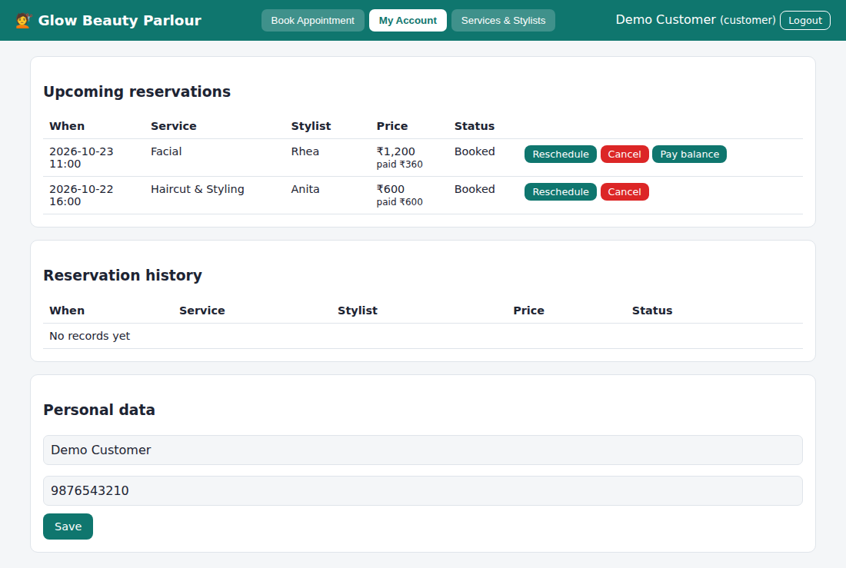
Fig. 7.5 – Customer – My Account
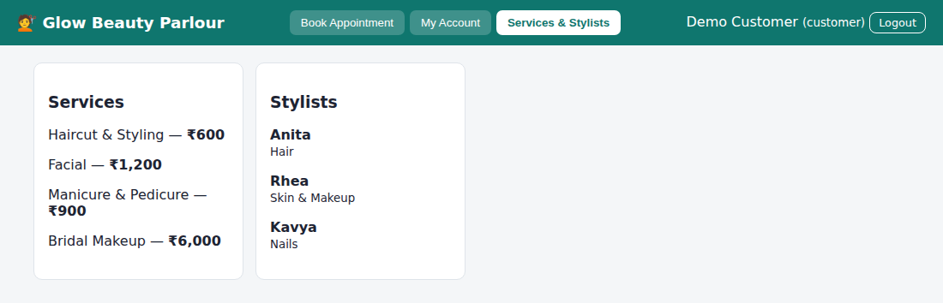
Fig. 7.6 – Customer – Services & Stylists
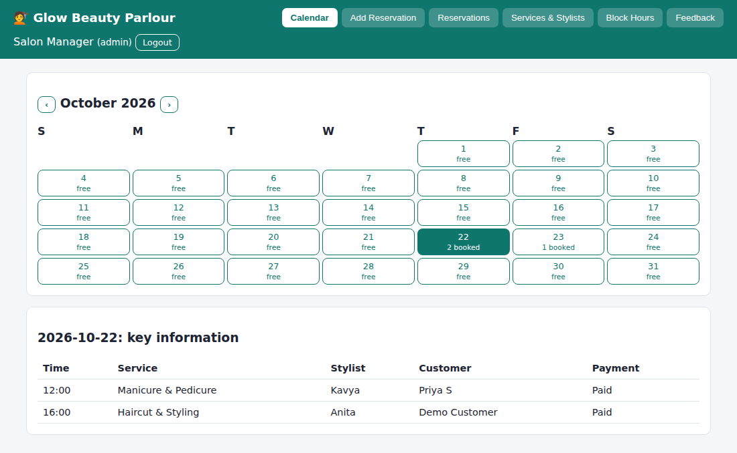
Fig. 7.7 – Manager – Calendar
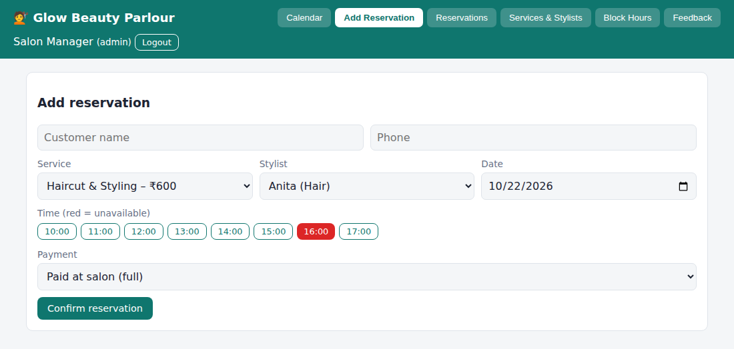
Fig. 7.8 – Manager – Add Reservation
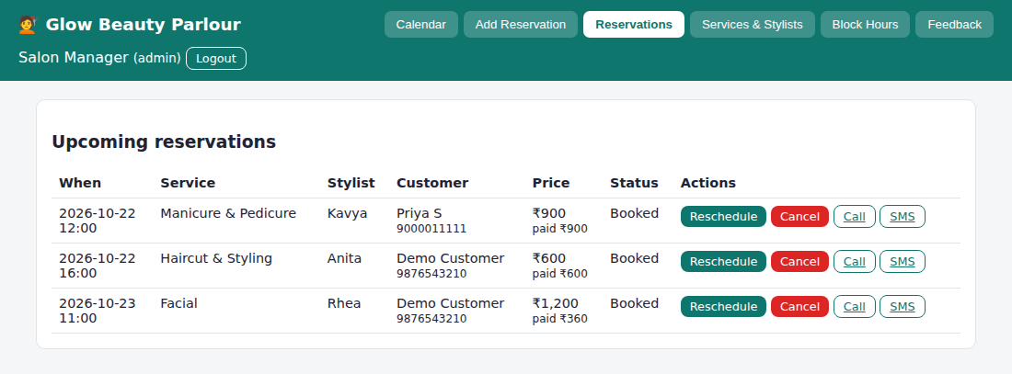
Fig. 7.9 – Manager – Reservations
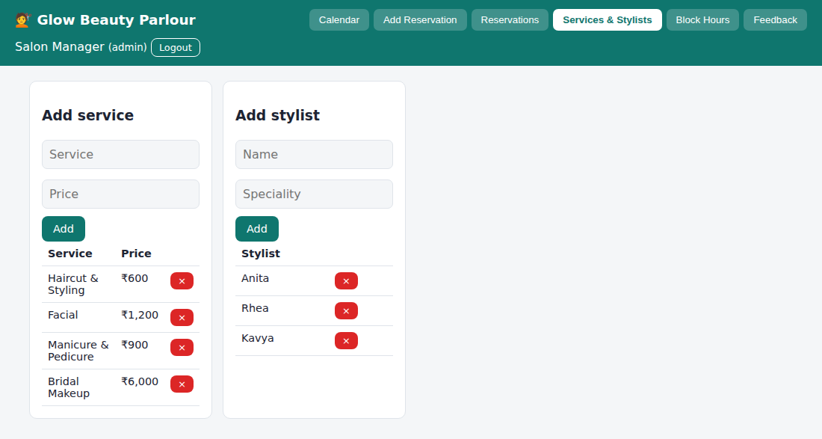
Fig. 7.10 – Manager – Services & Stylists
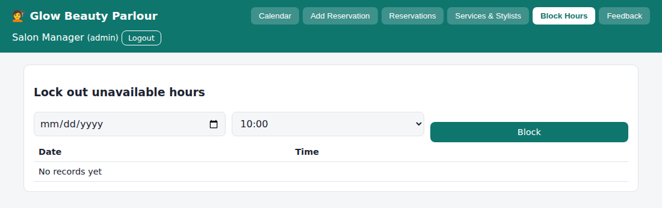
Fig. 7.11 – Manager – Block Hours
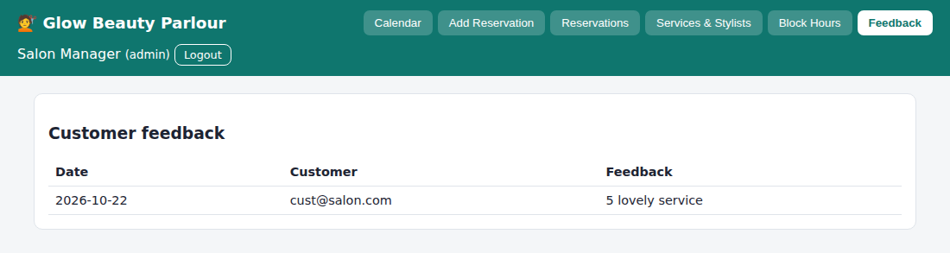
Fig. 7.12 – Manager – Feedback
RESULT
Thus the Beauty Parlour Appointment Booking website was designed and implemented successfully using HTML, CSS and JavaScript, and the output was verified.

Experiment No: 8
Name of the Experiment: Hospital Appointment Booking System
AIM
To develop a hospital appointment website in which patients search hospitals by location and specialty, view them on Google Maps, book appointments and review doctors, and hospitals manage details, doctors, appointments and statistics.
PROCEDURE
- Create a project folder and add the files index.html, style.css, common.js and app.js (hospital).
- In index.html create an empty container <div id="app"> and link the style sheet and the JavaScript files.
- In common.js write the shared helper functions: browser storage (localStorage), user registration, login, logout, table building and the page header with tabs.
- In app.js create the demo data: hospitals with location, address, phone and doctors with specialty and fee.
- Write the hospital screens: create and update hospital details and location, add doctors, manage appointments (approve, complete, cancel) and view statistics and ratings.
- Write the patient screens: search by location and specialty, view the hospital on Google Maps, book a doctor at a free time slot with a check-in form, view appointment status and cancel.
- Allow the patient to rate and review the doctor after the appointment is completed.
- Open index.html in a web browser and log in with the demo accounts to test every option.
- Observe the output, capture the screenshots and record the result.
CODE
index.html
<!DOCTYPE html><html lang="en"><head><meta charset="utf-8"><meta name="viewport" content="width=device-width,initial-scale=1"><title>8. Hospital Appointment Booking</title><link rel="stylesheet" href="style.css"></head><body data-ns="hosp_"><div id="app"></div><script src="common.js"></script><script src="app.js"></script></body></html>
app.js
Auth.seed([
{ name: "Demo Patient", email: "patient@hosp.com", password: "1234", role: "patient" },
{ name: "City Care Admin", email: "city@hosp.com", password: "1234", role: "hospital" },
{
name: "Green Valley Admin",
email: "green@hosp.com",
password: "1234",
role: "hospital",
},
]);
if (!DB.get("hs")) {
DB.set("ap", []);
DB.set("hs", [
{
owner: "city@hosp.com",
name: "City Care Hospital",
location: "Coimbatore",
address: "Avinashi Road, Coimbatore",
phone: "0422 2222222",
docs: [
{ id: "d1", name: "Dr. Ramesh", spec: "Cardiology", fee: 600 },
{ id: "d2", name: "Dr. Nisha", spec: "Dermatology", fee: 500 },
],
},
{
owner: "green@hosp.com",
name: "Green Valley Hospital",
location: "Chennai",
address: "Anna Nagar, Chennai",
phone: "044 3333333",
docs: [
{ id: "d3", name: "Dr. Arun", spec: "Orthopedics", fee: 700 },
{ id: "d4", name: "Dr. Lakshmi", spec: "Cardiology", fee: 650 },
],
},
]);
}
const HS = () => DB.get("hs", []),
AP = () => DB.get("ap", []),
SLOT = ["09:00", "10:00", "11:00", "12:00", "14:00", "15:00", "16:00"];
const myH = () => HS().find((h) => h.owner === Auth.me().email),
docOf = (id) => {
for (const h of HS()) {
const d = h.docs.find((x) => x.id === id);
if (d) return { ...d, h };
}
return null;
};
const rate = (id) => {
const r = AP().filter((a) => a.did === id && a.rating);
return r.length
? (r.reduce((s, a) => s + +a.rating, 0) / r.length).toFixed(1) + " ★ (" + r.length + ")"
: "No ratings";
};
const taken = (id, d, t, skip) =>
AP().some(
(a) =>
a.did === id &&
a.date === d &&
a.time === t &&
a.id !== skip &&
["Pending", "Approved"].includes(a.status),
);
function start() {
const me = Auth.me();
if (!me)
return mountAuth(
$("#app"),
{
regRoles: ["patient", "hospital"],
hint: "Demo: patient@hosp.com / 1234 · city@hosp.com / 1234 (hospital)",
},
start,
);
shell(
"🏥 MedFinder",
me.role === "hospital"
? {
"Hospital Details": detView,
Doctors: docView,
Appointments: apAdmin,
"Statistics & Ratings": statView,
}
: { Search: searchView, "My Appointments": myAp, Profile: profile },
me,
);
}
const map = (h) =>
`<iframe title="map" loading="lazy" style="width:100%;height:220px;border:0;border-radius:8px" src="https://www.google.com/maps?q=${encodeURIComponent(h.address + " " + h.location)}&output=embed"></iframe>`;
function searchView(m) {
m.innerHTML = `<div class="card"><div class="row"><input id="l" placeholder="Location (city)"><input id="s" placeholder="Specialty or doctor"></div></div><div id="g"></div><div id="sel"></div>`;
const d = () => {
const l = $("#l").value.toLowerCase(),
s = $("#s").value.toLowerCase();
$("#g").innerHTML =
HS()
.filter(
(h) =>
h.location.toLowerCase().includes(l) &&
(!s || h.docs.some((x) => (x.spec + x.name).toLowerCase().includes(s))),
)
.map(
(h) =>
`<div class="card"><h3>${esc(h.name)}</h3><p>📍 ${esc(h.address)} · ☎ ${esc(h.phone)}</p>${tbl(
["Doctor", "Specialty", "Fee", "Rating", ""],
h.docs
.filter((x) => !s || (x.spec + x.name).toLowerCase().includes(s))
.map((x) => [
esc(x.name),
esc(x.spec),
rs(x.fee),
rate(x.id),
`<button class="btn sm" onclick="bookForm('${x.id}')">Book</button>`,
]),
)}<details><summary>View map</summary>${map(h)}</details></div>`,
)
.join("") || '<div class="card">No hospitals found.</div>';
};
$("#l").oninput = $("#s").oninput = d;
d();
}
function bookForm(id) {
const x = docOf(id);
let T = "";
$("#sel").innerHTML =
`<div class="card"><h3>Book ${esc(x.name)} · ${esc(x.h.name)}</h3><form id="f"><div class="row"><div><label>Date</label><input type="date" name="date" min="${today()}" value="${today()}"></div><div><label>Age</label><input name="age" type="number" required></div></div><label>Time</label><div id="sl" style="display:flex;gap:6px;flex-wrap:wrap;margin:6px 0 12px"></div><textarea name="sym" placeholder="Check-in form: symptoms / reason for visit" required></textarea><button class="btn">Book appointment</button></form></div>`;
const draw = () => {
const d = $("#f").date.value;
T = "";
$("#sl").innerHTML = SLOT.map(
(t) =>
`<button type="button" class="btn sm ${taken(id, d, t) ? "red" : "sec"}" ${taken(id, d, t) ? "disabled" : ""}>${t}</button>`,
).join("");
$$("#sl button:not([disabled])").forEach(
(b) =>
(b.onclick = () => {
T = b.textContent;
$$("#sl button:not([disabled])").forEach((y) =>
y.classList.toggle("sec", y !== b),
);
}),
);
};
$("#f").onchange = draw;
draw();
$("#sel").scrollIntoView();
$("#f").onsubmit = (e) => {
const f = fd(e);
if (!T) return toast("Choose a time");
const a = AP();
a.push({
id: uid(),
patient: Auth.me().email,
pname: Auth.me().name,
hid: x.h.owner,
did: id,
date: f.date,
time: T,
age: f.age,
sym: f.sym,
status: "Pending",
});
DB.set("ap", a);
alert("Appointment requested. Reminder will be sent by email/SMS (simulated).");
refresh();
};
}
function myAp(m) {
m.innerHTML = `<div class="card"><h3>My appointments</h3>${tbl(
["Doctor", "Hospital", "When", "Status", "Past visit", ""],
AP()
.filter((a) => a.patient === Auth.me().email)
.reverse()
.map((a) => {
const d = docOf(a.did) || { name: "(removed)", h: { name: "" } };
return [
esc(d.name),
esc(d.h.name),
a.date + " " + a.time,
a.status,
esc(a.sym),
["Pending", "Approved"].includes(a.status)
? `<button class="btn sm red" onclick="setAp('${a.id}','Cancelled')">Cancel</button>`
: a.status === "Completed" && !a.rating
? `<button class="btn sm" onclick="review('${a.id}')">Rate doctor</button>`
: a.rating
? a.rating + " ★"
: "",
];
}),
)}</div>`;
}
function review(id) {
const r = prompt("Rating 1-5"),
t = prompt("Write a short review");
if (!(+r >= 1 && +r <= 5)) return toast("Enter 1-5");
const a = AP(),
x = a.find((y) => y.id === id);
x.rating = +r;
x.review = t || "";
DB.set("ap", a);
refresh();
}
function setAp(id, s) {
const a = AP();
a.find((x) => x.id === id).status = s;
DB.set("ap", a);
refresh();
}
function profile(m) {
const u = Auth.me();
m.innerHTML = `<div class="card"><h3>Profile</h3><form id="f"><input name="name" value="${esc(u.name)}"><input value="${esc(u.email)}" disabled><button class="btn">Save</button></form></div>`;
$("#f").onsubmit = (e) => {
Auth.save({ ...u, ...fd(e) });
toast("Saved");
};
}
function detView(m) {
const h = myH() || { name: "", location: "", address: "", phone: "" };
m.innerHTML = `<div class="card"><h3>${myH() ? "Update" : "Create"} hospital details</h3><form id="f"><input name="name" placeholder="Hospital name" value="${esc(h.name)}" required><input name="location" placeholder="Location / city" value="${esc(h.location)}" required><input name="address" placeholder="Full address (used for Google Map)" value="${esc(h.address)}" required><input name="phone" placeholder="Phone" value="${esc(h.phone)}"><button class="btn">Save details</button></form>${myH() ? map(h) : ""}</div>`;
$("#f").onsubmit = (e) => {
const f = fd(e),
l = HS(),
x = l.find((y) => y.owner === Auth.me().email);
if (x) Object.assign(x, f);
else l.push({ owner: Auth.me().email, ...f, docs: [] });
DB.set("hs", l);
toast("Saved");
refresh();
};
}
function docView(m) {
const h = myH();
if (!h)
return (m.innerHTML = '<div class="card">Create your hospital details first.</div>');
m.innerHTML = `<div class="card"><h3>Add doctor</h3><form id="f" class="row"><input name="name" placeholder="Doctor name" required><input name="spec" placeholder="Specialty" required><input name="fee" type="number" placeholder="Fee" required><button class="btn">Add</button></form>${tbl(
["Doctor", "Specialty", "Fee", "Rating", ""],
h.docs.map((d) => [
esc(d.name),
esc(d.spec),
rs(d.fee),
rate(d.id),
`<button class="btn sm red" onclick="delDoc('${d.id}')">Remove</button>`,
]),
)}</div>`;
$("#f").onsubmit = (e) => {
const f = fd(e),
l = HS();
l.find((x) => x.owner === h.owner).docs.push({ id: uid(), ...f, fee: +f.fee });
DB.set("hs", l);
refresh();
};
}
function delDoc(id) {
const l = HS();
const h = l.find((x) => x.owner === Auth.me().email);
h.docs = h.docs.filter((d) => d.id !== id);
DB.set("hs", l);
refresh();
}
function apAdmin(m) {
m.innerHTML = `<div class="card"><h3>Manage appointments</h3>${tbl(
["Patient", "Doctor", "When", "Check-in details", "Status", "Update"],
AP()
.filter((a) => a.hid === Auth.me().email)
.reverse()
.map((a) => [
esc(a.pname),
esc((docOf(a.did) || {}).name || "-"),
a.date + " " + a.time,
"Age " + a.age + "<br>" + esc(a.sym),
a.status,
`<select onchange="setAp('${a.id}',this.value)">${["Pending", "Approved", "Rejected", "Completed", "Cancelled"].map((s) => `<option${s === a.status ? " selected" : ""}>${s}</option>`).join("")}</select>`,
]),
)}</div>`;
}
function statView(m) {
const a = AP().filter((x) => x.hid === Auth.me().email),
h = myH() || { docs: [] };
m.innerHTML = `<div class="grid">${["Pending", "Approved", "Completed", "Cancelled"].map((s) => `<div class="card"><small>${s}</small><p class="big">${a.filter((x) => x.status === s).length}</p></div>`).join("")}</div><br><div class="card"><h3>Ratings & reviews</h3>${tbl(
["Doctor", "Rating", "Reviews"],
h.docs.map((d) => [
esc(d.name),
rate(d.id),
a
.filter((x) => x.did === d.id && x.review)
.map((x) => "“" + esc(x.review) + "”")
.join("<br>") || "-",
]),
)}</div>`;
}
start();
Common files (common.js, style.css) are listed in the Appendix.

OUTPUT
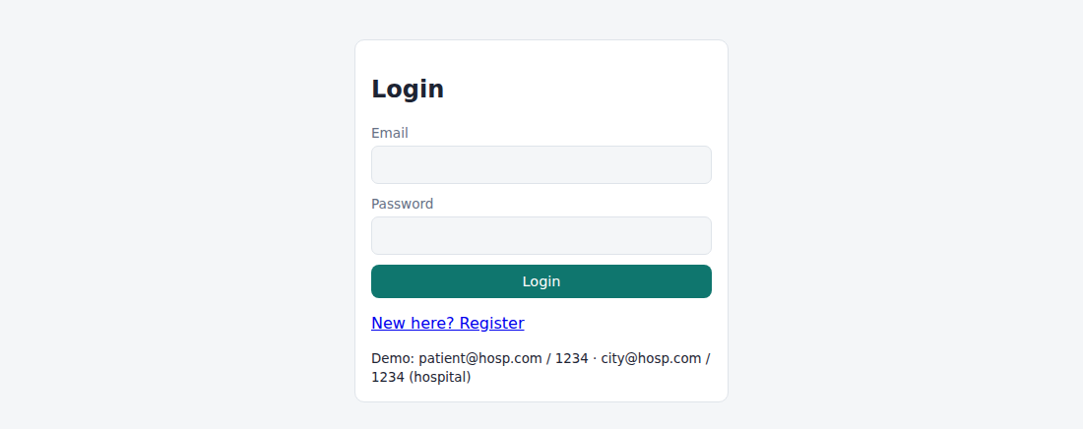
Fig. 8.1 – Login page
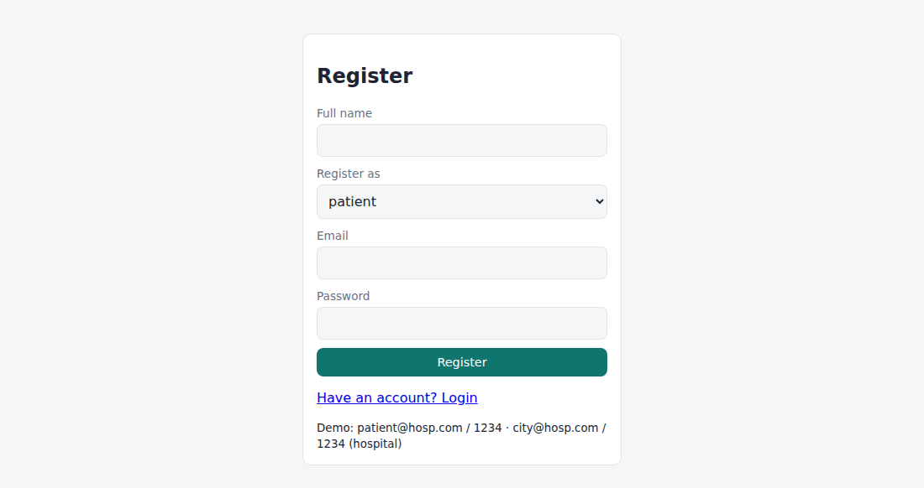
Fig. 8.2 – Registration page
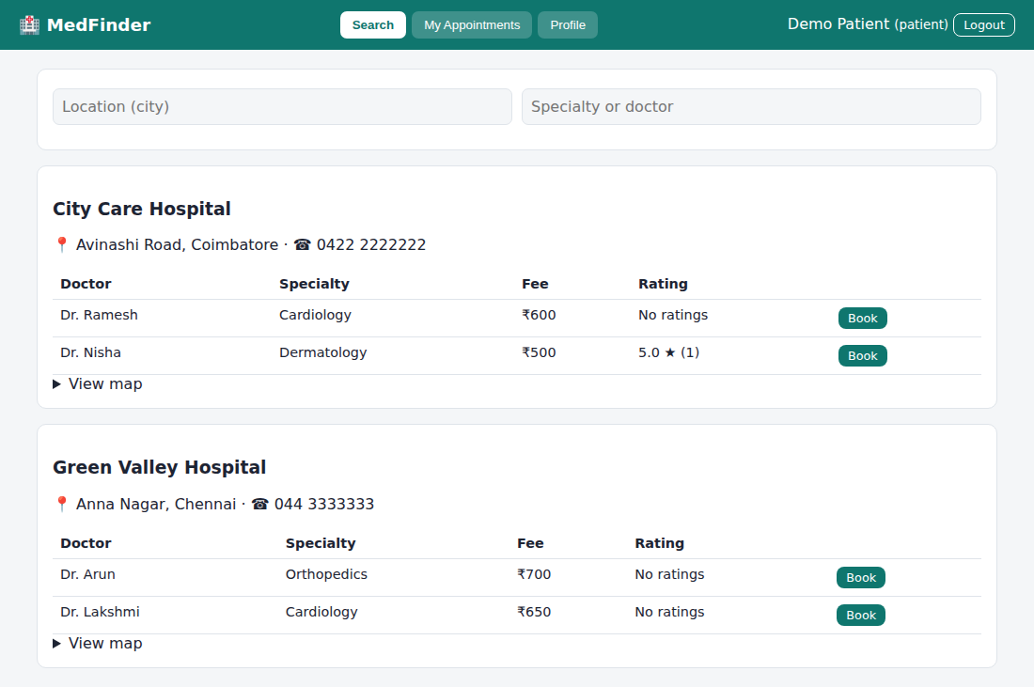
Fig. 8.3 – Patient – Search
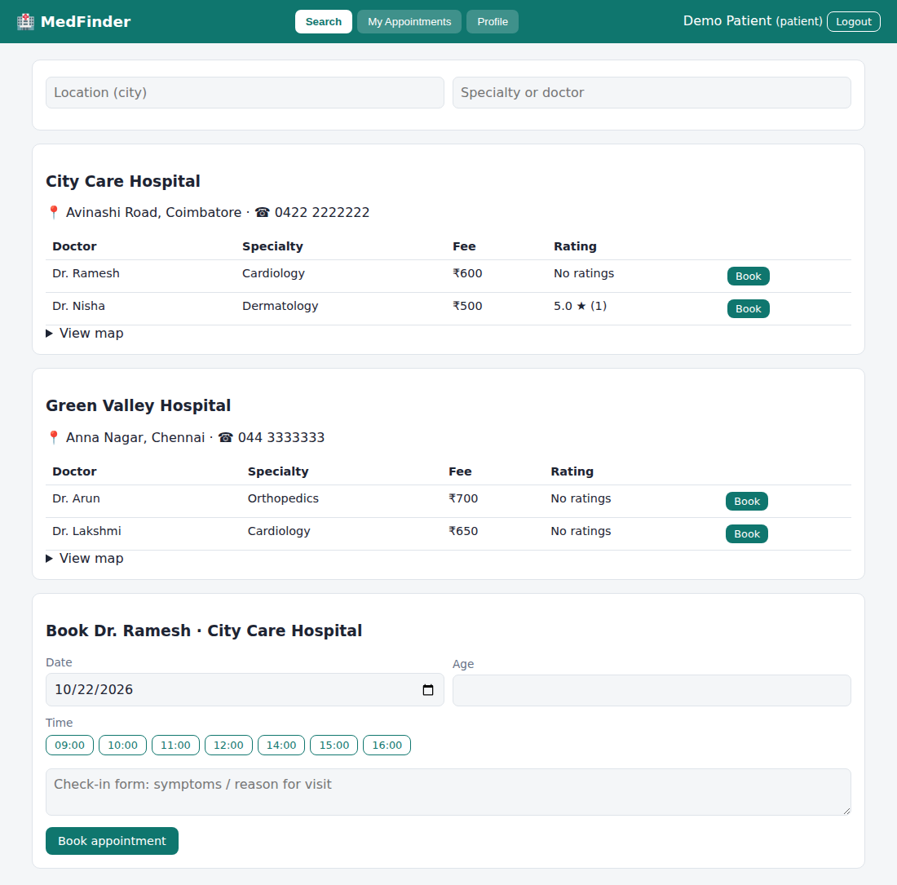
Fig. 8.4 – Patient – appointment booking form
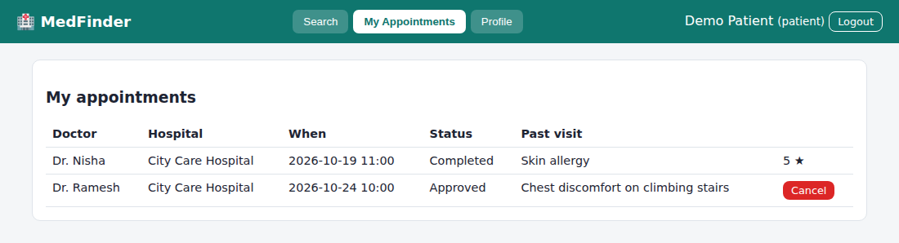
Fig. 8.5 – Patient – My Appointments
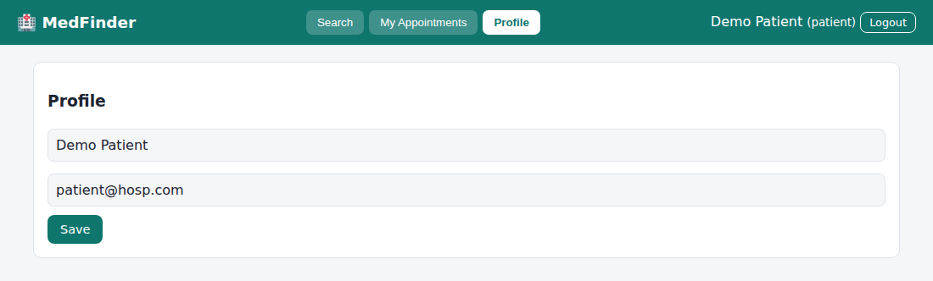
Fig. 8.6 – Patient – Profile
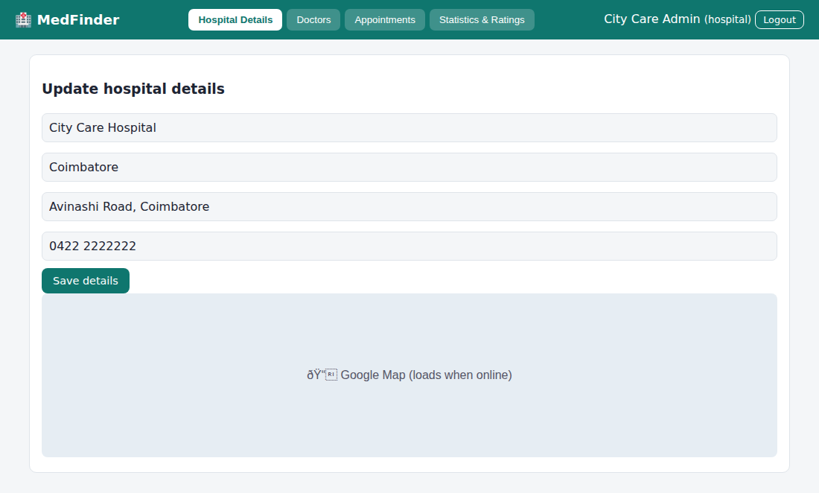
Fig. 8.7 – Hospital – Hospital Details
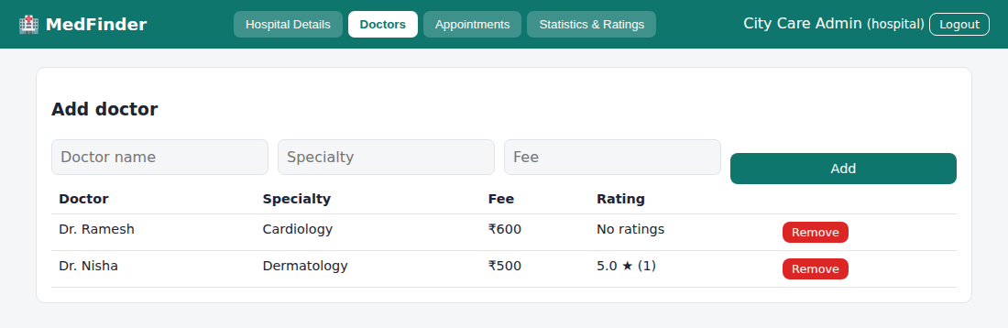
Fig. 8.8 – Hospital – Doctors
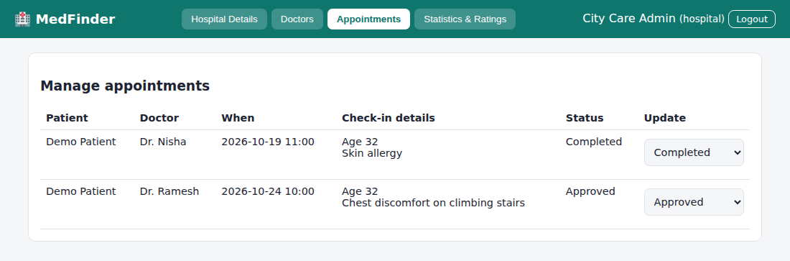
Fig. 8.9 – Hospital – Appointments
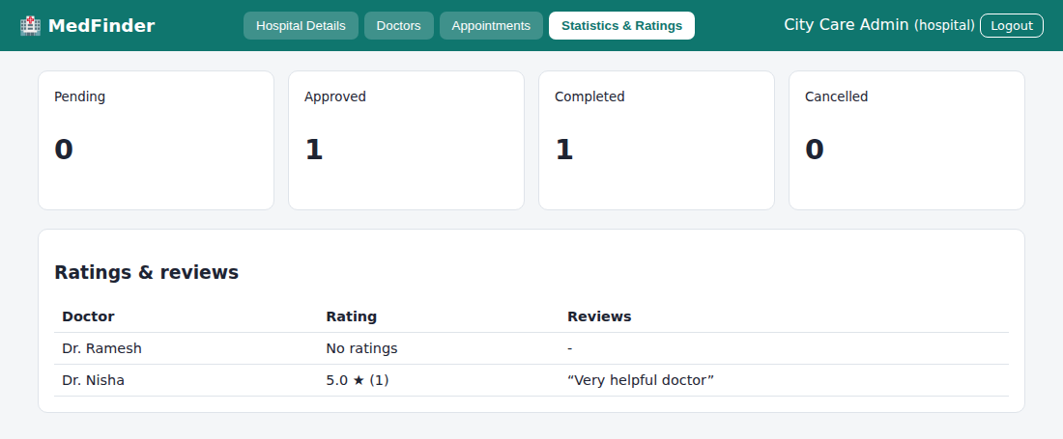
Fig. 8.10 – Hospital – Statistics & Ratings
RESULT
Thus the Hospital Appointment Booking System website was designed and implemented successfully using HTML, CSS and JavaScript, and the output was verified.

Experiment No: 9
Name of the Experiment: TechSavvy Online Shopping Platform
AIM
To develop an electronic gadgets shopping website with categories and sub-categories, search, availability check, cart, wishlist, reviews, checkout, order tracking and an admin panel to add or remove items, change prices and descriptions and view customer orders.
PROCEDURE
- Create a project folder and add the files index.html, style.css, common.js and app.js (shop).
- In index.html create an empty container <div id="app"> and link the style sheet and the JavaScript files.
- In common.js write the shared helper functions: browser storage (localStorage), user registration, login, logout, table building and the page header with tabs.
- In app.js create the demo data: products with category, sub-category, price, stock, description and sales count.
- Write the home page that lists the categories (most popular first) with their sub-categories, product search, availability check, product details and customer reviews.
- Write the wishlist, the shopping cart (add, edit quantity, remove) and the checkout with address, payment method and the promo code TECH10, then the order status and history pages.
- Write the admin screens: add and remove items, change price and description, update stock, and view customer information and orders.
- Open index.html in a web browser and log in with the demo accounts to test every option.
- Observe the output, capture the screenshots and record the result.
CODE
index.html
<!DOCTYPE html><html lang="en"><head><meta charset="utf-8"><meta name="viewport" content="width=device-width,initial-scale=1"><title>9. TechSavvy Online Shop</title><link rel="stylesheet" href="style.css"></head><body data-ns="tech_"><div id="app"></div><script src="common.js"></script><script src="app.js"></script></body></html>
app.js
Auth.seed([
{ name: "Shop Admin", email: "admin@tech.com", password: "admin123", role: "admin" },
{ name: "Demo Customer", email: "cust@tech.com", password: "1234", role: "customer" },
]);
if (!DB.get("prod")) {
DB.set("orders", []);
DB.set("prod", [
{
id: "p1",
name: "Nova X Phone",
cat: "Smartphones",
sub: "Android",
price: 24999,
stock: 15,
sold: 40,
img: "📱",
desc: '6.5" AMOLED, 128 GB, 50 MP camera.',
rev: [],
},
{
id: "p2",
name: "iStar 15",
cat: "Smartphones",
sub: "iOS",
price: 69999,
stock: 6,
sold: 25,
img: "📱",
desc: "Premium phone with 256 GB storage.",
rev: [],
},
{
id: "p3",
name: "ProBook Air",
cat: "Laptops",
sub: "Ultrabook",
price: 64999,
stock: 8,
sold: 30,
img: "💻",
desc: '14" display, 16 GB RAM, 512 GB SSD.',
rev: [],
},
{
id: "p4",
name: "Titan G5",
cat: "Laptops",
sub: "Gaming",
price: 94999,
stock: 4,
sold: 12,
img: "🎮",
desc: "RTX graphics, 144 Hz screen.",
rev: [],
},
{
id: "p5",
name: "TabLite 10",
cat: "Tablets",
sub: "Android",
price: 15999,
stock: 20,
sold: 18,
img: "📲",
desc: '10" tablet for study and streaming.',
rev: [],
},
{
id: "p6",
name: "BassBuds Pro",
cat: "Accessories",
sub: "Audio",
price: 2999,
stock: 50,
sold: 60,
img: "🎧",
desc: "Wireless earbuds, 30 h battery.",
rev: [],
},
{
id: "p7",
name: "Fast Charger 65W",
cat: "Accessories",
sub: "Chargers",
price: 1499,
stock: 0,
sold: 22,
img: "🔌",
desc: "GaN charger with two ports.",
rev: [],
},
]);
}
const P = () => DB.get("prod", []),
O = () => DB.get("orders", []),
ck = () => "cart_" + Auth.me().email,
wk = () => "wish_" + Auth.me().email,
CT = () => DB.get(ck(), []),
WL = () => DB.get(wk(), []);
let FC = "",
FS = "";
const pop = (c) =>
P()
.filter((p) => p.cat === c)
.reduce((s, p) => s + p.sold, 0);
function start() {
const me = Auth.me();
if (!me)
return mountAuth(
$("#app"),
{
regRoles: ["customer"],
hint: "Demo: admin@tech.com / admin123 · cust@tech.com / 1234. Promo code: TECH10",
},
start,
);
shell(
"🛒 TechSavvy",
me.role === "admin"
? { Products: prodAdmin, Orders: ordAdmin }
: { Home: home, Wishlist: wishView, Cart: cartView, Orders: myOrders },
me,
);
}
function home(m) {
const cats = [...new Set(P().map((p) => p.cat))].sort((a, b) => pop(b) - pop(a));
const hist = O()
.filter((o) => o.user === Auth.me().email)
.flatMap((o) => o.items.map((i) => i.cat)),
fav = hist.sort(
(a, b) => hist.filter((x) => x === b).length - hist.filter((x) => x === a).length,
)[0];
m.innerHTML = `<div class="card"><input id="q" placeholder="Search products…"><div>${cats
.map(
(c) =>
`<div style="margin:6px 0"><b>${c}</b> ${[
...new Set(
P()
.filter((p) => p.cat === c)
.map((p) => p.sub),
),
]
.map(
(s) =>
`<button class="btn sm sec" onclick="FC='${c}';FS='${s}';refresh()">${s}</button>`,
)
.join(" ")}</div>`,
)
.join(
"",
)}<button class="btn sm" onclick="FC='';FS='';refresh()">Show all</button> ${FC ? '<span class="tag">' + FC + (FS ? " / " + FS : "") + "</span>" : ""}</div></div>${fav && !FC ? `<p>⭐ Recommended for you (based on your purchases: ${fav})</p>` : ""}<div class="grid" id="g"></div><div id="det"></div>`;
const d = () => {
const q = $("#q").value.toLowerCase();
$("#g").innerHTML =
P()
.filter(
(p) =>
(!FC || p.cat === FC) &&
(!FS || p.sub === FS) &&
p.name.toLowerCase().includes(q),
)
.sort((a, b) => (b.cat === fav) - (a.cat === fav) || b.sold - a.sold)
.map(
(p) =>
`<div class="card"><div style="font-size:60px;text-align:center">${p.img}</div><h4>${esc(p.name)}</h4><span class="tag">${p.cat} / ${p.sub}</span><p><b>${rs(p.price)}</b><br>${p.stock > 0 ? '<span class="ok">In stock (' + p.stock + ")</span>" : '<span class="bad">Out of stock</span>'}</p><button class="btn sm sec" onclick="detail('${p.id}')">Details</button> <button class="btn sm" ${p.stock ? "" : "disabled"} onclick="addCart('${p.id}')">Add to cart</button></div>`,
)
.join("") || "<p>No products found.</p>";
};
$("#q").oninput = d;
d();
}
function detail(id) {
const p = P().find((x) => x.id === id);
$("#det").innerHTML =
`<div class="card"><h3>${esc(p.name)} ${rs(p.price)}</h3><p>${esc(p.desc)}</p><button class="btn sm" onclick="wish('${id}')">♡ Wishlist</button><h4>Reviews</h4>${p.rev.map((r) => `<p><b>${esc(r.u)}</b> ${"★".repeat(r.r)}<br>${esc(r.t)}</p>`).join("") || "<p>No reviews yet.</p>"}<form id="rf" class="row"><select name="r">${opt([5, 4, 3, 2, 1])}</select><input name="t" placeholder="Write a review" required><button class="btn sm">Post</button></form></div>`;
$("#det").scrollIntoView();
$("#rf").onsubmit = (e) => {
const f = fd(e),
l = P();
l.find((x) => x.id === id).rev.push({ u: Auth.me().name, r: +f.r, t: f.t });
DB.set("prod", l);
detail(id);
};
}
function wish(id) {
const w = WL();
if (!w.includes(id)) w.push(id);
DB.set(wk(), w);
toast("Saved to wishlist");
}
function wishView(m) {
m.innerHTML = `<div class="card"><h3>Wishlist</h3>${tbl(
["Item", "Price", ""],
WL()
.map((id) => P().find((p) => p.id === id))
.filter(Boolean)
.map((p) => [
esc(p.name),
rs(p.price),
`<button class="btn sm" onclick="addCart('${p.id}')">Add to cart</button> <button class="btn sm red" onclick="unwish('${p.id}')">Remove</button>`,
]),
)}</div>`;
}
function unwish(id) {
DB.set(
wk(),
WL().filter((x) => x !== id),
);
refresh();
}
function addCart(id) {
const c = CT(),
x = c.find((i) => i.id === id);
if (x) x.q++;
else c.push({ id, q: 1 });
DB.set(ck(), c);
toast("Added to cart");
}
function cartView(m) {
const c = CT(),
rows = c
.map((i, n) => ({ i, n, p: P().find((p) => p.id === i.id) }))
.filter((r) => r.p);
let sub = rows.reduce((s, r) => s + r.p.price * r.i.q, 0);
m.innerHTML = `<div class="card"><h3>Shopping cart</h3>${tbl(
["Item", "Price", "Qty", "Total", ""],
rows.map((r) => [
esc(r.p.name),
rs(r.p.price),
`<input type="number" min="1" max="${r.p.stock}" value="${r.i.q}" style="width:70px" onchange="setQ(${r.n},this.value)">`,
rs(r.p.price * r.i.q),
`<button class="btn sm red" onclick="rmCart(${r.n})">Remove</button>`,
]),
)}<p class="big">Subtotal ${rs(sub)}</p></div>${rows.length ? `<div class="card"><h3>Checkout</h3><form id="f"><div class="row"><input name="name" placeholder="Name" value="${esc(Auth.me().name)}" required><input name="phone" placeholder="Phone" required></div><textarea name="addr" placeholder="Shipping address" required></textarea><div class="row"><input name="promo" placeholder="Promo code (TECH10)"><select name="pay">${opt(["Card", "UPI", "Net banking", "Cash on delivery"])}</select></div><button class="btn">Place order</button></form></div>` : ""}`;
if (rows.length)
$("#f").onsubmit = (e) => {
const f = fd(e),
disc = f.promo.toUpperCase() === "TECH10" ? Math.round(sub * 0.1) : 0,
l = P();
if (rows.some((r) => r.i.q > r.p.stock))
return toast("Some items exceed available stock");
rows.forEach((r) => {
const p = l.find((x) => x.id === r.p.id);
p.stock -= r.i.q;
p.sold += r.i.q;
});
DB.set("prod", l);
const o = O();
o.push({
id: uid(),
user: Auth.me().email,
items: rows.map((r) => ({
name: r.p.name,
cat: r.p.cat,
q: r.i.q,
price: r.p.price,
})),
total: sub - disc,
disc,
ship: f,
pay: f.pay,
status: "Processing",
date: today(),
});
DB.set("orders", o);
DB.set(ck(), []);
alert("Order placed! Confirmation sent (simulated).");
refresh();
};
}
function setQ(n, v) {
const c = CT();
c[n].q = Math.max(1, +v || 1);
DB.set(ck(), c);
refresh();
}
function rmCart(n) {
const c = CT();
c.splice(n, 1);
DB.set(ck(), c);
refresh();
}
const its = (o) => o.items.map((i) => esc(i.name) + " ×" + i.q).join("<br>");
function myOrders(m) {
m.innerHTML = `<div class="card"><h3>Order history & status</h3>${tbl(
["Order", "Date", "Items", "Total", "Status"],
O()
.filter((o) => o.user === Auth.me().email)
.reverse()
.map((o) => [
o.id.slice(-5),
o.date,
its(o),
rs(o.total) + (o.disc ? "<br><small>discount " + rs(o.disc) + "</small>" : ""),
"<b>" + o.status + "</b>",
]),
)}</div>`;
}
function prodAdmin(m) {
m.innerHTML = `<div class="card"><h3>Add item</h3><form id="f"><div class="row"><input name="name" placeholder="Name" required><input name="cat" placeholder="Category" required><input name="sub" placeholder="Sub category" required></div><div class="row"><input name="price" type="number" placeholder="Price" required><input name="stock" type="number" placeholder="Stock" required><input name="img" placeholder="Emoji" value="📦"></div><textarea name="desc" placeholder="Description"></textarea><button class="btn">Add item</button></form></div><div class="card">${tbl(
["Item", "Category", "Price", "Stock", ""],
P().map((p) => [
esc(p.name),
p.cat + " / " + p.sub,
rs(p.price),
p.stock,
`<button class="btn sm" onclick="editP('${p.id}')">Price / description</button> <button class="btn sm red" onclick="delP('${p.id}')">Remove</button>`,
]),
)}</div>`;
$("#f").onsubmit = (e) => {
const f = fd(e),
l = P();
l.push({ id: uid(), ...f, price: +f.price, stock: +f.stock, sold: 0, rev: [] });
DB.set("prod", l);
refresh();
};
}
function editP(id) {
const l = P(),
p = l.find((x) => x.id === id);
p.price = +prompt("New price", p.price) || p.price;
p.desc = prompt("Description", p.desc) ?? p.desc;
p.stock = +prompt("Stock", p.stock);
DB.set("prod", l);
refresh();
}
function delP(id) {
if (confirm("Remove item?")) {
DB.set(
"prod",
P().filter((p) => p.id !== id),
);
refresh();
}
}
function ordAdmin(m) {
m.innerHTML = `<div class="card"><h3>Orders & customer information</h3>${tbl(
["Order", "Customer", "Items", "Total", "Status"],
O()
.slice()
.reverse()
.map((o) => [
o.id.slice(-5),
esc(o.ship.name) +
"<br>" +
esc(o.ship.phone) +
"<br><small>" +
esc(o.ship.addr) +
"</small>",
its(o),
rs(o.total),
`<select onchange="setO('${o.id}',this.value)">${["Processing", "Shipped", "Delivered"].map((s) => `<option${s === o.status ? " selected" : ""}>${s}</option>`).join("")}</select>`,
]),
)}</div>`;
}
function setO(id, s) {
const o = O();
o.find((x) => x.id === id).status = s;
DB.set("orders", o);
toast("Updated");
}
start();
Common files (common.js, style.css) are listed in the Appendix.

OUTPUT
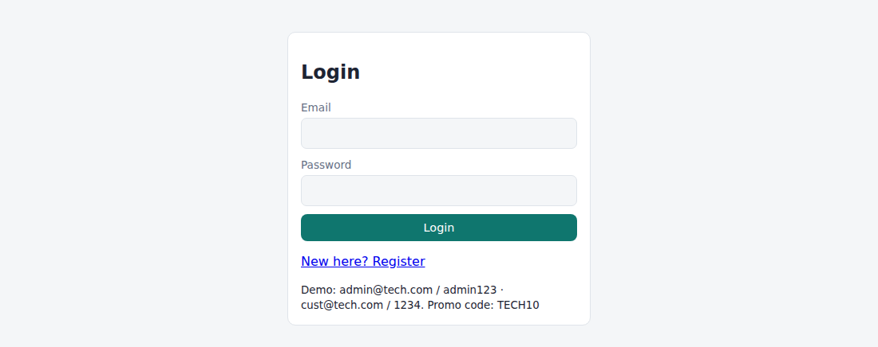
Fig. 9.1 – Login page
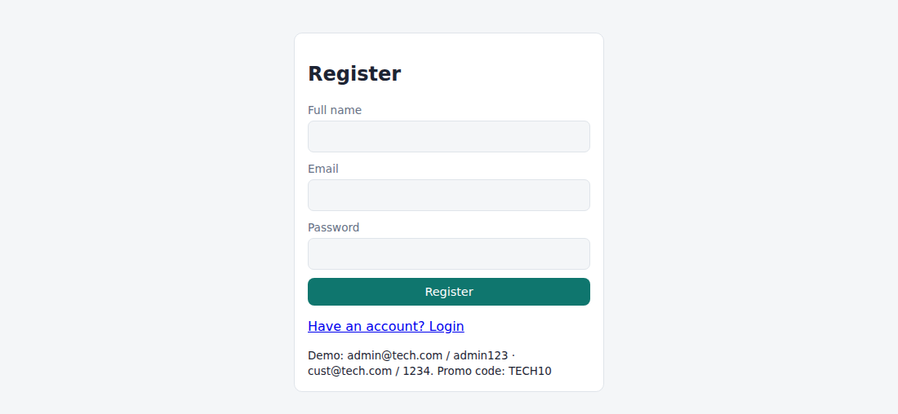
Fig. 9.2 – Registration page
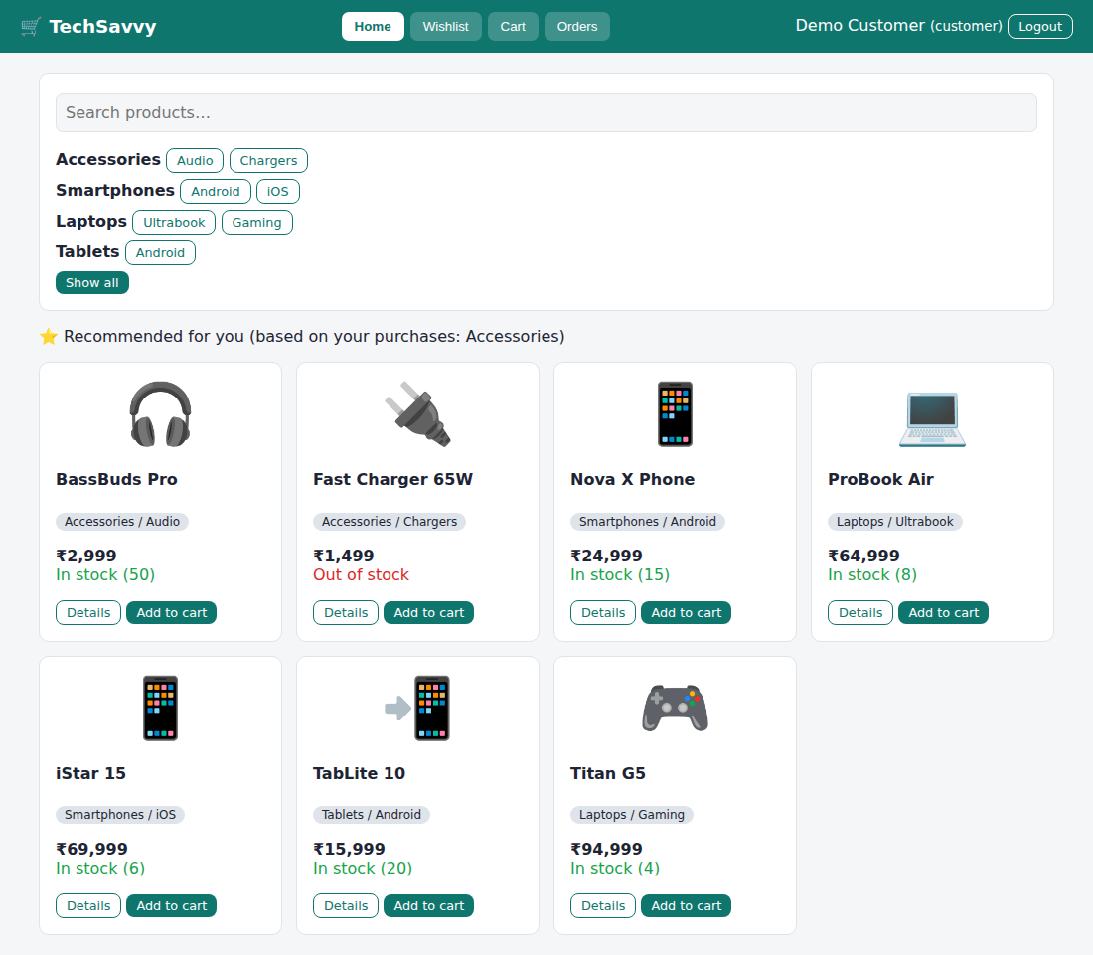
Fig. 9.3 – Customer – Home
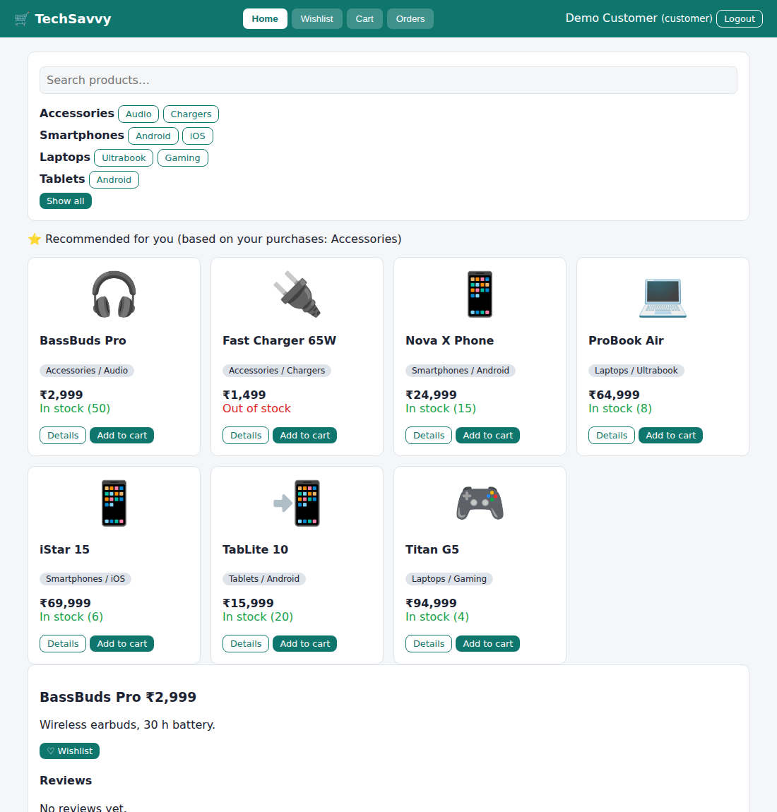
Fig. 9.4 – Customer – product details and reviews
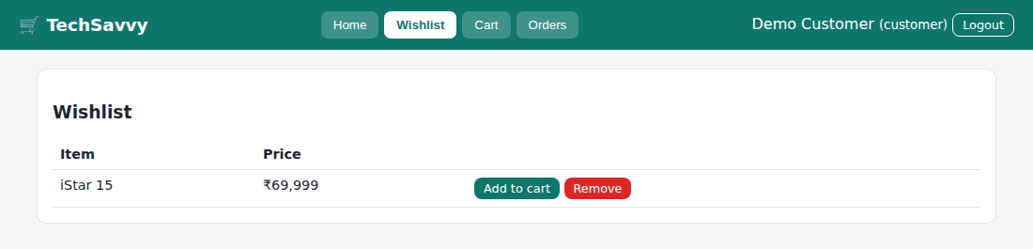
Fig. 9.5 – Customer – Wishlist
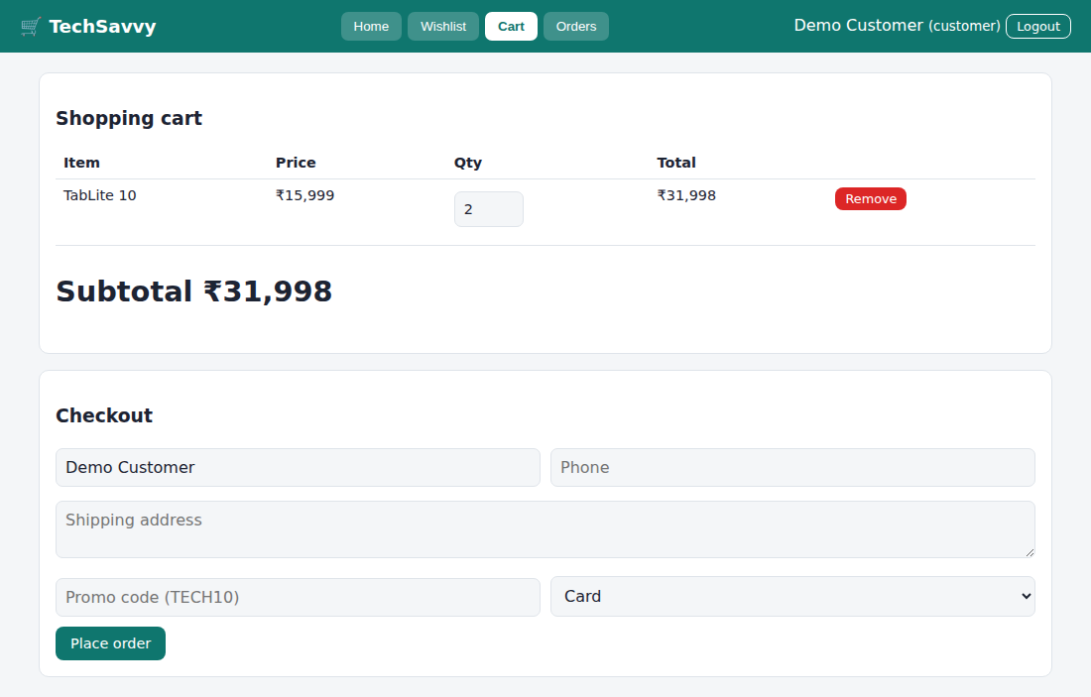
Fig. 9.6 – Customer – Cart
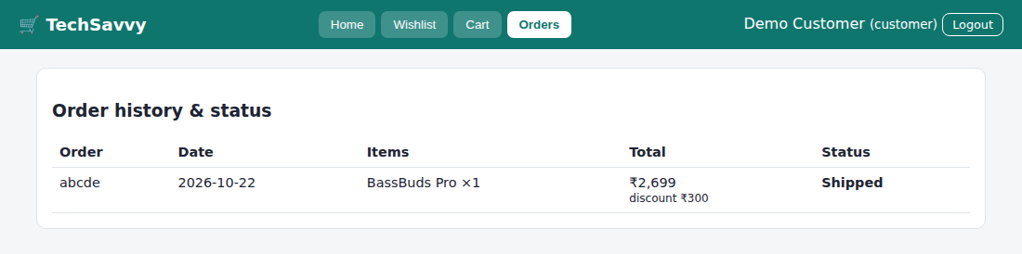
Fig. 9.7 – Customer – Orders
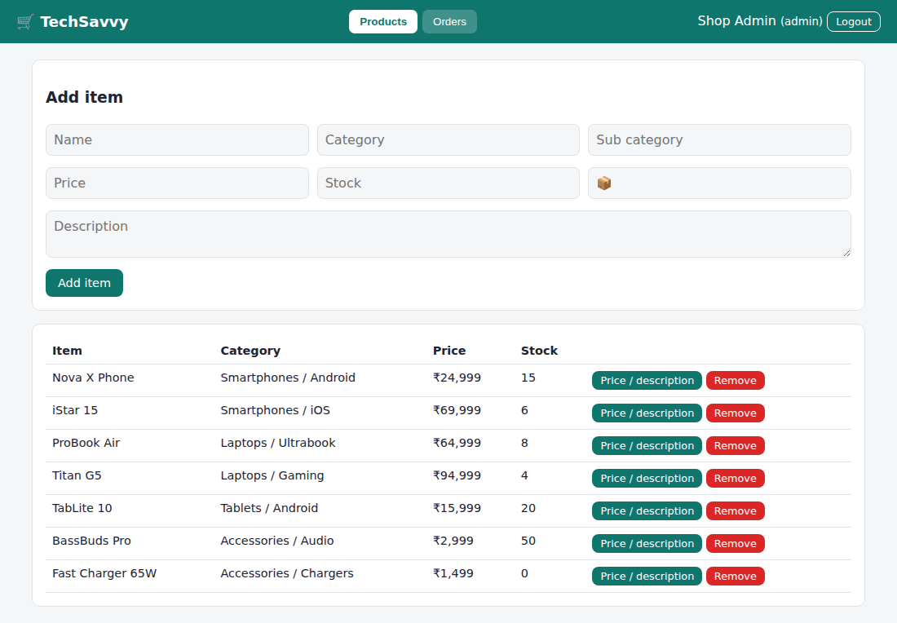
Fig. 9.8 – Admin – Products
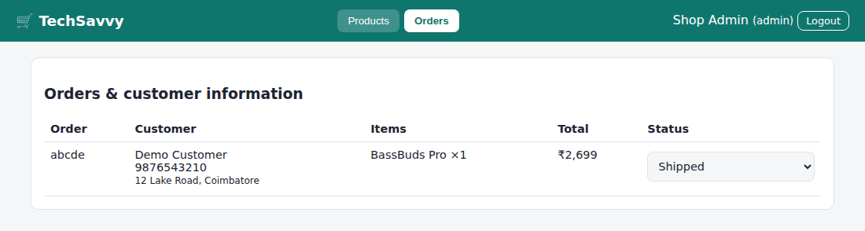
Fig. 9.9 – Admin – Orders
RESULT
Thus the TechSavvy Online Shopping Platform website was designed and implemented successfully using HTML, CSS and JavaScript, and the output was verified.

Appendix – Common files used by Experiments 1 to 9
common.js
/* Shared helpers: storage, auth (demo, localStorage), layout */
const NS = document.body.dataset.ns || "app_";
const DB = {
get(k, d) {
try {
const v = JSON.parse(localStorage.getItem(NS + k));
return v == null ? d : v;
} catch (e) {
return d;
}
},
set(k, v) {
localStorage.setItem(NS + k, JSON.stringify(v));
},
del(k) {
localStorage.removeItem(NS + k);
},
};
const $ = (s, r = document) => r.querySelector(s),
$$ = (s, r = document) => [...r.querySelectorAll(s)];
const uid = () => Date.now().toString(36) + Math.random().toString(36).slice(2, 6);
const esc = (s) =>
String(s ?? "").replace(
/[&<>"']/g,
(c) => ({ "&": "&amp;", "<": "&lt;", ">": "&gt;", '"': "&quot;", "'": "&#39;" })[c],
);
const ymd = (d) =>
new Date(d.getTime() - d.getTimezoneOffset() * 6e4).toISOString().slice(0, 10);
const today = () => ymd(new Date());
const addDays = (s, n) => {
const x = new Date(s + "T00:00:00");
x.setDate(x.getDate() + n);
return ymd(x);
};
const diffDays = (a, b) =>
Math.round((new Date(b + "T00:00:00") - new Date(a + "T00:00:00")) / 864e5);
const fd = (e) => {
e.preventDefault();
return Object.fromEntries(new FormData(e.target));
};
const opt = (a, all) =>
(all != null ? `<option value="">${all}</option>` : "") +
a.map((x) => `<option>${esc(x)}</option>`).join("");
const tbl = (h, r) =>
`<div class="tblwrap"><table><tr>${h.map((x) => `<th>${x}</th>`).join("")}</tr>${r.length ? r.map((c) => `<tr>${c.map((x) => `<td>${x}</td>`).join("")}</tr>`).join("") : `<tr><td colspan="${h.length}">No records yet</td></tr>`}</table></div>`;
const rs = (n) => "₹" + Number(n).toLocaleString("en-IN", { maximumFractionDigits: 2 });
function toast(m) {
const t = document.createElement("div");
t.className = "toast";
t.textContent = m;
document.body.append(t);
setTimeout(() => t.remove(), 2300);
}
function download(name, text) {
const a = document.createElement("a");
a.href = URL.createObjectURL(new Blob([text], { type: "text/plain" }));
a.download = name;
a.click();
}
const Auth = {
users: () => DB.get("users", []),
seed(l) {
if (!DB.get("seeded")) {
DB.set("users", l);
DB.set("seeded", 1);
}
},
me() {
const e = DB.get("session");
return Auth.users().find((u) => u.email === e) || null;
},
save(u) {
DB.set(
"users",
Auth.users().map((x) => (x.email === u.email ? u : x)),
);
},
logout() {
DB.del("session");
location.reload();
},
};
function mountAuth(el, o, cb) {
o = o || {};
const rr = o.regRoles || ["user"];
el.innerHTML = `<div class="card auth"><h2 id="at">${o.title || "Login"}</h2><form id="af"><div class="rg hide"><label>Full name</label><input name="name">${rr.length > 1 ? `<label>Register as</label><select name="role">${opt(rr)}</select>` : `<input type="hidden" name="role" value="${rr[0]}">`}${o.extra || ""}</div><label>Email</label><input name="email" type="email" required><label>Password</label><input name="password" type="password" required minlength="4"><button class="btn" style="width:100%">Login</button></form>${o.noReg ? "" : '<p><a href="#" id="sw">New here? Register</a></p>'}<small>${o.hint || ""}</small></div>`;
let reg = false;
const sw = $("#sw", el);
if (sw)
sw.onclick = (e) => {
e.preventDefault();
reg = !reg;
$(".rg", el).classList.toggle("hide", !reg);
$("#at", el).textContent = reg ? "Register" : o.title || "Login";
$("#af button", el).textContent = reg ? "Register" : "Login";
sw.textContent = reg ? "Have an account? Login" : "New here? Register";
};
$("#af", el).onsubmit = (e) => {
const f = fd(e),
us = Auth.users();
if (reg) {
if (!f.name) return toast("Enter your name");
if (us.some((u) => u.email === f.email)) return toast("Email already registered");
us.push(f);
DB.set("users", us);
} else if (!us.some((u) => u.email === f.email && u.password === f.password))
return toast("Invalid email or password");
DB.set("session", f.email);
cb();
};
}
let CUR, TABS;
function refresh() {
TABS[CUR]($("#mn"));
}
function shell(title, tabs, me) {
TABS = tabs;
document.body.innerHTML = `<header><h1>${title}</h1><nav id="nv"></nav><span>${esc(me.name)} <small>(${esc(me.role)})</small> <button class="btn sm sec" style="color:inherit;border-color:currentColor" id="lo">Logout</button></span></header><main id="mn"></main>`;
$("#lo").onclick = Auth.logout;
Object.keys(tabs).forEach((n) => {
const b = document.createElement("button");
b.textContent = n;
b.onclick = () => {
CUR = n;
$$("#nv button").forEach((x) => x.classList.toggle("on", x === b));
refresh();
};
$("#nv").append(b);
});
$("#nv button").click();
}
function forgot(el) {
$(".auth", el).insertAdjacentHTML(
"beforeend",
'<p><a href="#" id="fp">Forgot password?</a></p>',
);
$("#fp", el).onclick = (e) => {
e.preventDefault();
const em = prompt("Registered email"),
u = Auth.users().find((x) => x.email === em);
if (!u) return toast("Email not found");
const p = prompt("Enter new password (min 4 characters)");
if (p && p.length >= 4) {
u.password = p;
Auth.save(u);
toast("Password reset. Please login.");
}
};
}
function pwView(m) {
m.innerHTML = `<div class="card"><h3>Change password</h3><form id="pf"><label>Current password</label><input type="password" name="o" required><label>New password</label><input type="password" name="n" minlength="4" required><button class="btn">Update password</button></form></div>`;
$("#pf").onsubmit = (e) => {
const f = fd(e),
u = Auth.me();
if (u.password !== f.o) return toast("Current password is wrong");
u.password = f.n;
Auth.save(u);
toast("Password changed");
e.target.reset();
};
}
const seatGrid = (labels, taken) =>
`<div style="display:grid;grid-template-columns:repeat(auto-fill,minmax(52px,1fr));gap:6px;max-width:360px">${labels.map((l) => `<button type="button" class="btn sm ${taken.includes(l) ? "red" : "sec"}" ${taken.includes(l) ? "disabled" : ""} onclick="seat(this,'${l}')">${l}</button>`).join("")}</div><small>Red = already booked</small>`;
style.css
:root {
--bg: #f4f6f8;
--card: #fff;
--tx: #1d2433;
--mut: #667085;
--pri: #0f766e;
--bd: #dfe4ea;
}
@media (prefers-color-scheme: dark) {
:root {
--bg: #12161c;
--card: #1b212b;
--tx: #e7eaf0;
--mut: #9aa4b2;
--pri: #2dd4bf;
--bd: #2c3441;
}
}
* {
box-sizing: border-box;
}
body {
margin: 0;
font-family: "Segoe UI", system-ui, sans-serif;
background: var(--bg);
color: var(--tx);
}
header {
background: var(--pri);
color: #fff;
padding: 12px 20px;
display: flex;
flex-wrap: wrap;
gap: 10px;
align-items: center;
justify-content: space-between;
}
@media (prefers-color-scheme: dark) {
header {
color: #06231f;
}
}
header h1 {
font-size: 1.15rem;
margin: 0;
}
nav {
display: flex;
flex-wrap: wrap;
gap: 6px;
}
header nav button {
background: rgba(255, 255, 255, 0.2);
color: inherit;
border: 0;
padding: 7px 13px;
border-radius: 7px;
cursor: pointer;
}
header nav button.on {
background: #fff;
color: #0f766e;
font-weight: 600;
}
.btn {
background: var(--pri);
color: #fff;
border: 0;
padding: 9px 15px;
border-radius: 8px;
cursor: pointer;
font: inherit;
font-size: 0.9rem;
}
@media (prefers-color-scheme: dark) {
.btn {
color: #06231f;
}
}
.btn.sec {
background: transparent;
color: var(--pri);
border: 1px solid var(--pri);
}
.btn.red {
background: #dc2626;
color: #fff;
}
.btn.sm {
padding: 4px 10px;
font-size: 0.8rem;
}
main {
max-width: 1050px;
margin: 20px auto;
padding: 0 14px;
}
.card {
background: var(--card);
border: 1px solid var(--bd);
border-radius: 10px;
padding: 16px;
margin-bottom: 16px;
}
.grid {
display: grid;
grid-template-columns: repeat(auto-fill, minmax(220px, 1fr));
gap: 14px;
}
.grid .card {
margin: 0;
}
input,
select,
textarea {
width: 100%;
padding: 9px;
border: 1px solid var(--bd);
border-radius: 7px;
background: var(--bg);
color: var(--tx);
font: inherit;
margin: 4px 0 10px;
}
label {
font-size: 0.85rem;
color: var(--mut);
}
table {
width: 100%;
border-collapse: collapse;
}
th,
td {
padding: 8px;
border-bottom: 1px solid var(--bd);
text-align: left;
font-size: 0.9rem;
vertical-align: top;
}
.tblwrap {
overflow-x: auto;
}
.row {
display: flex;
gap: 10px;
flex-wrap: wrap;
align-items: flex-end;
}
.row > * {
flex: 1;
min-width: 140px;
}
.tag {
display: inline-block;
padding: 2px 9px;
border-radius: 99px;
background: var(--bd);
font-size: 0.75rem;
}
.ok {
color: #16a34a;
}
.bad {
color: #dc2626;
}
.big {
font-size: 1.8rem;
font-weight: 700;
}
.toast {
position: fixed;
bottom: 20px;
left: 50%;
transform: translateX(-50%);
background: #111;
color: #fff;
padding: 10px 18px;
border-radius: 8px;
z-index: 9;
}
.hide {
display: none !important;
}
.auth {
max-width: 380px;
margin: 40px auto;
}
.bar {
height: 14px;
background: var(--pri);
border-radius: 7px;
min-width: 2px;
}
@media print {
header,
nav,
.noprint {
display: none !important;
}
}

